Reference Manual

William Stephenson: Project Manager

Aidan Vos: Client Liaison

Changlai Zhao: Lead Programmer

Samuel Fahey: Lead Programmer

WenHao Wang: Testing Manager

Weibo Chen: Report Coordinator

Sa Ma: Marketing Coordinator

# 

# 

**1. Introduction** **3**

**2. Code structure** **3**

2.1 Android 3

2.1.1 Application’s entry point 3

2.1.2 File structure 4

2.2 iOS 13

2.2.1 Application’s entry point 13

2.2.2 File structure 13

**3. Compiling** **18**

3.1 Android Studio 18

3.2 iOS 23

**4. Installation and troubleshooting - Hao** **26**

4.1 Android 26

4.1.1 Install application directly from .apk: 26

4.1.2 Install application directly from .apk: 28

4.2 iOS 29

**5. Development tools** **31**

5.1 Android Studio 31

5.1.1 How To Install 31

5.1.2 How to Use 37

5.2 XCode 37

5.2.1 How to Install 37

5.2.2 How to Use 38

5.3 GitHub 40

5.3.1 How to Install 40

5.3.2 How to Use 40

5.4 SQLite 43

5.4.1 How to Use 43

**6. Modifying the Android application** **45**

6.1 Adding New Default Cards 45

6.2 Adding New Default Helpful Contacts 46

6.3 Editing About the Kit Information 47

6.4 Editing Default Icons 48

6.5 Finalising additions and edits 49

**7. Modifying the iOS application** **50**

7.1 Adding New Default Cards 50

7.2 Editing About the Kit Information 53

7.3 Editing Default Icons 55

**8. Publishing software - Aidan** **58**

8.1 Android 58

8.1.1 Unsigned apk 58

8.1.2 Signed apk 59

8.2 iOS 59

8.2.1 How to Submit to the App Store 59

**9. Implementing Extra Features** **61**

**10. Appendix I - Method Definitions** **61**

10.1 iOS 61

10.1.1 databaseHelper.swift 61

10.1.2 CreatePasswordViewController.swift 65

10.1.3 ConfirmPasswordViewController.swift 65

10.1.4 AboutViewController.swift 65

10.1.5 SettingsTableViewController.swift 65

10.1.6 AddCardViewController.swift 66

10.1.7 CardCollectionViewCell.swift 66

10.1.8 CardsViewController.swift 66

10.1.9 EditCardViewController.swift 67

10.1.10 ForgotPasswordViewController.swift 68

10.1.11 JournalEntryViewController.swift 68

10.1.12 JournalLockViewController.swift 68

10.1.13 JournalViewController.swift 68

10.1.14 ResetPasswordViewController.swift 69

10.1.15 ResourcesViewController.swift 69

10.1.16 EmotionBankViewController.swift 69

10.2 Android 70

# 

# **1. Introduction**

This document is a comprehensive guide to the My Wellbeing Kit application and source code. For a user focused guide to application installation and features, please see the Application User Guide document.

The My Wellbeing Kit application has been developed by the UTAS Wellbeing Kit Project Team in conjunction with the Clarence City Council’s - Live Clarence division. The application is designed to provide a digital alternative to the Clarence City Council’s existing My Wellbeing Kit; a physical set of 13 illustrated cards targeted at promoting mental wellbeing.

The application has been developed for both Android and iOS devices. Each part of this guide will feature separate subsections for the Android and iOS applications.

As this document is technically focused, an introductory knowledge of Swift, Java and SQLite will be assumed. Some familiarity with XCode and Android Studio will also be beneficial.

# **2. Code structure**

## **2.1 Android**

Android studios development is primarily based in Java. The core features of the application are coded in .java file’s and all files (not just the .java files) are set to Android studio’s file structure. The application also includes Gradle files and folders, .iml files and an app folders located in the root directory. All Gradle files and folders are generated automatically, which these packages, are then used throughout the whole project. The .iml file is a temporary file. It often uses to store plugins. These detail will be expanded upon in the next section. It should be noted that all files should never be manually edited, everything relevant will automatically be updated as changes are made to the project.

### **2.1.1 Application’s entry point**

Components are the essential building blocks of any Android application. Each component is an entry point through which the system or user can access your app. Some components depend on others.

There are four different types of app components:

* Activities
* Services
* Broadcast receivers
* Content providers

**Activities**

An *activity* is the entry point for interacting with the user. It represents a single screen with a user interface.

**Services**

A *service* is a general-purpose entry point for keeping an app running in the background that may be necessary for whatever reasons. It is a component that runs in the background to perform long-running operations or to perform work for remote processes. A service does not provide a user interface.

**Broadcast receivers**

A *broadcast receiver* is a component that enables the system to deliver events to the app outside of a regular user flow, allowing the app to respond to system-wide broadcast announcements. Because broadcast receivers are another well-defined entry into the app, the system can deliver broadcasts even to apps that aren't currently running.

**Content providers**

A *content provider* manages a shared set of app data that you can store in the file system, in a SQLite database, on the web, or on any other persistent storage location that your app can access. Through the content provider, other apps can query or modify the data if the content provider allows it.

### 

### **2.1.2 File structure**

* App
  + manifests
    - AndroidManifest.xml
      * The manifest is essential in order to run the application. declare Activity、[BroadCast receiver](http://www.ourunix.org/android/post/70.html)、[service](http://www.ourunix.org/android/post/73.html)、[Content Provider](http://www.ourunix.org/android/post/78.html) in this file.
  + Java
  + Com.mobilewellbeingkit
  + Adapter
    - CardListAdapter
      * This adapter is a bridge between the CardView and the underlying data for that view.
    - ExpandlistAdapter
      * This adapter is a bridge between the EmotionlistView and the underlying data for that view.
    - JournalEntryAdapter
      * This adapter is a bridge between the JournalEntryView and the underlying data for that view.
    - ResourceListAdapter
      * This adapter is a bridge between an ResourceView and the underlying data for that view.
    - TutoialImageAdapter
      * This adapter is a bridge between an TutorialImageView and the underlying data for that view.

* + Helper
  + DatabaseHelper
    - * This class holds all the methods needed to build and interface with the SQLite database. It is used to store the applications data in tables and data fields and allows for easy access and retrieval.

* + Model
    - Card
      * This model is use to provide the data to the CardView.
    - JournalEntry
      * This model is use to provide the data to the JournalEntryView.
    - UserResource
      * This model is use to provide the data to the UserResourceView.
  + View
    - AboutActivity
      * This class holds the logic and UI data for the activity_about_application.xml.
    - CardsActivity
      * This class holds the logic and UI data for the activity_cards.xml.
    - ChangePasswordActivity
      * This class holds the logic and UI data for the activity_change_password.xml.
    - CreatePasswordActivity
      * This class holds the logic and UI data for the activity_create_password.xml.
    - CustomCardActivity
      * This class holds the logic and UI data for the activity_custom_card.xml.
    - DisablePasswordActivity
      * This class holds the logic and UI data for the activity_disable_password.xml.
    - EnterPasswordActivity
      * This class is used to check the users input answer against the database’s stored input. This class holds the logic and UI data for the activity_journal_lockscreen, and security_question.xml.
    - ExpandableListActivity
      * This class holds the logic and UI data for the collapsable_list_group.xml, spinner_item.xml, and collapsable_list_item.xml.
    - ForgotPasswordActivity
      * This class holds the logic and UI data for the activity_disable_password.xml and activity_change_password.xml.
    - HelpfulContactActivity
      * This class holds the logic and UI data for the activity_disable_password.
    - JournalActivity
      * This class holds the logic and UI data for the activity_journal.xml.
    - JournalEntryActivity
      * This class holds the logic and UI data for the
    - SettingsActivity
      * This class holds the logic and UI data for the activity_settings.xml, cardview_wellbeing_card.xml, activity_disable_password.xml. and cardview_wellbeing_card_grid.xml.
    - SplashActivity
      * This class holds the logic and UI data for activity_splash.xml.
    - TutorialAcitivity
      * This class holds the logic and UI data for the tutorial.xml and tutorial_screens.xml.
    - ViewCardActivity
      * This class holds the logic and UI data for activity_cards, activity_custom_cards, cardview_wellbeing_card.xml, and cardview_wellbeing_card_grid.xml.
    - WellbeingHomeScreen
      * This class holds the logic and UI data for the wellbeing_home_screen.xml.
  + Com.mobilewellbeingkit (android Test)
  + ExampleinstrumentedTest
    - * Context of the app under test.
  + Com.mobilewellbeingkit (test)
  + ExampleUnitTest
    - * Example local unit test, which will execute on the development machine (host).
  + res
  + Anim
  + Card_file_in.xml
    - Card animation (flip in).
  + Card_flip_out.xml
  + Card animation (flip out)
  + drawable
  + About
    - * This folder contains some different size PNGs used by the logo of the Helpful Contact Floating Action menu.
  + Achieve_something.png
    - * This picture is one of the twelve original patterns of the card.
  + Add
    - * This folder contains some different size PNGs used by the icon of the custom card.
  + Bmenu
    - * This folder contains some different size PNGs used by the icon of the rolling menu.
  + Card_screen.jpg
    - * This picture illustrate the Floating Action menu in the Cardview.
  + Card_screen_menu.jpg
    - * This picture illustrate the Cardview with the Floating Action menu.
  + Cards
    - * This folder contains some different size PNGs used by the icon of the card in the Floating Action menu.
  + Cardviewshape.xml
    - * An xml file which control the shape of the card view.
  + Eat_the_good_stuff.png
    - * This picture is one of the twelve original patterns of the card.
  + Edittextshape.xml
    - * An xml file which control the edittext shape of the card view.
  + Embrace_the_beauty_in_nature.png
    - * This picture is one of the twelve original patterns of the card.
  + Find_a_furry_friend.png
    - * This picture is one of the twelve original patterns of the card.
  + Get_some_help.png
    - * This picture is one of the twelve original patterns of the card.
  + Have_a_good_sleep_routine.png
    - * This picture is one of the twelve original patterns of the card.
  + have_a_laugh.png
    - * This picture is one of the twelve original patterns of the card.
  + Helpful_contact_screen.jpg
    - * This picture illustrate the helpful_contacts_screen.
  + Homescreen_background.png
    - * This image is used as the background of the home screen.
  + Ic_launcher_background.xml
    - * It use to the background of the icon (adaptive icons).
  + Ic_launcher_foreground.xml
    - * It use to the foreground of the icon (adaptive icon).
  + Journal_screen.jpg
    - * The journal screen.
  + Journaling
    - * This folder contains some different size PNGs used by the icon of journal in the Floating Action menu.
  + Just_breathe.png
    - * This picture is one of the twelve original patterns of the card.
  + Keep_moving.png
    - * This picture is one of the twelve original patterns of the card.
  + Logocity.png
    - * This picture is the logo of the clarence city government in the about interface.
  + No_image.png
    - * This picture use to reminder user to selects a image in the custom card view
  + Question
    - * The foreground of the icon which is the How To use This Kit in the setting interface.
  + Round_button.xml
    - * An xml file which control the background of every icons.
  + Round_favorit_boder_red_48
    - * Contains the PNGs used on Cards to favourite them.
  + Round_favorite_red
    - * Contains the PNGs used on Cards to favourite them.
  + Round_help_48
    - * This folder contains some different size PNGs used by the icon of ‘How To use This Kit’ in the setting interface.
  + Round_info_black_48
    - * This folder contains some different size PNGs used by the icon of ‘About the Kit’ in the setting interface.
  + Round_lock_black_48
    - * This folder contains some different size PNGs used by the icon of ‘Journal Password Lock’ in the setting interface.
  + Round_view_module_black_48
    - * This folder contains some different size PNGs used by the icon of ‘Card Grid View’ in the setting interface.
  + Settings
    - * This folder contains some different size PNGs used by the icon of the ‘Clicking Setting’ in Floating Action menu.
  + Setting_screen.jpg
    - * The setting interface.
  + Take_care_of_myself.png
    - * This picture is one of the twelve original patterns of the card.
  + Take_time_out_for_me.png
    - * This picture is one of the twelve original patterns of the card.
  + Toggle_selector.xml
    - * An xml file which distinguish if it should display the faorite_red icon or favorite_boder_red icon.
  + Trans_menu_about
    - * This folder contains some different size PNGs used by the foreground of the ‘About the Kit’ icon in the setting interface.
  + Trans_menu_back
    - * This folder contains some different size PNGs used by ‘Return’ icon in the about interface.
  + Trans_menu_cards
    - * This folder contains some different size PNGs used by the icon of the ‘Cards’ in Floating Action menu.
  + Trans_menu_helpful
    - * This folder contains some different size PNGs used by the icon of the ‘Setting’ in Floating Action menu.
  + Trans_menu_journal
    - * This folder contains some different size PNGs used by the icon of the ‘Helpful Contact’ in Floating Action menu.
  + Trans_menu_menu
    - * This folder contains some different size PNGs used by the icon of ‘Floating Action menu’.
  + Trans_menu_settings
    - * This folder contains some different size PNGs used by the icon of the ‘Setting’ in Floating Action menu.
  + Wellbeing_main.png
    - * This image used by the icon of the home interface.
  + font
  + Asar.xml
    - * An xml file which used to provide some different types of the font.
  + Layout
  + Activity_about_application.xml
    - * An XML file which holds all view related information for ‘About’ interface.
  + Activity_cards.xml
    - * An XML file which holds all view related information for ‘cards’ interface.
  + Activity_change_password.xml
    - * An XML file which holds all view related information for ‘change password’ interface.
  + Activity_create_password.xml
    - * An XML file which holds all view related information for ‘create password’ interface.
  + Activity_custom_card.xml
    - * An XML file which holds all view related information for ‘custom card’ interface.
  + Activity_disable_password.xml
    - * An XML file which holds all view related information for ‘disable password’ interface.
  + Activity_emotion_bank.xml
    - * An XML file which holds all view related information for ‘create password’ interface.
  + Activity_helpful_contacts.xml
    - * An XML file which holds all view related information for ‘helpful contact’ interface.
  + Activity_journal.xml
    - * An XML file which holds all view related information for ‘journal’ interface.
  + Activity_journal_lockscreen.xml
    - * An XML file which holds all view related information for ‘journal lockscreen’’ interface.
  + Activity_security_question.xml
    - * An XML file which holds all view related information for ‘security question’’ interface.
  + Activity_settings.xml
    - * An XML file which holds all view related information for ‘setting’ interface.
  + Activity_splash.xml
    - * An XML file which holds all view related information for ‘splash’ interface.
  + Activity_ view_card.xml
    - * An XML file which holds all view related information for ‘the backside of the card view’ interface.
  + Activity_view_journal_entry.xml
    - * An XML file which holds all view related information for ‘journal entry’ interface.
  + Cardview_wellbeing_card.xml
    - * An XML file which holds all view related information for ‘cardview with favorite icon’ interface.
  + Cardview_wellbeing_card_grid.xml
    - * An XML file which holds all view related information for ‘grid card’ interface.
  + Collapsable_list_group.xml
    - * An XML file which holds all view related information for ‘list group’ interface in the expandable list. .
  + Collapsable_list_item.xml
    - * An XML file which holds all view related information for ‘list item interface in the expandable list. .
  + List_item_journal.xml
    - * An XML file which holds all view related information for ‘journal list’ interface in the journal system.
  + List_item_resource.xml
    - * An XML file which holds all view related information for ‘resource list’ interface in the helpful resource.
  + Spinner_item.xml
    - * An XML file which holds all view related information for ‘spinner’ interface in the journal list. .
  + Tutorial.xml
    - * An XML file which holds all view related information for ‘tutorial’ interface
  + Tutorial_screens.xml
    - * An XML file which holds all view related information for ‘detail of tutorial’ interface
  + Wellbeing_home_screen.xml
    - * An XML file which holds all view related information for ‘home’ interface
  + Menu
  + Jourmal_popup_emotion.xml
    - * An XML file which holds all view related information for ‘spinner list ’ interface
  + Mipmap
  + Ic_launcher
    - * This folder contains some different size PNGs used by the icon of the ‘My Wellbeing Kit’ in android system.
  + Ic_launcher_background
    - * This folder contains some different size PNGs used by the background of the ‘My Wellbeing Kit’ icon in android system.
  + Ic_launcher_bookmark_new
    - * This folder contains some different size PNGs used by the new bookmark of the ‘My Wellbeing Kit’ icon in android system.
  + Ic_launcher_bookmard_new_round
    - * This folder contains some different size PNGs used by the new bookmark round of the ‘My Wellbeing Kit’ icon in android system.
  + Ic_launcher_foreground
    - * This folder contains some different size PNGs used by the foreground of the ‘My Wellbeing Kit’ icon in android system.
  + Ic_launcher_round
    - * This folder contains some different size PNGs used by the round of the ‘My Wellbeing Kit’ icon in android system.
  + Values
  + Colors.xml
    - * An xml file which use to change color in different interface.
  + Dimens.xml
    - * An xml file which use to change dimension in different interface.
  + Font_certs.xml
    - * An xml file which use to certificate the font could be used in the system.
  + Ic_launcher_background.xml
    - * An xml file which use to give the default color of the icon.
  + Preloaded_fonts.xml
    - * An xml file which use to preload fonts.
  + Strings.xml
    - * The text displayed on the screen is defined in strings.xml
  + Styles.xml
    - * An xml file which allows you to reference the value of an attribute in the current theme
  + Xml
  + File_paths.xml
    - * An xml file which keep the external-path custom_card_image in the custom card interface.
* Gradle Scripts
  + - * All of file in the gradle script are automatically generated by Android Studio. It used to generate source code so that the program can be executed correctly.

## 

## **2.2 iOS**

iOS applications all have a set base file structure. The root directory contains a .xcodeproj file which contains links to source code and project configuration data. This should never be manually edited, everything relevant will automatically be updated as changes are made to the project.

### **2.2.1 Application’s entry point**

All iOS applications follow a complicated launch sequence which is automatically handled by UIKit. The generated ‘main’ method will call a series of methods which (among other things) generate a UIApplication object and load the interface from the Storyboard file. See <https://developer.apple.com/documentation/uikit/core_app/managing_your_app_s_life_cycle/responding_to_the_launch_of_your_app/about_the_app_launch_sequence> for more information.

Upon completion, the ‘application(_:didFinishLaunchingWithOptions:)’ method located in the AppDelegate.swift file will be called. Should any additional code be needed to initialize the application, it can be placed here, however none is currently necessary upon delivery of the project.

After this the application will present the user with the Cards screen as it is the first element of the Tab Bar which is the application’s default entry point. To change this it is as simple as dragging the ‘Storyboard Entry Point’ element currently attached to the tab bar onto another ViewController.

The Cards screen is controlled by the CardsViewController.swift file which contains a single CardsViewController class and multiple extensions. The first method called in this class is the viewDidLoad() method which is being overridden from the superclass (UIViewController). Inserting code or method calls in the start of this function is the most convenient way to quickly test code.

### **2.2.2 File structure**

* My-Wellbeing-Kit-iOS/
  + My Wellbeing Kit.xcodeproj
    - This is actually a folder, however Mac OS will treat it as a single file.
    - Links to source code and project configuration data.
    - This should never be manually edited, everything relevant will automatically be updated as changes are made to the project.
  + SQLite.swift-master/...
    - This contains the files used by the Swift SQLite Wrapper module (see databaseAdapter.swift).
  + .DS_Store
    - A file generated by XCode which contains file indexing information.
  + My Wellbeing Kit/
    - Assets.xcassets
      * AppIcon.appiconset/
        + This folder contains all the different sizes and image types for the application’s logo.
      * Default Cards/
        + This folder contains all the .imageset files for the default cards.
      * Main/
        + defaultPhoto.imageset

This image used in the custom card screen before an image has been picked.

* + - * + Logocity.imageset

The Live Clarence logo used in the ‘About the Kit’ screen.

* + - * icons/
        + Round_delete_black_48pt.imageset

Contains PNGs used on cards to delete them.

* + - * + Round_help_white_36pt.imageset

Contains the PNGs used by the tab bar for Helpful Contacts.

* + - * + Round_import_contacts_white_36pt.imageset

Contains the PNGs used by the tab bar for the Journal.

* + - * + Round_info black_48pt.imageset

Contains the PNGs used by the Settings page for the ‘About the Wellbeing Kit’ section.

* + - * + Round_lock_black_48pt.imageset

Contains the PNGs used by the Settings page for the ‘Journal Password Lock’ toggle.

* + - * + Round_settings_white_36pt.imageset

Contains the PNGs used by the tab bar for Settings.

* + - * + Round_view_carousel_white_36pt.imageset

Contains the PNGs used by the tab bar for Cards.

* + - * + Round_view_module_black_48pt.imageset

Contains the PNGs used by the Settings Page for the ‘Cards in Grid Layout’ toggle.

* + - * + Twotone_favourite_black_48pt.imageset

Contains the PNGs used on Cards to favourite them.

* + - * + Twotone_filter_none_black_48pt.imageset

Contains the PNGs used on cards to duplicate them.

* + - * Launchscreen.imageset
        + Contains the PNG displayed by the application when it is launching.
    - Base.lproj
      * LaunchScreen.storyboard
        + An XML file which holds all view related information for the app’s launch screen. This should never be edited manually, only through XCode’s Interface Builder.
      * Main.storyboard
        + An XML file which holds information about all views, UI elements and segues in the application. This should never be edited manually, only through XCode’s Interface Builder.
        + See <https://developer.apple.com/xcode/interface-builder/> for more details.
    - Model/
      * Card.swift
        + This is the model class which has the constructors and logic used to create and manage Cards.
      * JournalEntry.swift
        + This is the model class which has the constructors and logic used to create and manage Journal entries.
      * Resource.swift
        + This is the model class which has the constructors and logic used to create and manage Helpful Contacts.
    - View/
      * Cards/
        + AddCardViewController.swift

The view controller that manages the Add Card view.

* + - * + CardCollectionViewCell.swift

This class holds the logic and UI data for each individual card in the collection view.

* + - * + CardsViewController.swift

The view controller that manages the Cards view (the main cards screen that is selected from the tab bar).

* + - * + EditCardViewController.swift

The view controller that manages the Edit Card view (the view presented to the user when the card is flipped).

* + - * Emotion Bank/
        + EmotionBankViewController.swift

The view controller that manages the Emotion Bank system.

* + - * Helpful Resources/
        + ResourceTableViewCell.swift

This class holds the logic and UI data for each individual helpful resource in the Helpful Resources table.

* + - * + ResourceViewController.swift

The view controller that manages the Helpful Contacts view.

* + - * Journal/
        + ForgotPasswordViewController.swift

The view controller that manages the Forgot Password view.

* + - * + JournalEntryViewController.swift

The view controller that manages the Journal Entry view (the same controller is used for both new and existing journal entries).

* + - * + JournalLockViewController.swift

The view controller that manages the Journal Locked view (the view that prompts the user to input their password when enabled).

* + - * + JournalTableViewCell.swift

This class holds the logic and UI data for each individual journal entry in the Journal table.

* + - * + JournalViewController.swift

The view controller that manages the Journal view (the main journal screen that is selected from the tab bar).

* + - * + ResetPasswordViewController.swift

The view controller that manages the Reset Password view.

* + - * AboutViewContoller.swift
        + The view controller that manages the ‘About The Kit’ view which can be accessed from the settings menu.
      * ConfirmPasswordViewController.swift
        + The view controller that manages the Confirm Password view which is presented after creating a password in the settings menu.
      * CreatePasswordViewController.swift
        + The view controller that manages the Create Password view which is presented after turning the ‘Journal Lock Password’ toggle option on in the settings menu.
      * SettingsTableViewController.swift
        + The view controller that manages the Settings view and the static table within it.
    - AppDelegate.swift
      * This file is automatically generated by Xcode and serves as the entry point for the application. It handles interactions with the system and other applications as well as general lifecycle functions.
      * For the purpose of this app, the only code added to this class was lines which save and resume the application’s state on closing and reopening the app respectively.
      * See <https://developer.apple.com/documentation/uikit/uiapplicationdelegate> for more details.
    - Info.plist
      * Automatically generated XML file which holds information about the Storyboard and user interface.
      * This should not be manually edited.
    - databaseHelper.swift
      * This class handles all database interactions using the Swift SQLite wrapper.
      * Creating an instance of this class will generate an object of type Connection which can be used to call functions from this class.

# 

# **3. Compiling**

The user can follow the step by step guide below for each of the two versions of the application for both Android system and iOS system to compile and make change to each project. The Android system used Android studio to develop the system and the iOS system used xcode.

## **3.1 Android Studio**

**About the source file:**

The source file called “mobile-wellbeing-kit”:

The Build version:

Compile “Sdk” Version: API 28: Android 9.0(Pie)

Build Tools Version: 28.0.3

Gradle version: 3.2.1

**How to compiling in Android Studio**

1. Open Android studio

Open the Android studio from the computer. Import project from source file.

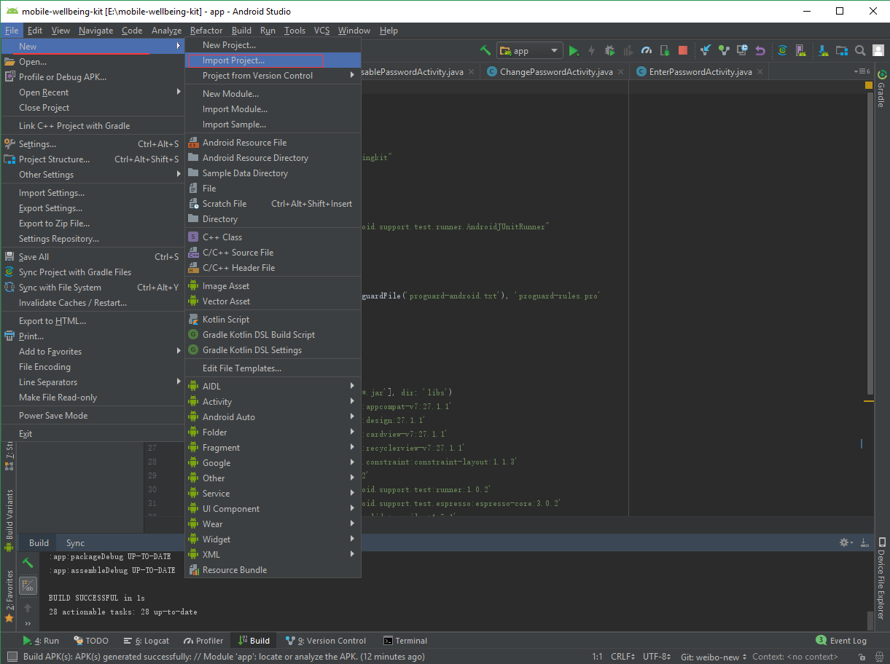

1. Clean Project

Clean the build through the top menu->build-> Clean Project:

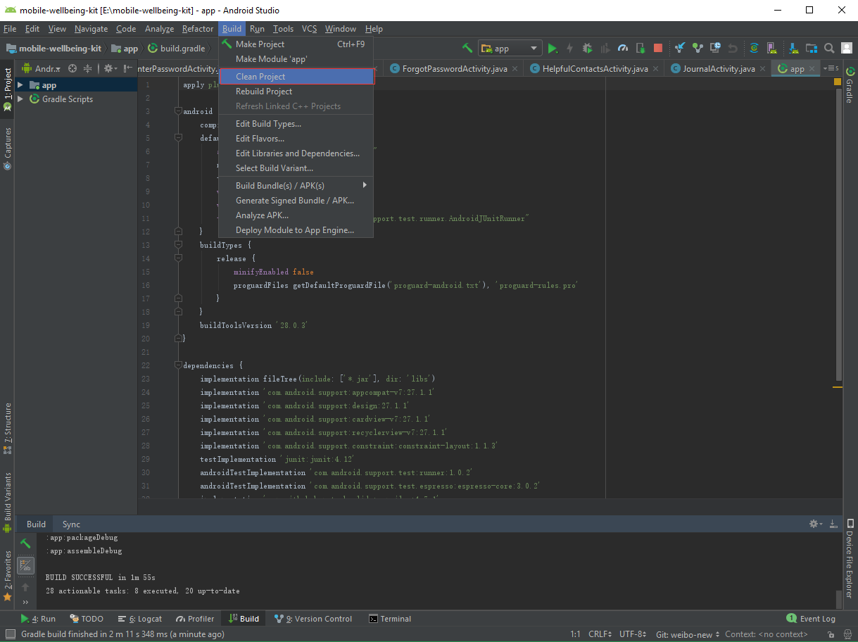

1. Create a emulator or connect your own device

Click the “AVD Manager” above the top menu on the right of the screen

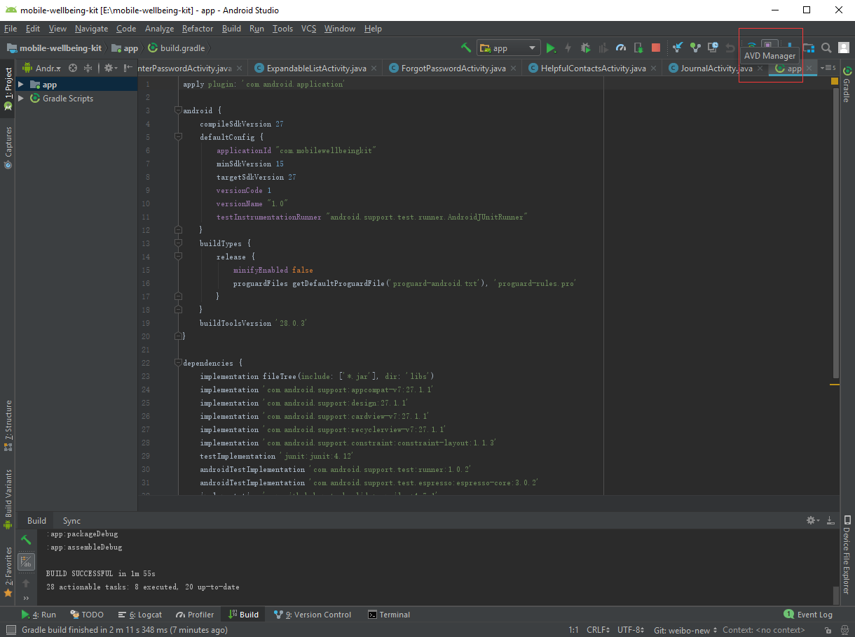

Open it and click the “Create Virtual Device...” button on the bottom left of the page to create your own emulator.

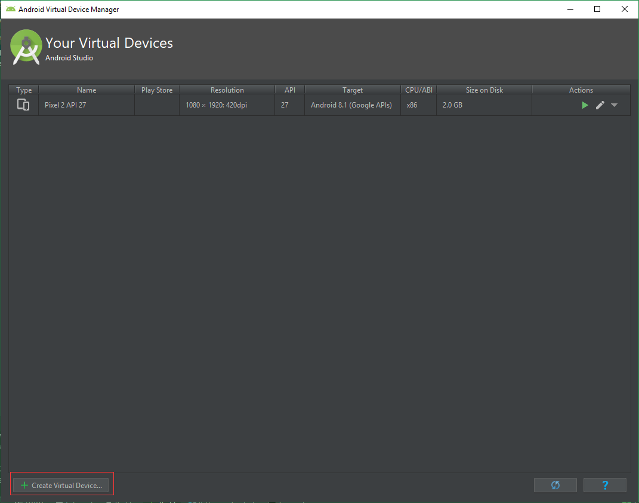

Or connect own device with a cable to Android studio.

1. Testing the application

Run the application by click “Run” button which is a green arrow on the same level of “AVD Manager”. Select the emulator and press OK.

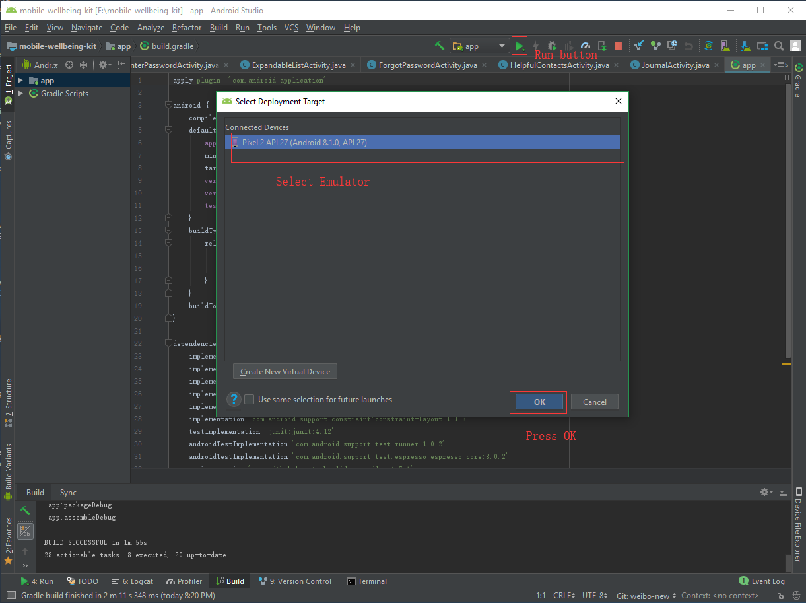

1. Compiling the application

Open “app file” from the left of the page, the user can compiling the application through each file.

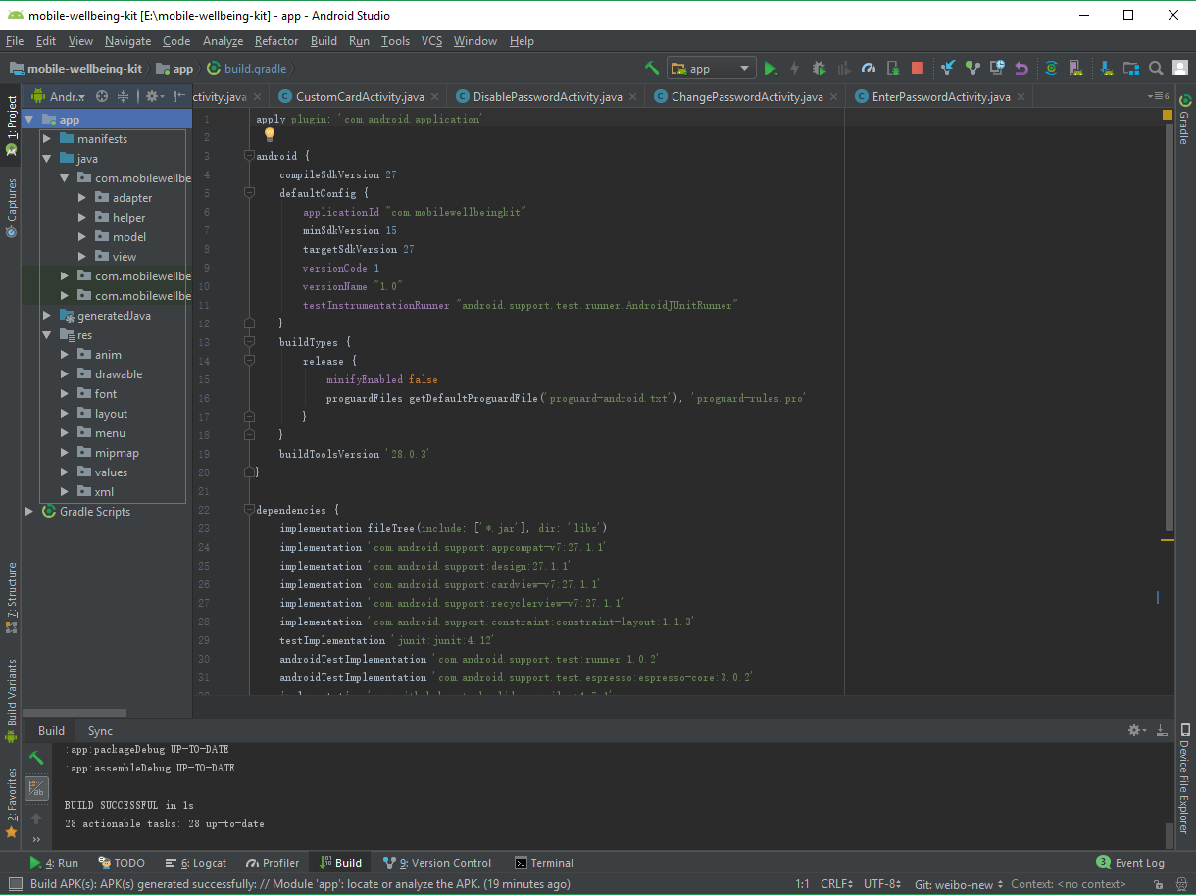

Each file contents many different class, user can modify it to implement new functions:

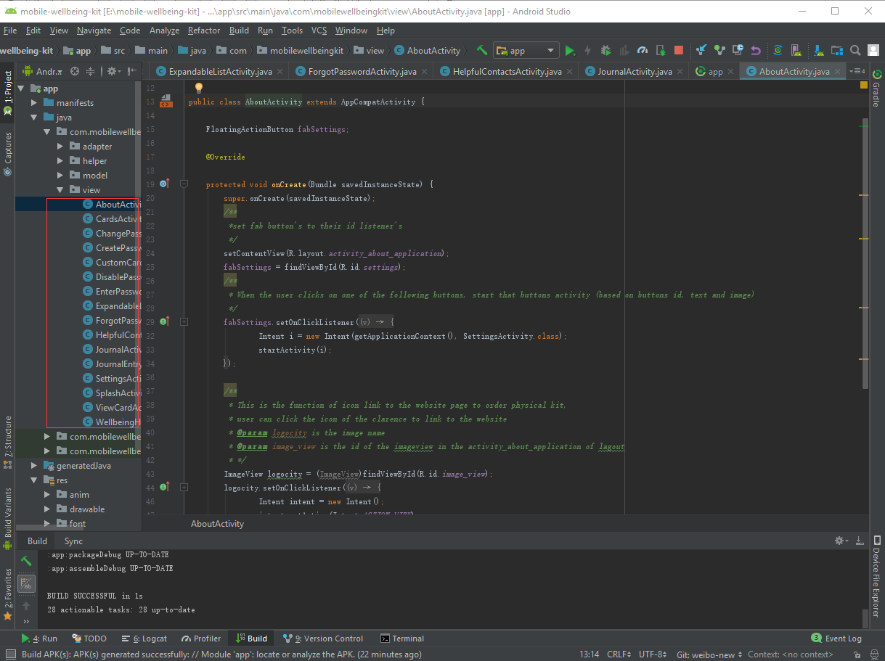

1. Build apk file with gradle

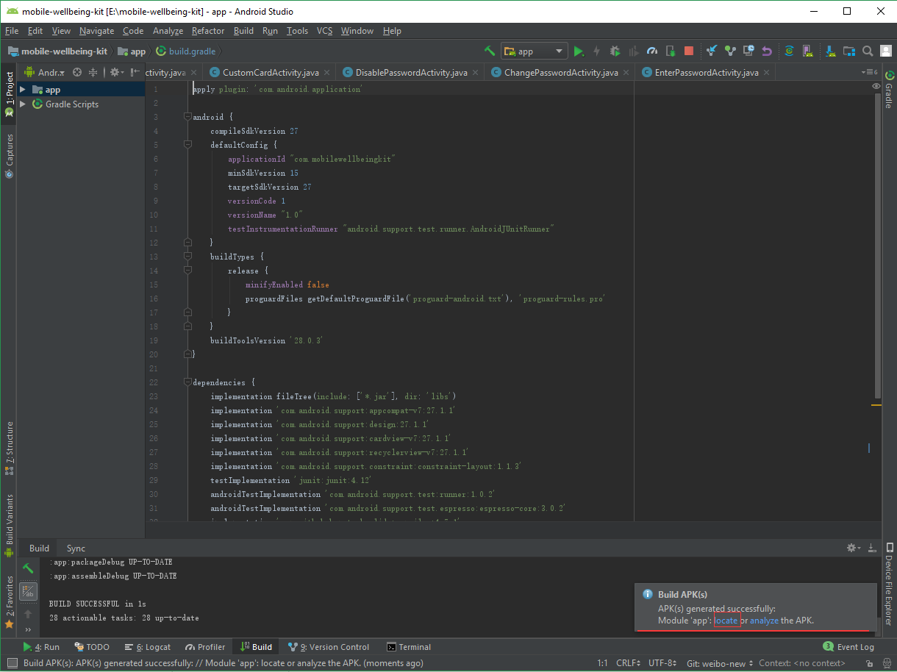Click Build to open the drop down menu->Select “Build APK(s)” from the “Build Bundle(s)/APK(s)”:

1. Open the file and get APK:

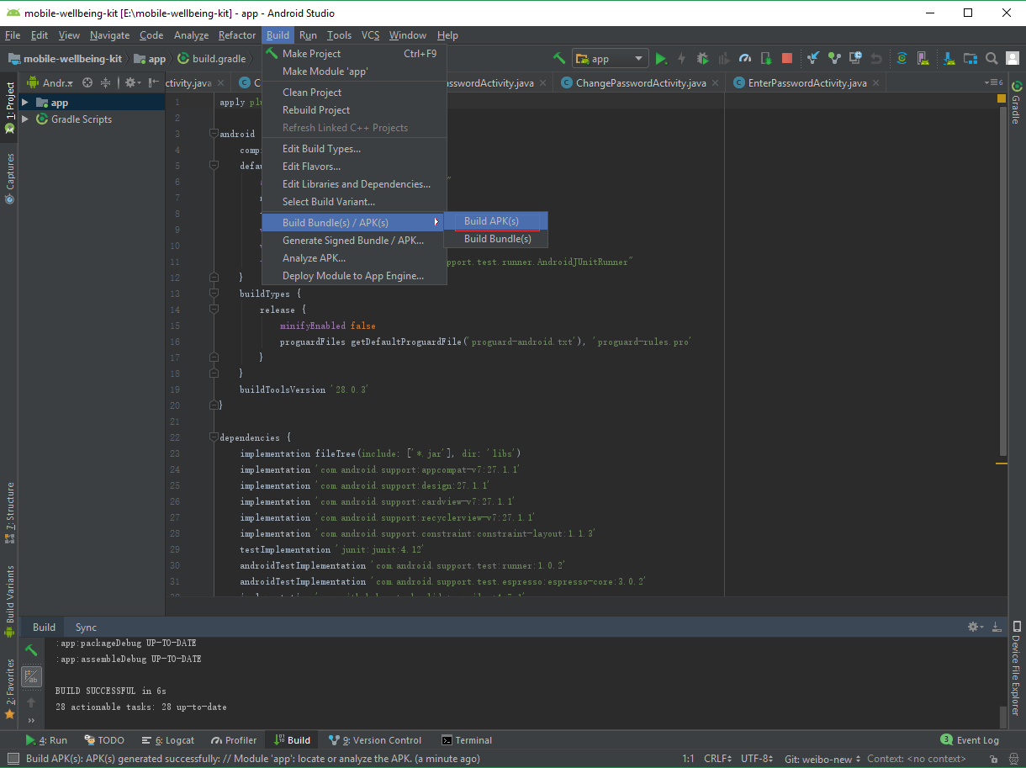After building the APK, in the bottom right of Android Studio a popup dialog will appear saying that the APK built successfully and is available to open through the text “locate”. Here the user can retrieve their APK.

1. Store the APK to the mobile to test it.

## **3.2 iOS**

Making changes to the iOS Application is a simple process. See instructions below.

1. Open the project with XCode. To do this either:
   1. Open XCode > Select the My Wellbeing Kit project if it is visible in the right window.
   2. Select the ‘Open another project…’ button in the bottom of the right window and navigate to the My Wellbeing Kit.xcodeproj file in Finder and select open.

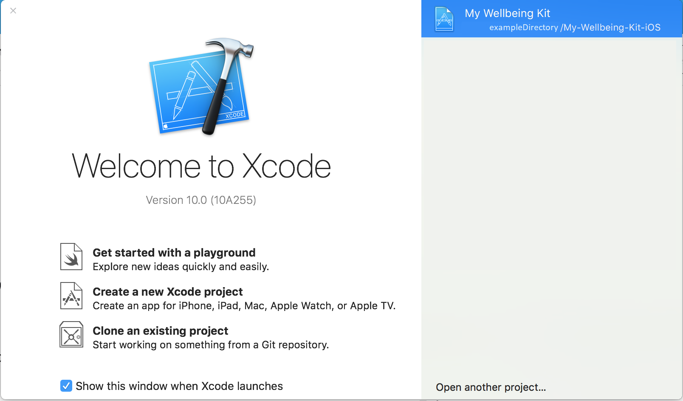

1. After user opened XCode software, the software will presented with the Settings page for the project.

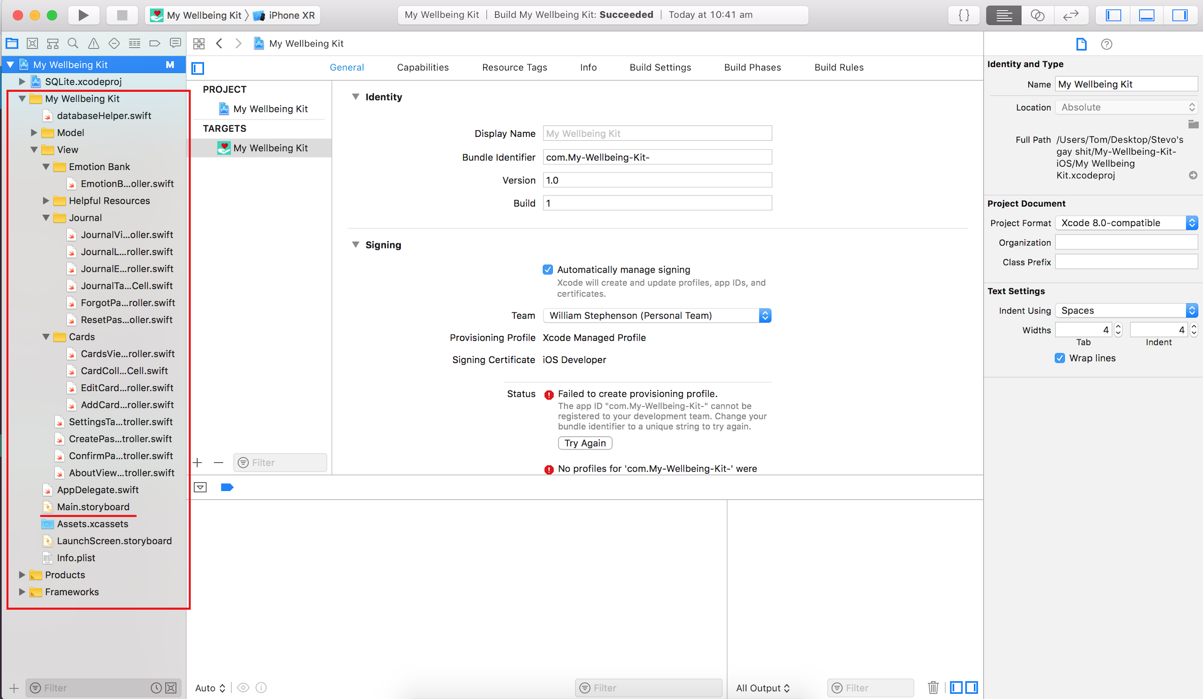

1. In order to edit the file, Search it by browse the navigation bar. After Click it , it will open Editor and allow user to do some changes. It has a slightly different with the Storyboard files work which will load the Interface Builder instead of Editor after click it.

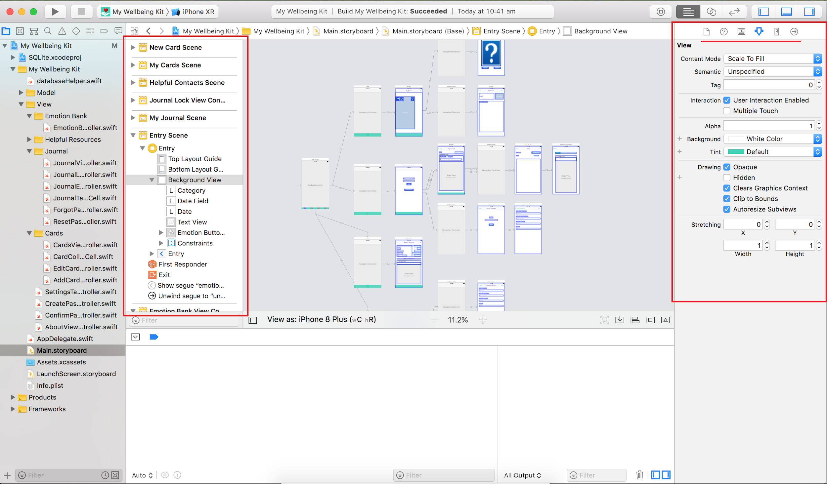

1. The Document Outline window is on the left of the Interface Builder, it displays hierarchical information about the ViewControllers in the Storyboard.
2. The Inspector is on the right side, There are multiple tabs in this which show information about the identities, attributes and sizing of files and UI elements.
3. After editing, user use the top menu bar “Window” -> Devices and Simulators

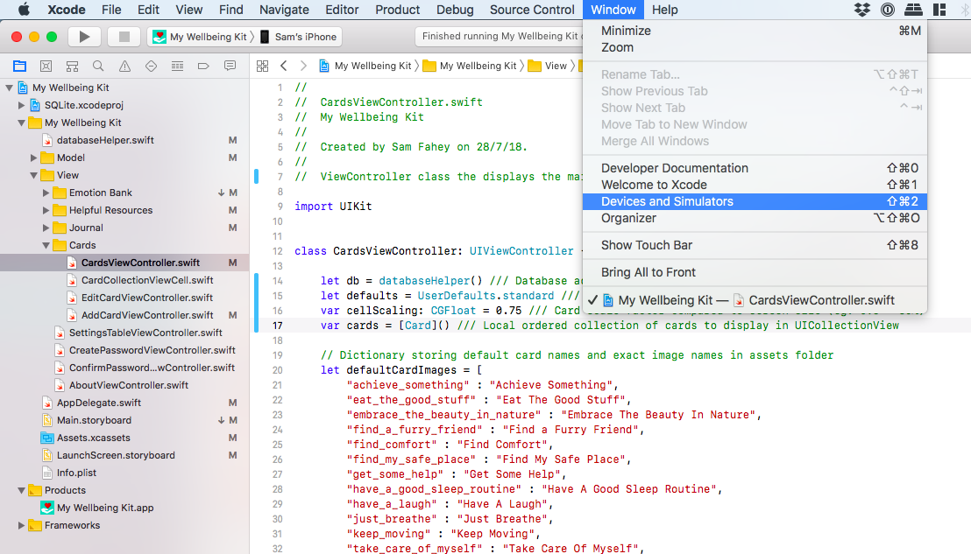

1. The emulator screen will show on the page->choose the device stored before.

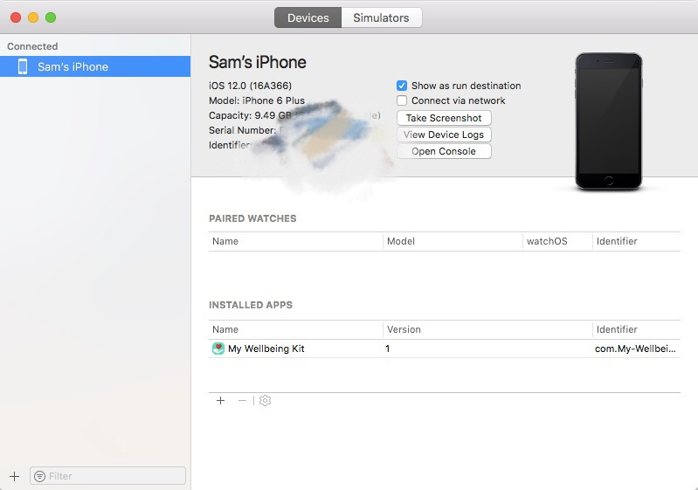

1. Drag and drop the ipa file into the Installed Apps as shown below: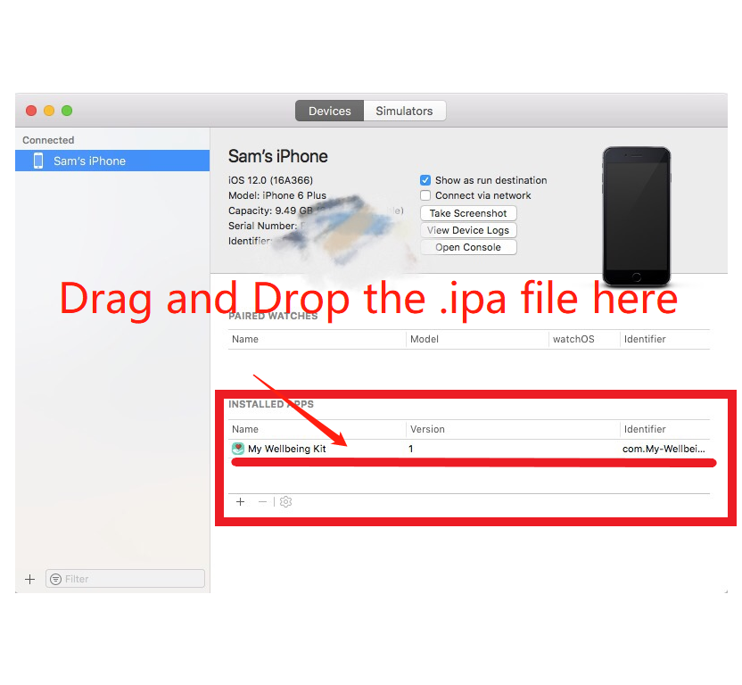

# **4. Installation and troubleshooting**

How to install your program

>Different from one in user guide

> Important to cover every step

> Include troubleshooting section

## **4.1 Android**

### **4.1.1 Install application directly from .apk:**

Below are the instructions for you to install the Mobile Wellbeing Kit application on your Android devices. Please note that some of your screens may look slightly different. Also if you are not greeted by the same prompts/windows as detailed below, attempt to continue on with the instructions anyway –

**Step 1.**

Copy the file ‘app-debug.apk’ onto your mobile device

or download the file ‘app-debug.apk’ from this email straight onto your device

**Step 2.**

Locate the ‘app- debug.apk’ file on your phone and select it

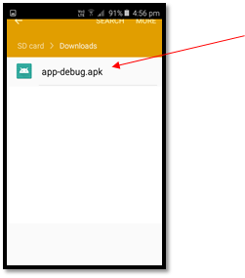

**Step 3.**

This will throw up a warning saying “Install blocked.” Select the option ‘SETTINGS’

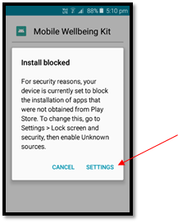

**Step 4.**

In the new window that has appeared select the option “Unknown Sources” (Toggle it on).

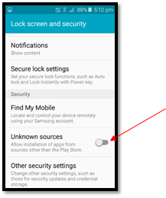

**Step 5.**

In the new window that appears check the “Allow this installation only” option and then select “OK”

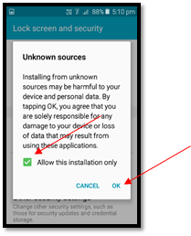

**Step 6.**

Now we are able to select the “INSTALL” button from the new screen that is presented.

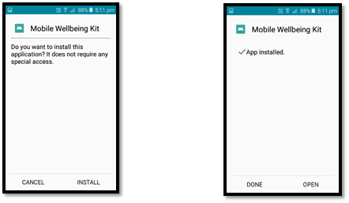

**Step 7.**

Once the installation has finished you can either select the “OPEN” option or find the newly installed app in your applications menu under the following icon…

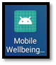

## 

## **4.2 iOS**

**4.2.1 Install application directly from .ipa:**

Below are the instructions for you to install the Mobile Wellbeing Kit application on your IOS devices. Please note that some of your screens may look different. Also if you are not greeted by the same prompts/windows as detailed below, attempt to continue on with the instructions anyway –

**Step 1:**

Connect your device to the Mac computer.

**Step 2:**

Launch Xcode development tool.

**Step 3:**

Go to the top menu bar, and go to Window -> Devices and Simulators



**Step 4:**

Devices screen will appear, and choose the device you want to install the app on.



**Step 5:**

Drag and drop your .ipa file into the Installed Apps as shown below:



# **5. Development tools**

## **5.1 Android Studio**

Android studios is an integrated development environment (IDE) used for the development of Android applications. The program is build off JetBrains' IntelliJ IDEA software. Its main features include Visual layout editor, APK analyzer, Code editor and a flexibility for build systems.

The mobile Wellbeing Kit application made use of Android studios 3.2 to code the Android application, through the utilisation of it various features. The program was used in coding both .java files for the main functionality of the application, while with the visual layout editor, the team coded the layout files in .xml. Android studios offered the team the tools to develop, compile and run the application on both physical and virtual android devices.

### **5.1.1 How To Install**

Step – 1 : Right click on downloaded .exe file and Run as Administrator.  
  
Step – 2 : You will see the below Setup wizard. (Click in Next)  
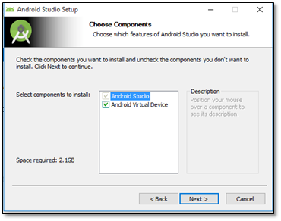

Step – 3 :  
Select Android Virtual Device (Click on Next)  


Step – 4 :  
The default installation path should be C:\Program Files\Android\, If you want to change the installation directory, you can freely use the Browse button and provide a new location (Click on Next).

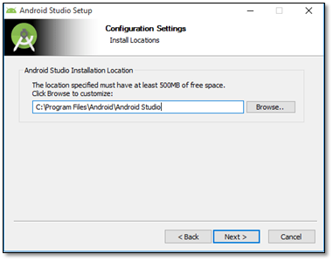

Step -5 :  
Click on Install.  
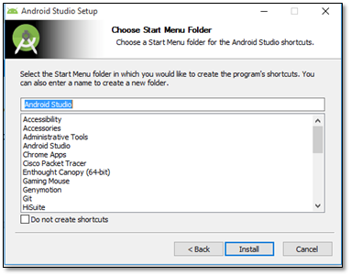

Step -6 :   
Actual installation in progress… After completion of the installation process click on Next

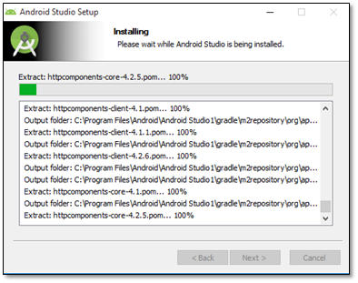

Step – 7 :  
Tick the Start Android Studio option and Click on Finish.  
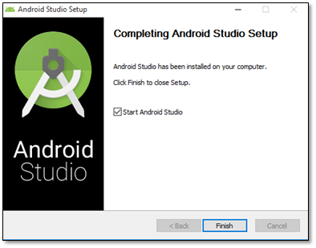

Step – 8 (The Welcome Screen):  
Click on Next

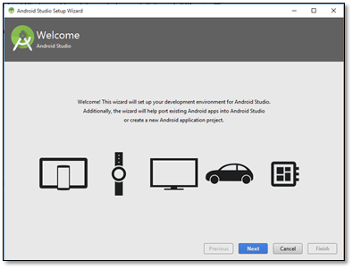

Step – 9 :  
It will ask for the Android Studio installation type. Default to the Standard setup, if you have any specific configuration setup then you can select the Custom option to manually setup. (Click on Next)

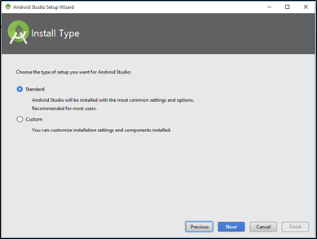  
  
Step -10 :  
For the UI Theme, set it to default; it would be IntelliJ. (Click on Next)

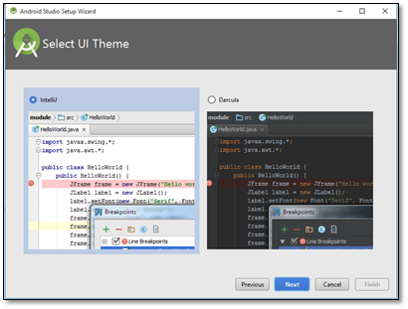

Step -11:  
It will ask for the confirmation for installation setting wizard. (Click Next)

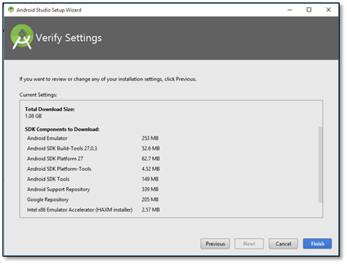

Step -12 :  
Download all necessary components to launch the Android Studio and setting up the environment.

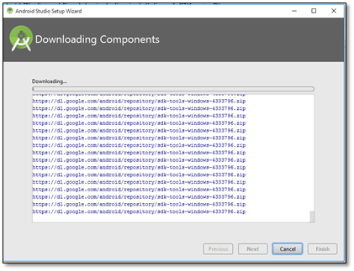   
After download and installation click on Finish.  
Android Studio has now been successfully installed.

### **5.1.2 How to Use**

**Opening new Android studio project:**

Open Android studios and open the top left toolbar option (File) > Open > navigate to your file > OK

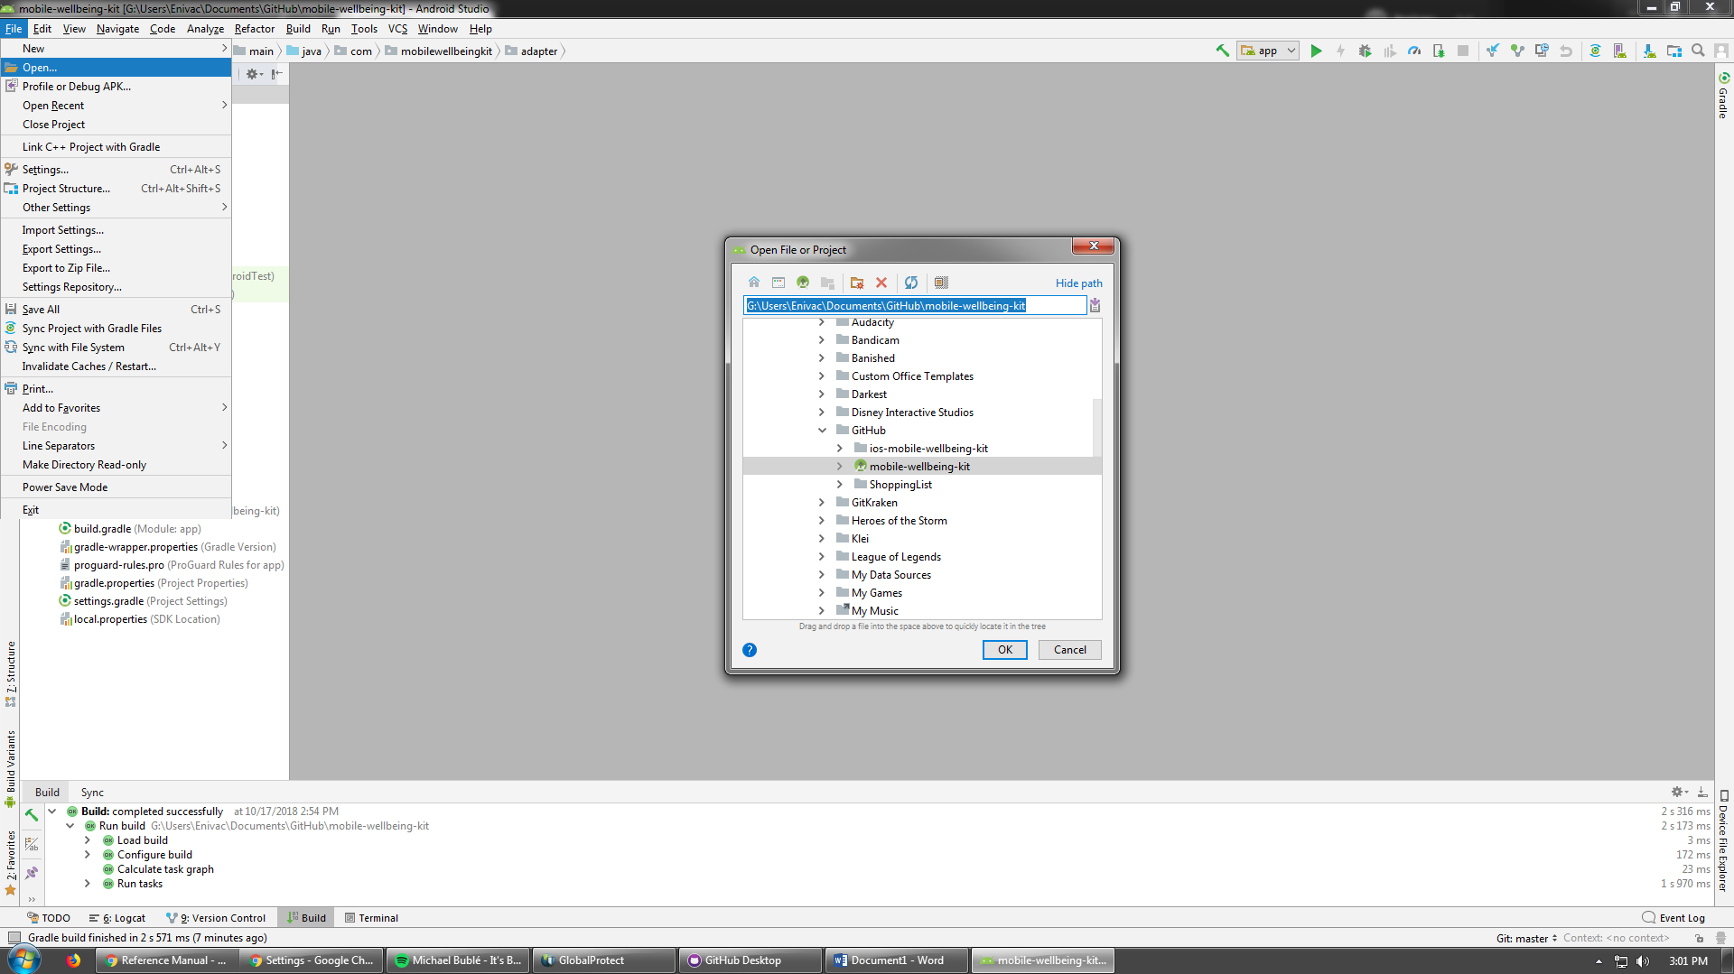

## **5.2 XCode**

XCode is an Integrated Development Environment available (exclusively) on macOS. It is used to develop software for macOS, iOS, watchOS and tvOS. The latest version is 10.0 which was released in September 2018. It can be accessed free from the Mac App Store. <https://developer.apple.com/xcode/>

The My Wellbeing Kit was built using version 10.0 of XCode.

### **5.2.1 How to Install**

1. Open Mac App Store on a device using macOS
2. Enter ‘xcode’ into search bar and press the ‘Return’ key

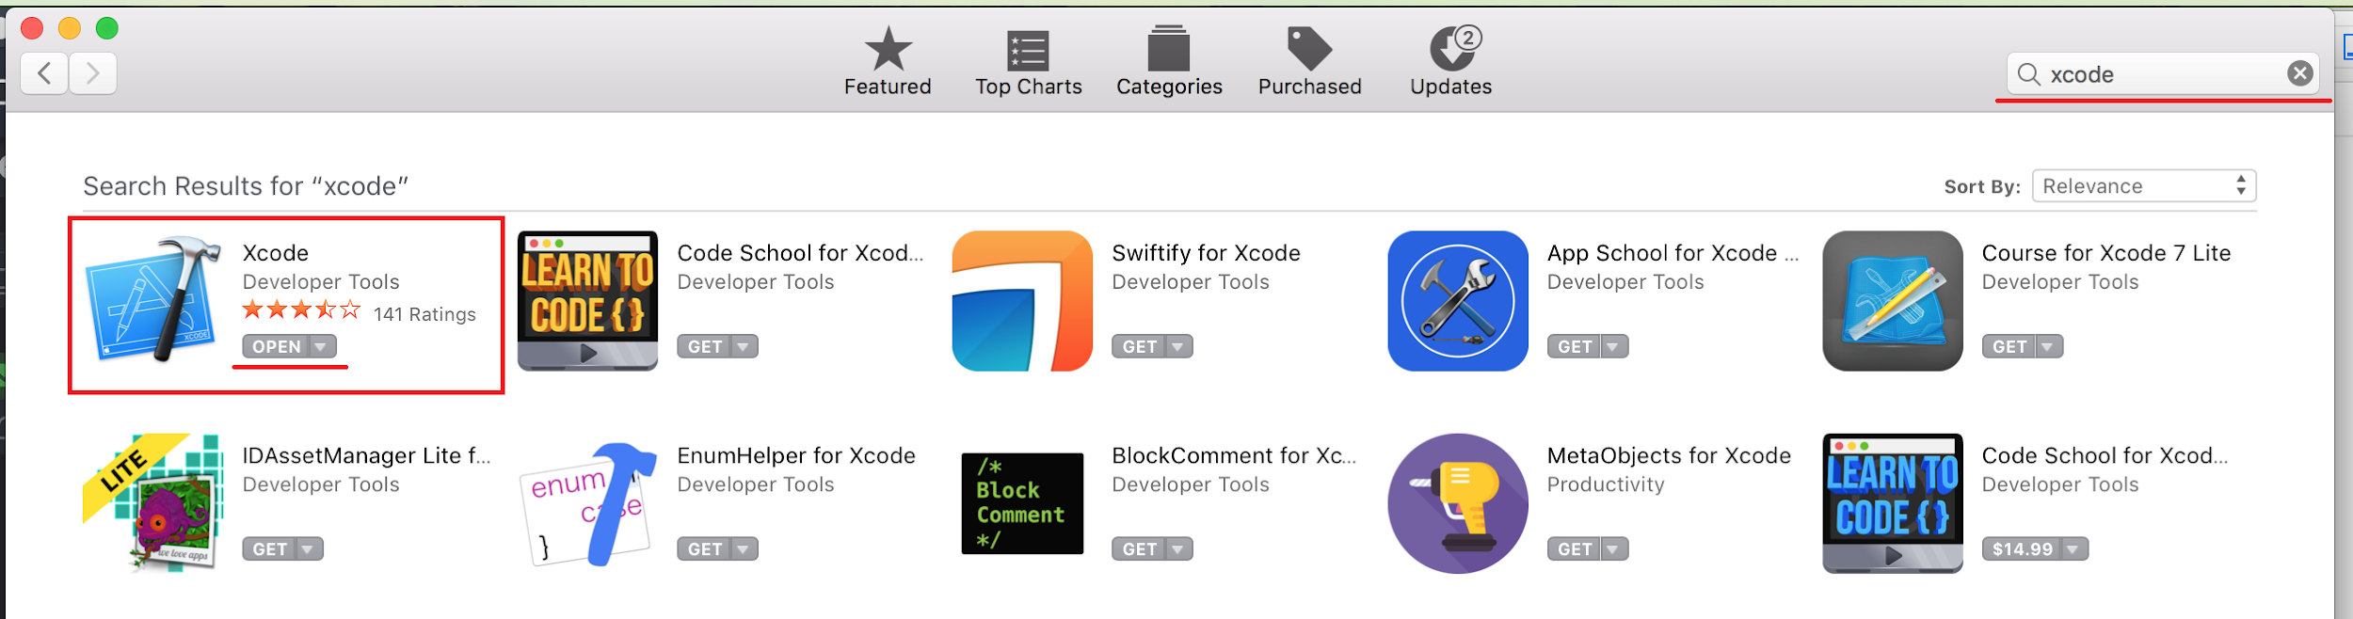

1. Select the first resulted (pictured above)
2. Press GET (if it is already installed then it will say OPEN)
3. Enter password when prompted
4. Wait for download to complete
5. Select the application
6. Accept XCode and iOS Licence Agreement
7. Enter password
8. The installation will be complete and the application will launch

### **5.2.2 How to Use**

**Opening XCode**

Opening XCode from macOS will give you this screen:



Select the My Wellbeing Kit project if it is visible in the right window. If it is not, select the ‘Open another project…’ button in the bottom of the right window and navigate to the My Wellbeing Kit.xcodeproj file in Finder and select open.

**Opening Files**

Once XCode has been opened, the user will be presented with the Settings page for the project.

To edit a file, browse the Navigator and search for it. Clicking on it will bring it up in the Editor and allow changes to be made.

Storyboard files work a little differently. When clicked on these will load the Interface Builder instead of the Editor.



On the left of the Interface Builder is the Document Outline window which displays hierarchical information about the ViewControllers in the Storyboard.

On the right of the Interface Builder is the Inspector. There are multiple tabs in this which show information about the identities, attributes and sizing of files and UI elements.

## **5.3 GitHub**

GitHub is an open source development platform utilised for its version control system. Github provides a place where developers can store their projects and network with likeminded people. You can host and review code, manage projects, and build software alongside any number of other developers. GitHub Desktop is supported on Microsoft Windows and OS X operating systems.

### **5.3.1 How to Install**

(Warning: You must have a 64-bit operating system to run GitHub Desktop).

Step 1 -  
Visit the [GitHub Desktop download page](https://desktop.github.com/).

Step 2 -  
Choose Download for Windows. (Note: If you are a network administrator, you can use the GitHub Desktop Windows installer package to deploy GitHub Desktop).

Step 3 -  
In your computer's Downloads folder, double-click GitHub Desktop.

Step 4 -  
In the pop-up window, click Install.  
After the program has been installed, click Run.

### **5.3.2 How to Use**

**New project:**

Step 1 -

To create a new project navigate to <https://github.com/> and login to or create a GitHub.com account.

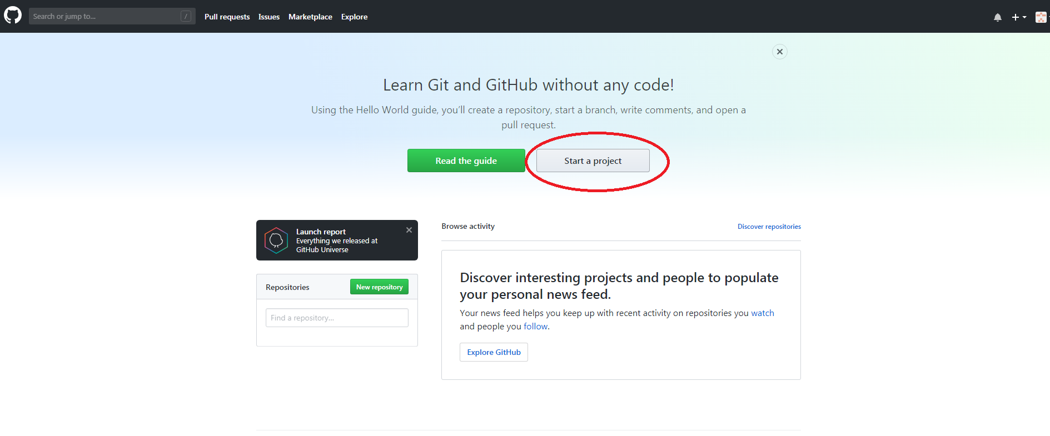  
Step 2- Once a account is setup start a new project by select the ‘Start a project’ option located on the front page of your account.

Step 3 -

Fill Out the proceeding form with your desired details and select ‘Create Repository’

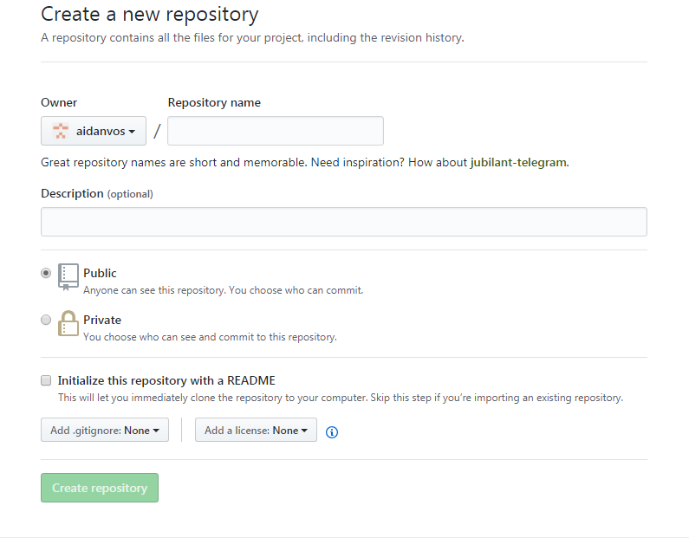

**Work on an already existing project:**

Step 1 -

Open Github desktop and login to or create a GitHub.com account

Step 2 -

Select File > Clone Repository…

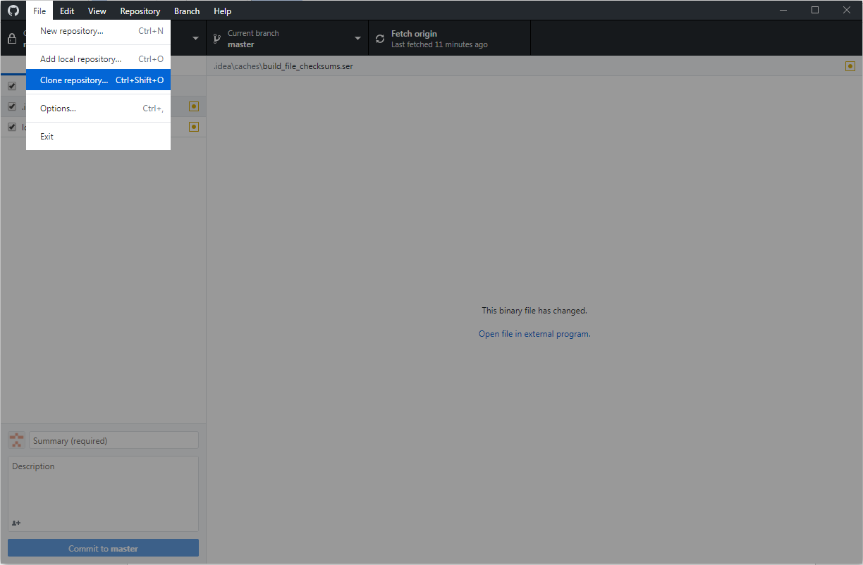

Step 3 -

Navigate to the URL tab and copy (CTRL + C) paste (CTRL + V) the URL of your project.  
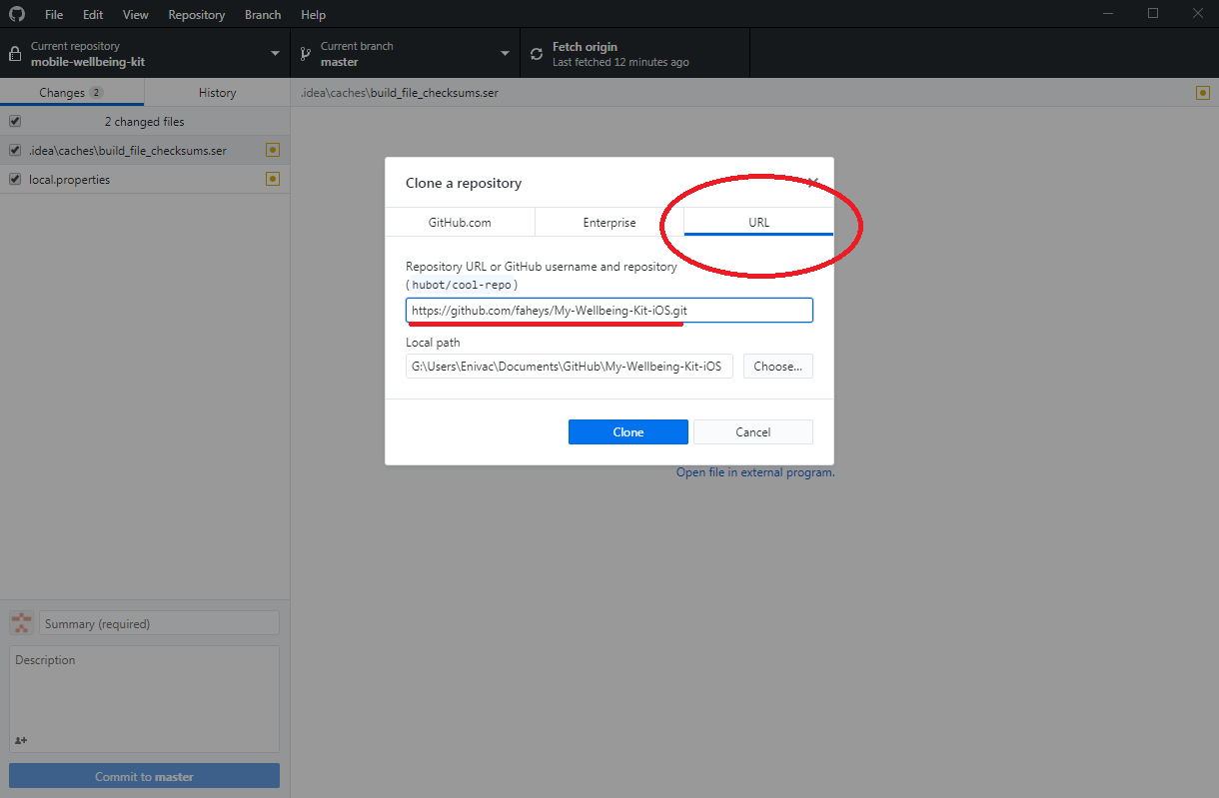

Step 4 -

Allow the project time to clone and when finished find your project added to your desktop.

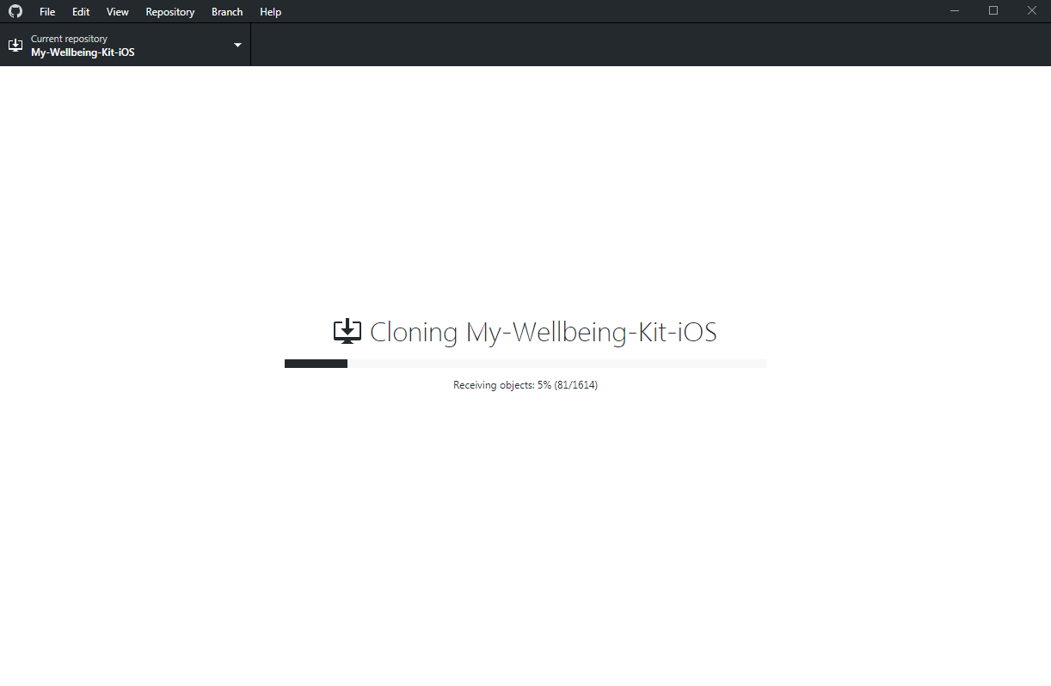

## **5.4 SQLite**

The utilisation of the open source software SQLite provides an SQL database that stores data to a text file on a device. Android Studios comes with a built in SQLite database implementation. This means that you will not need to install anything for to use SQLite with Android Studios. This allows for the saving of data to a database and is ideal for repeating or structured data.  
The APIs you'll need to use a database on Android are available in the [android.database.sqlite](https://developer.android.com/reference/android/database/sqlite/package-summary.html) package.

### **5.4.1 How to Use**

To make use of SQLite you will need to make use of the APIs provided in the [android.database.sqlite](https://developer.android.com/reference/android/database/sqlite/package-summary.html) package, depending on your needs.

Create a class named DatabaseHelper.java and extend the class from [SQLiteOpenHelper](https://developer.android.com/reference/android/database/sqlite/SQLiteOpenHelper.html). This class holds the database related methods to perform the CRUD operations (Create, Read, Update and Delete).

* 1. onCreate() will be called only once when the app is installed. In this method, we execute the create table sql statements to create necessary tables.
  2. 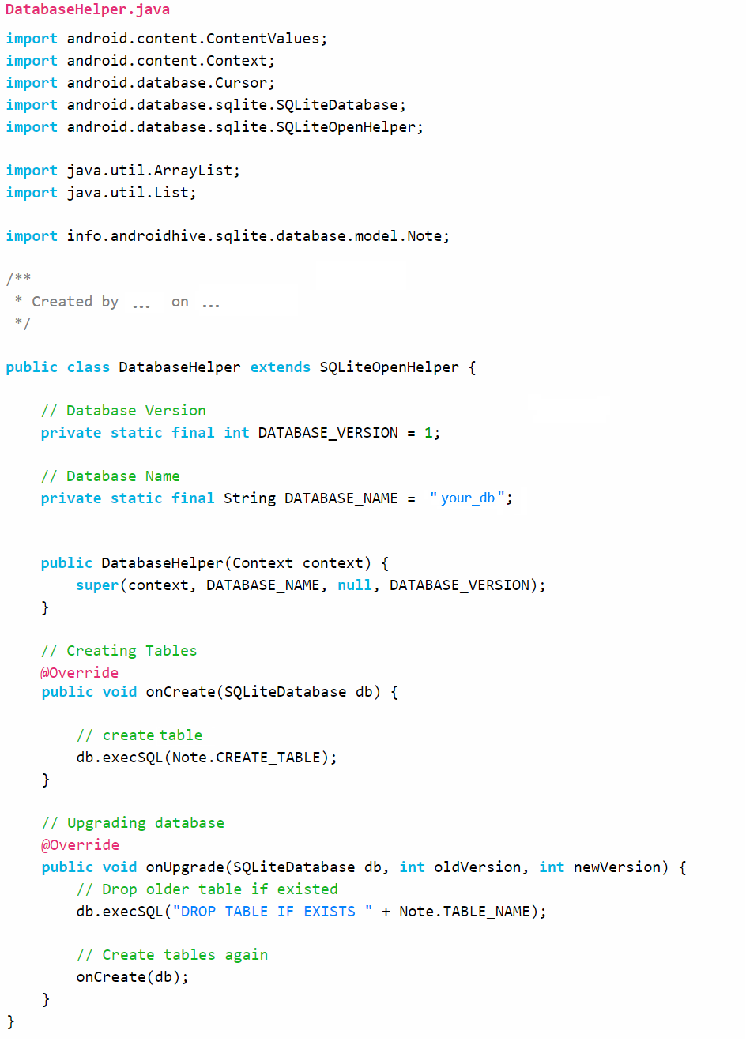onUpgrade() called when an update is released. You need to modify the DATABASE_VERSION in order to execute this method. You have to take care of database migrations here without losing the older data if necessary.

…

...

# 

# 

# **6. Modifying the Android application**

## **6.1 Adding New Default Cards**

First, save the image you want to add to your project's drawable folder.

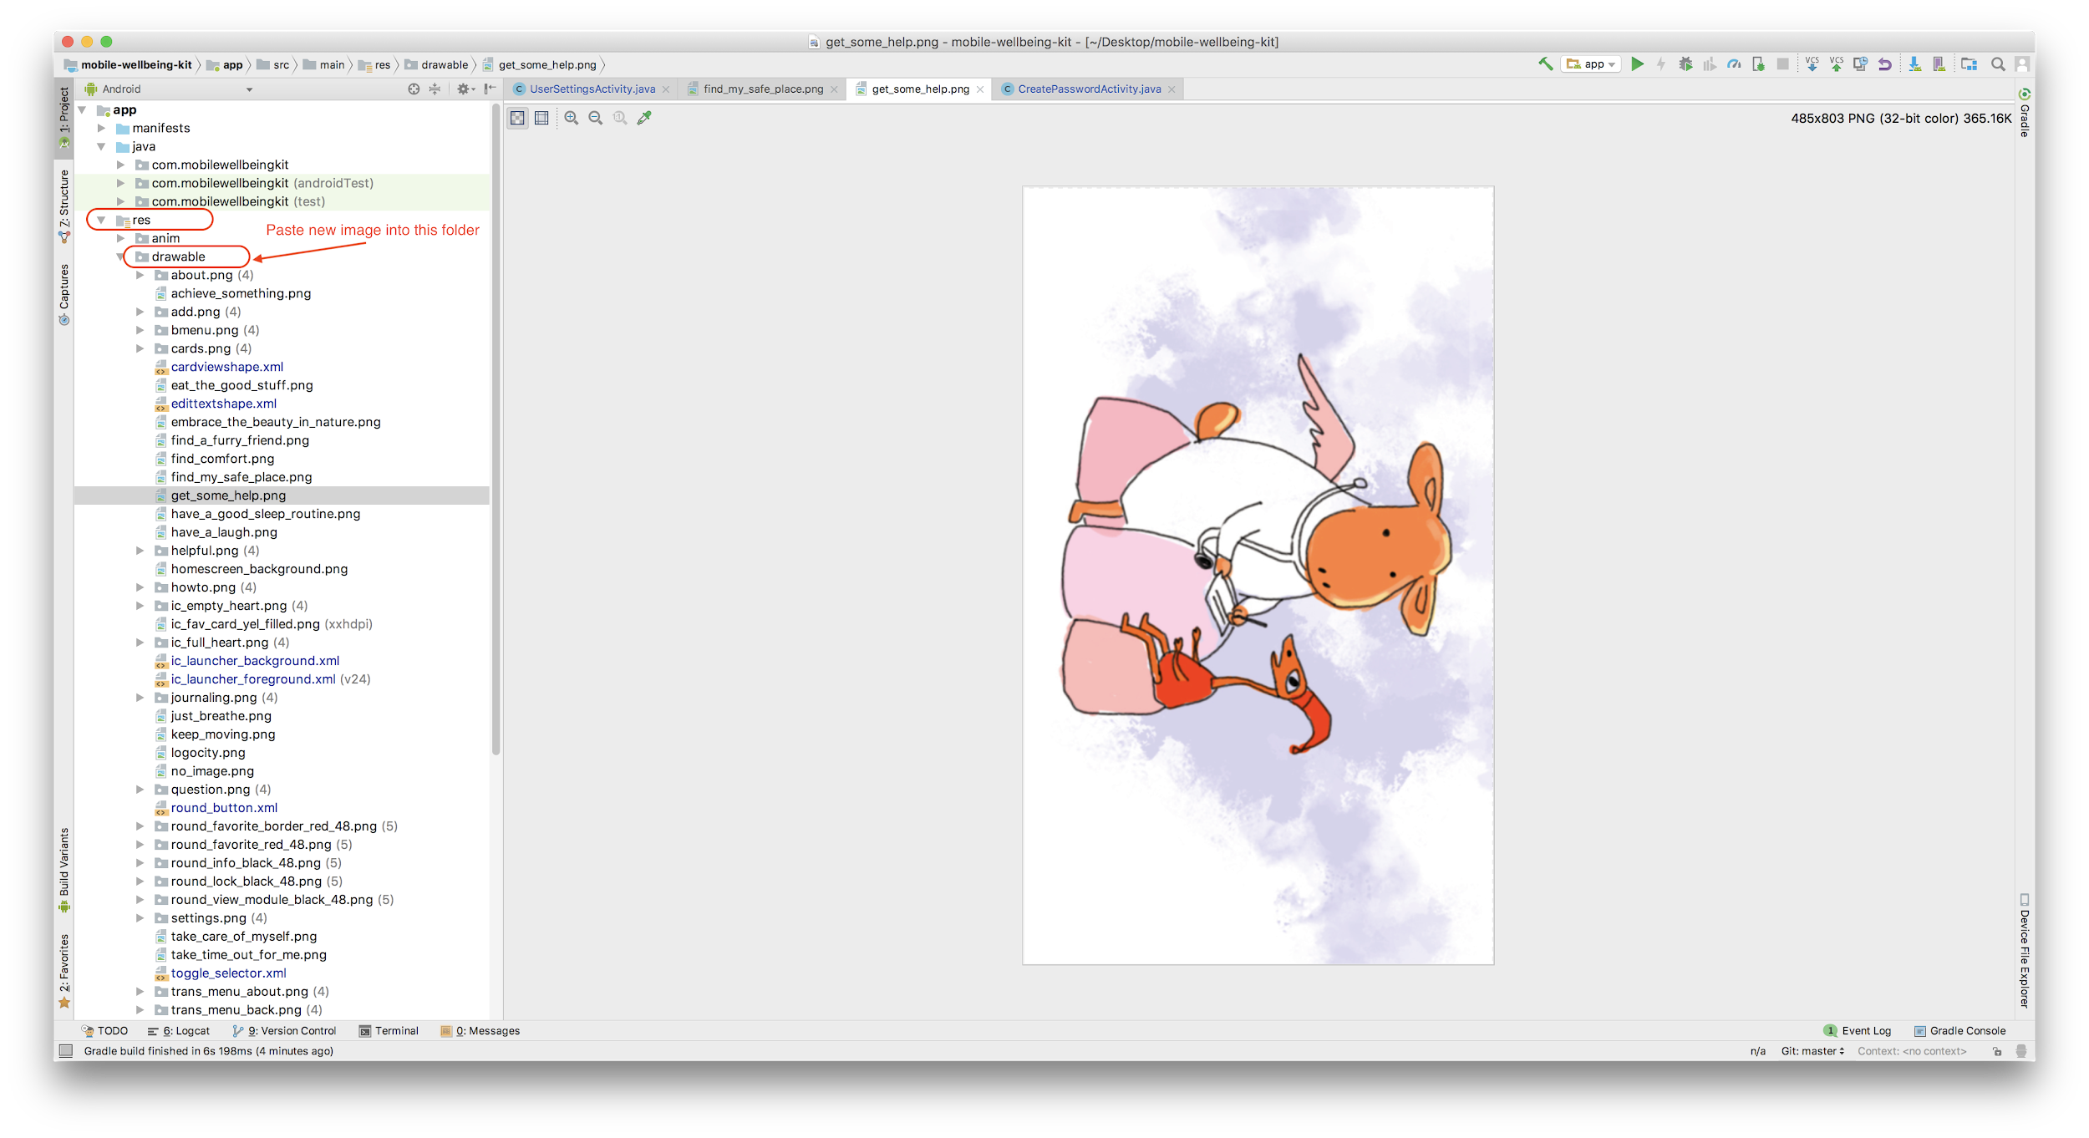

In the view package of the source code, open the CardActivity.java class. Find the initDefaultCards() function in this class, it is the function to initialize the default cards. Then, use the following format to get the uri of the image you want to add:

String (name of new card)_uri=Uri.parse("android.resource://" +getApplicationContext().getPackageName()+ "/"+ R.drawable.(name or image).toString();

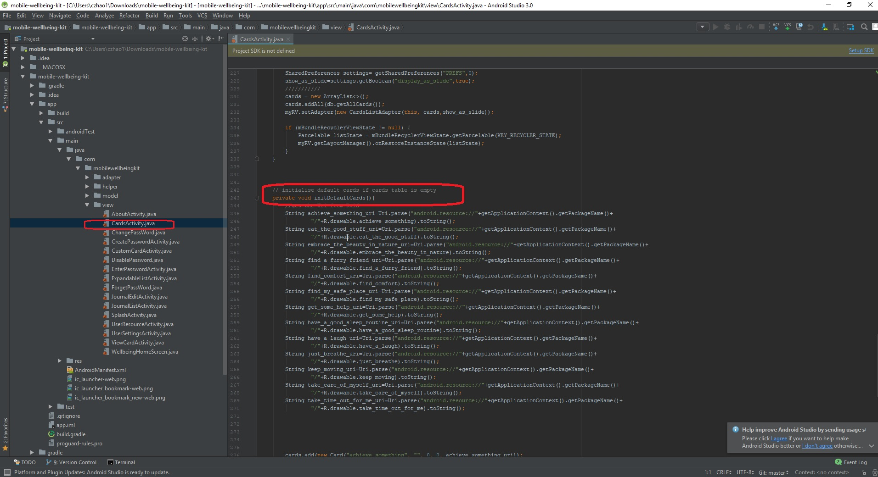

Finally, generate a new card and add it by following format：cards.add(new Card("name of new card", "", 0, 0, (name of new card)_uri));

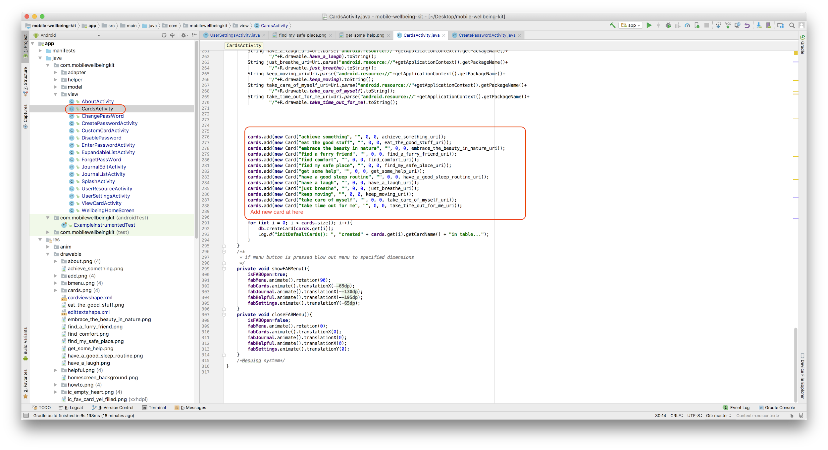

## **6.2 Adding New Default Helpful Contacts**

Go to the layout folder under the res folder of the source code and open the helpful_resour ces_view class. Then, press the “text” button.

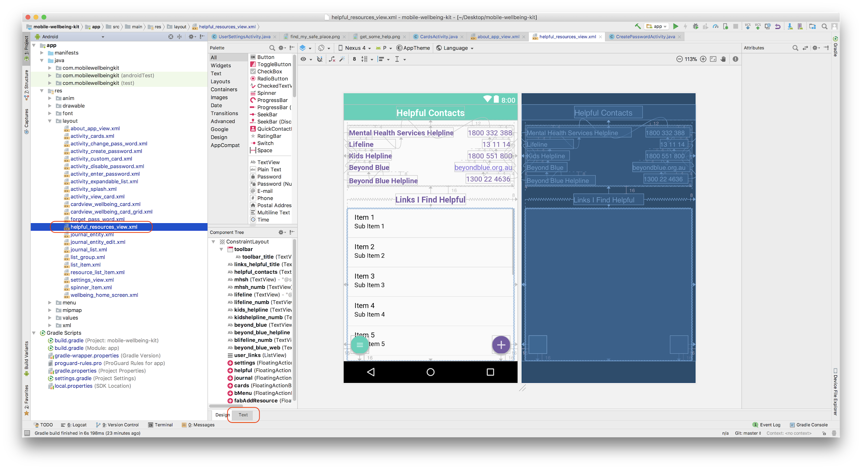

Then, you will enter the code page, you can add useful contacts by adding textview to this file. The text view format is as follows:： <TextView

android:id="@+id/(input resource name)"

android:layout_width="wrap_content"

android:layout_height="wrap_content"

android:layout_marginEnd="4dp"

android:layout_marginRight="4dp"

android:layout_marginTop="4dp"

android:autoLink="all"

android:text="(input phone number)"

android:textColor="@color/MainPurple"

android:textSize="16sp"

app:layout_constraintEnd_toEndOf="@+id/helpful_contacts"

app:layout_constraintTop_toBottomOf="@+id/lifeline_numb" />

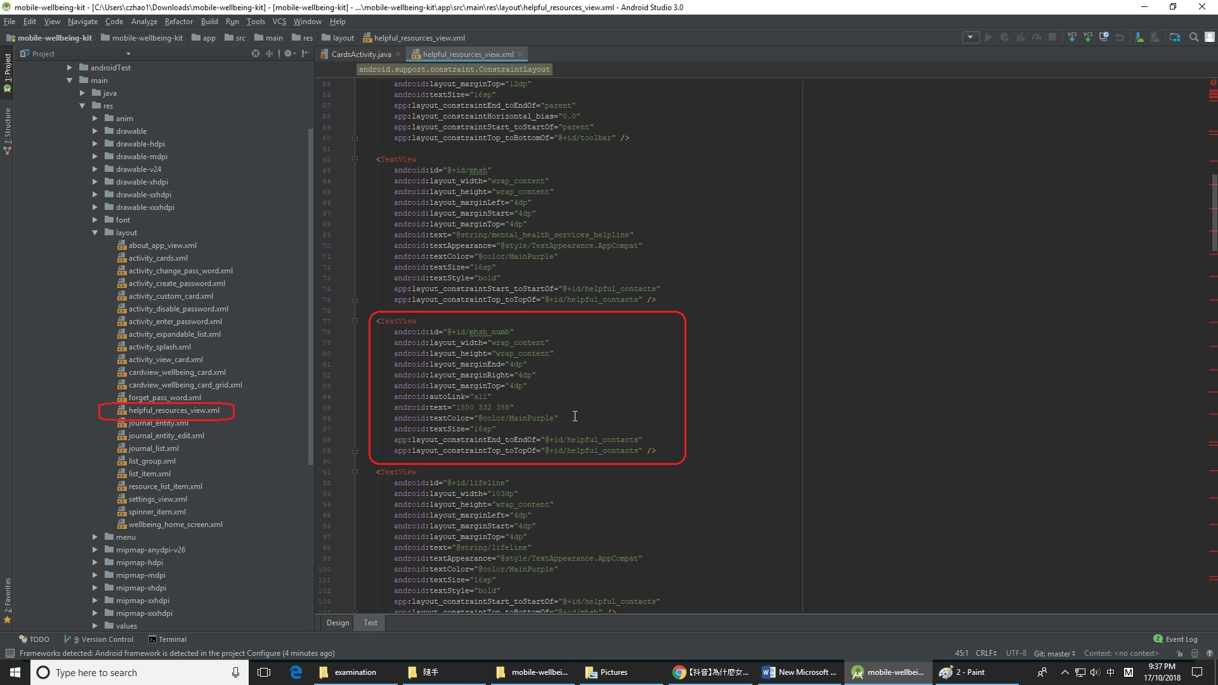

## **6.3 Editing About the Kit Information**

Go to the values folder under the res folder of the source code and open the file which name is string. You can modify the default Kit information by modifying the contents of the string.

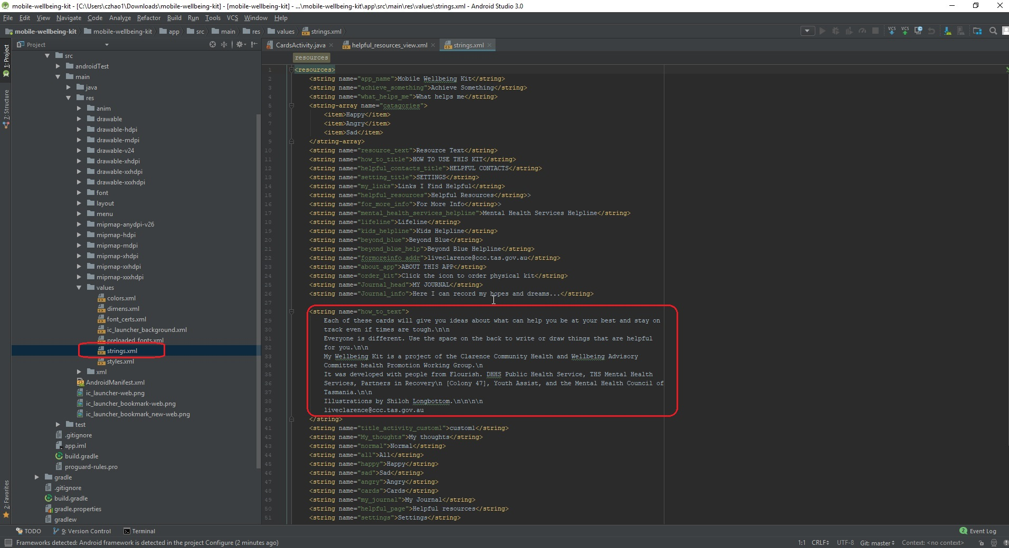

## **6.4 Editing Default Icons**

First, you need to find the ID corresponding to the icons in the code, and then enter the drawable folder under the res folder of the source code. 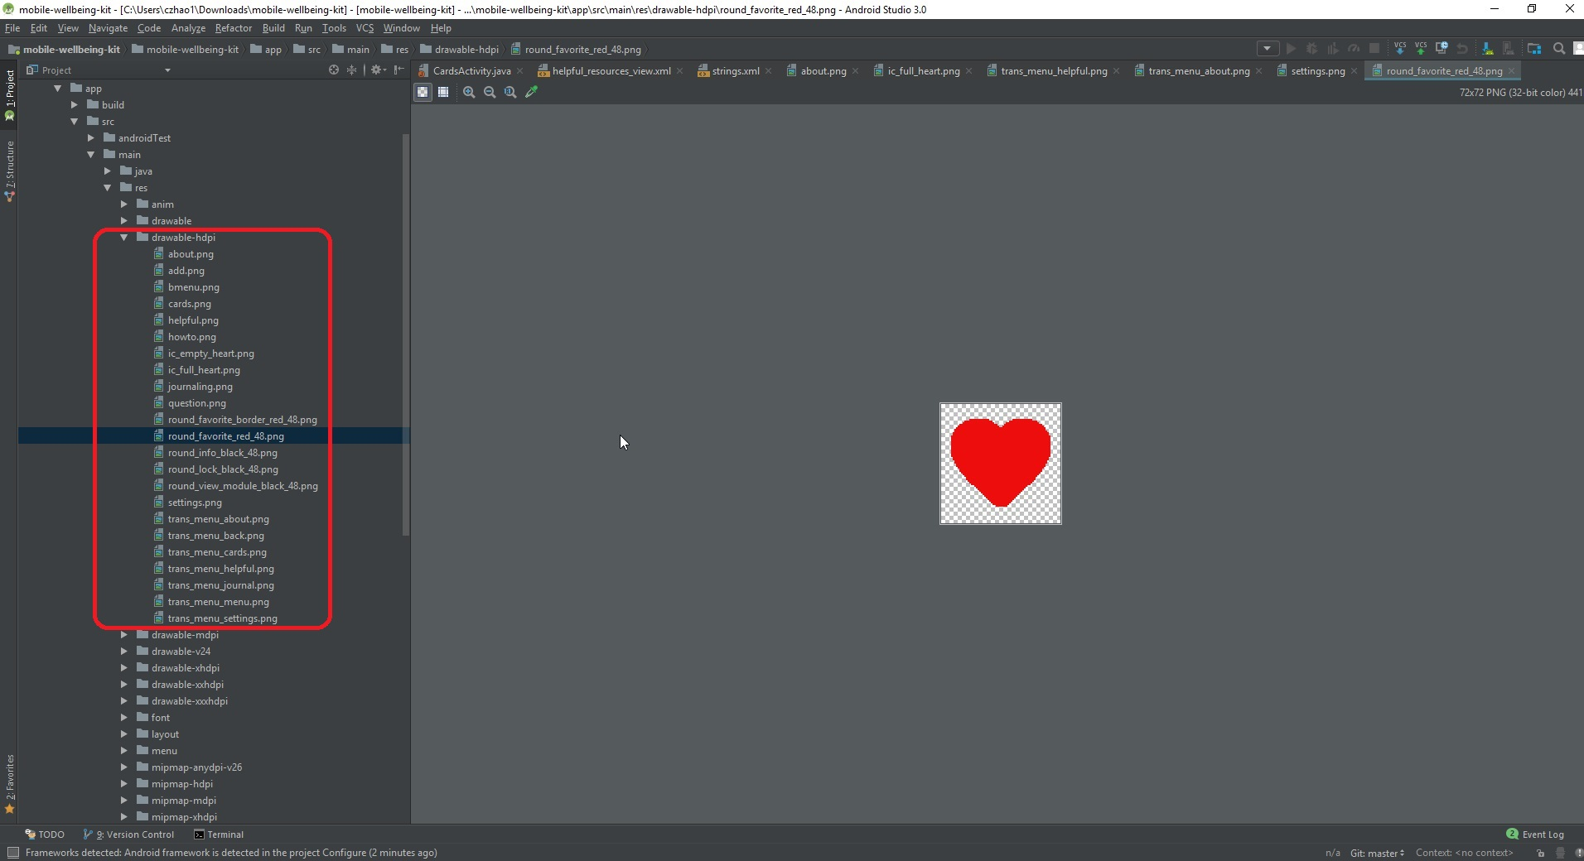

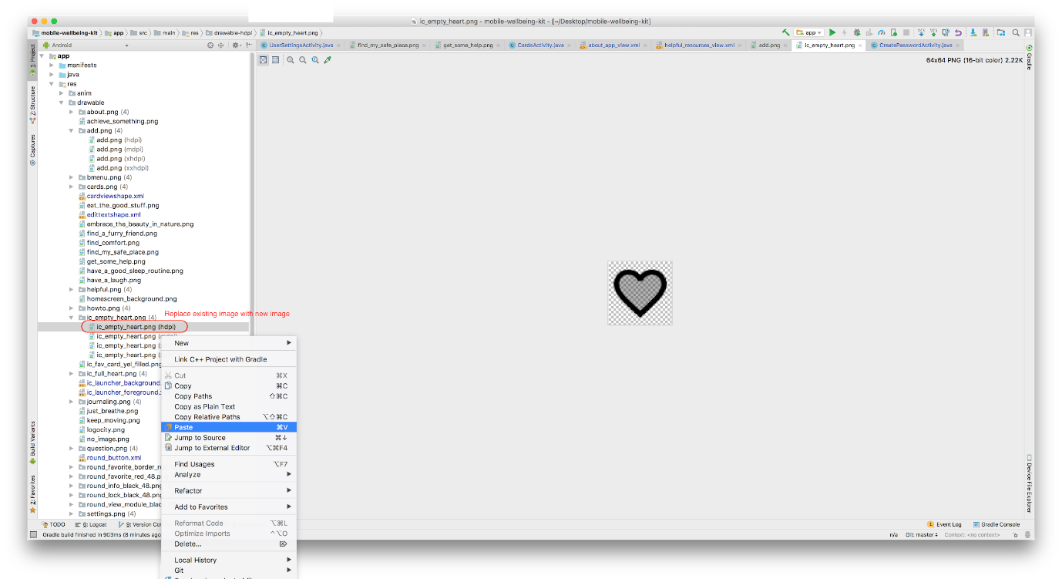You can replace the default icons by paste the new image into this folder.

## **6.5 Finalising additions and edits**

Once everything has been modified, you can save all your changes by clicking the Save button in andriod studio.

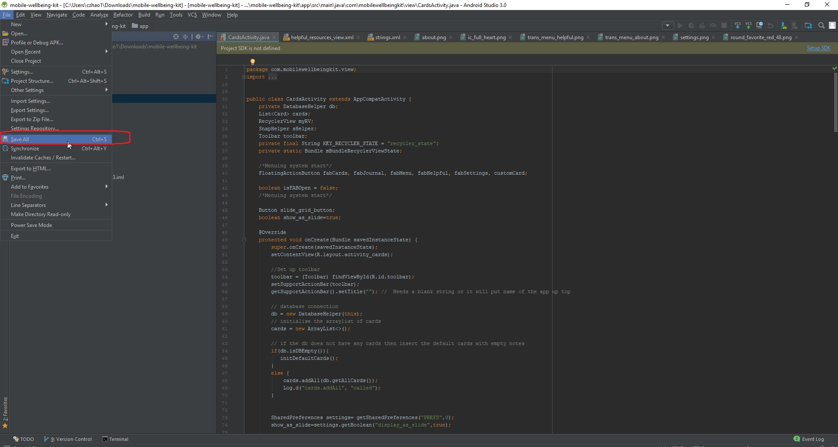

Once the save is complete, you can launch the emulator by clicking the "run" button in andrio studio, and you can also select the model of the phone you wish to simulate.

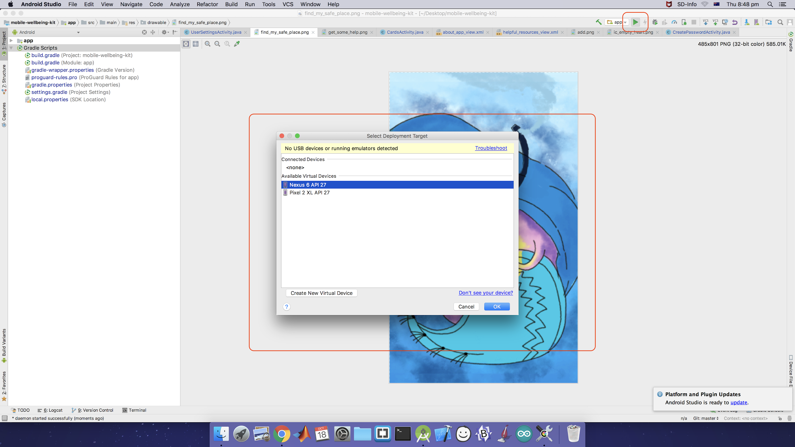

When everything goes fine in simulator, you can generate a new apk by clicking andrio studio->build->build apk.

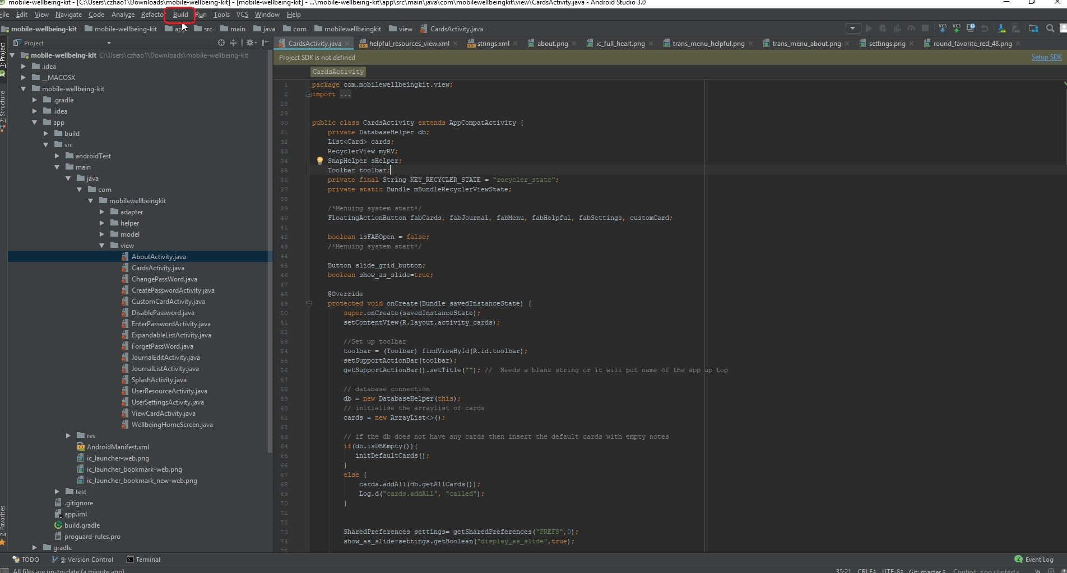

# **7. Modifying the iOS application**

## **7.1 Adding New Default Cards**

**Add Card Image to Resources folder**

1. Open XCode
2. Select Assets.xcassets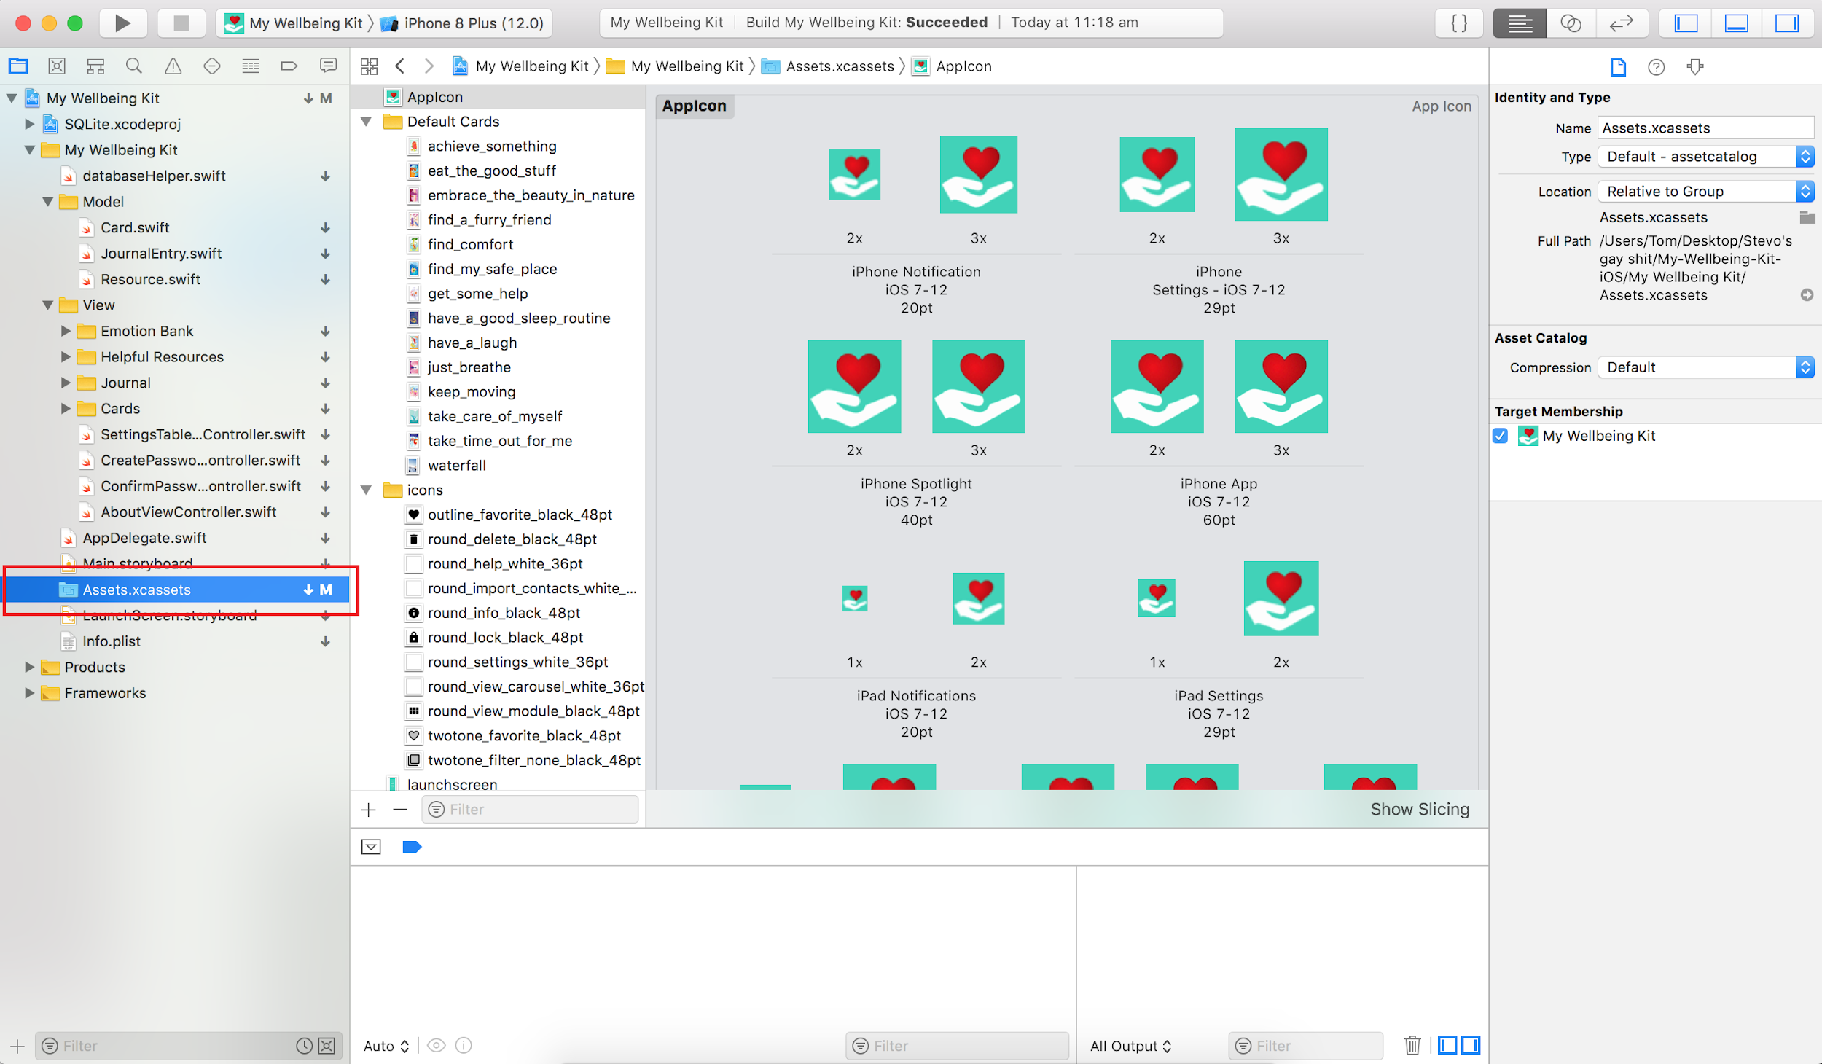
3. Select the Default Cards sub folder 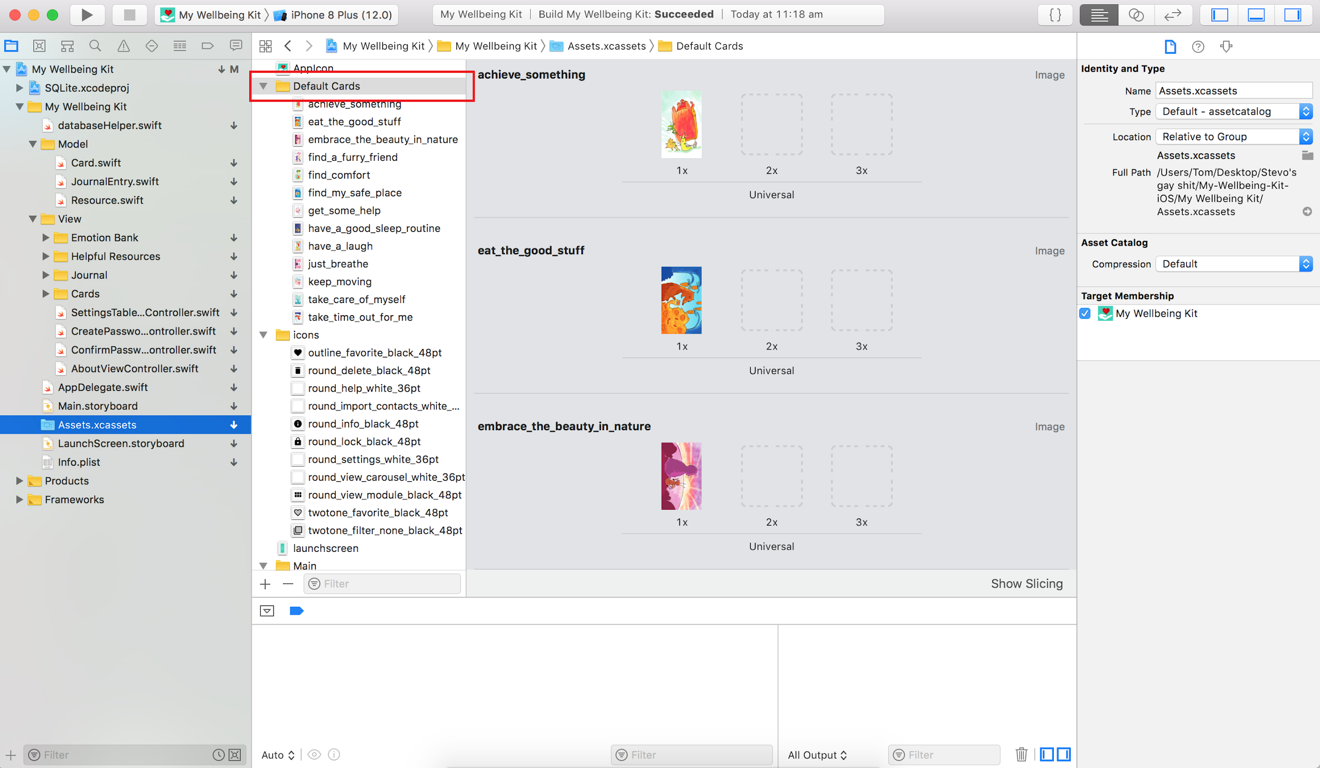
4. Drag the desired image into the main window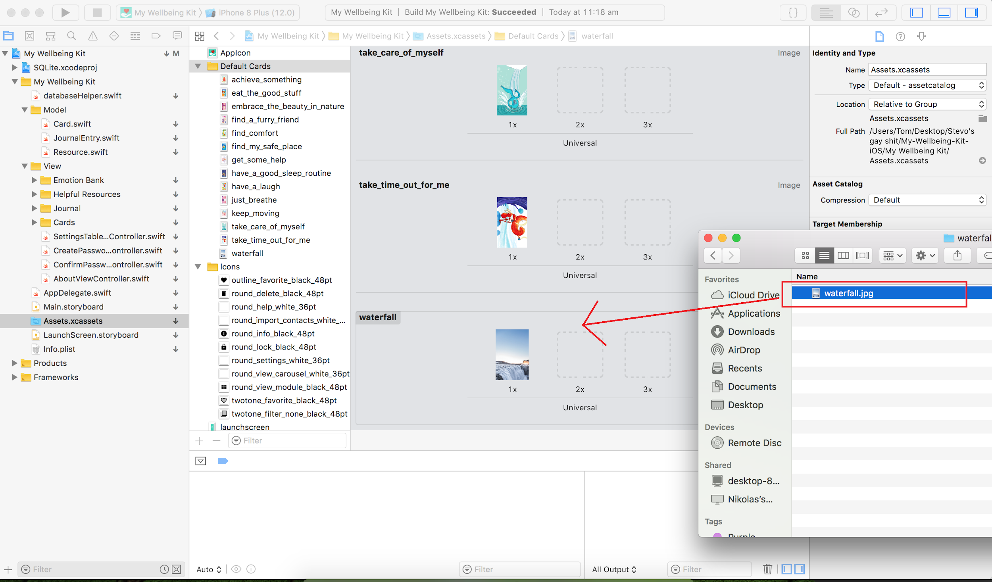

**Add Card to defaultCardImages Array**

1. Open /My Wellbeing Kit/View/Cards/CardsViewController.swift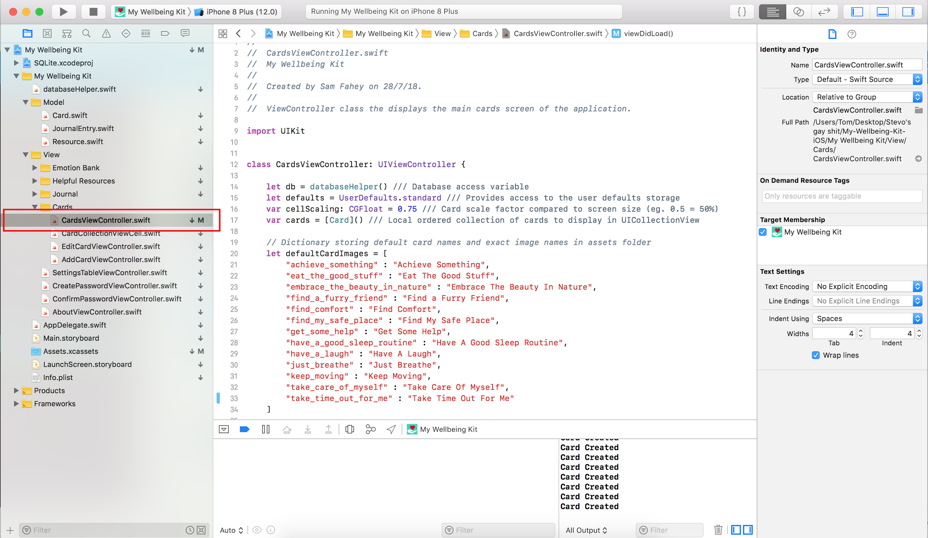
2. Add the name of the file and the title for the card to the defaultCardImages array
   1. It should be in the format: , “exact_file_name” : “card description” 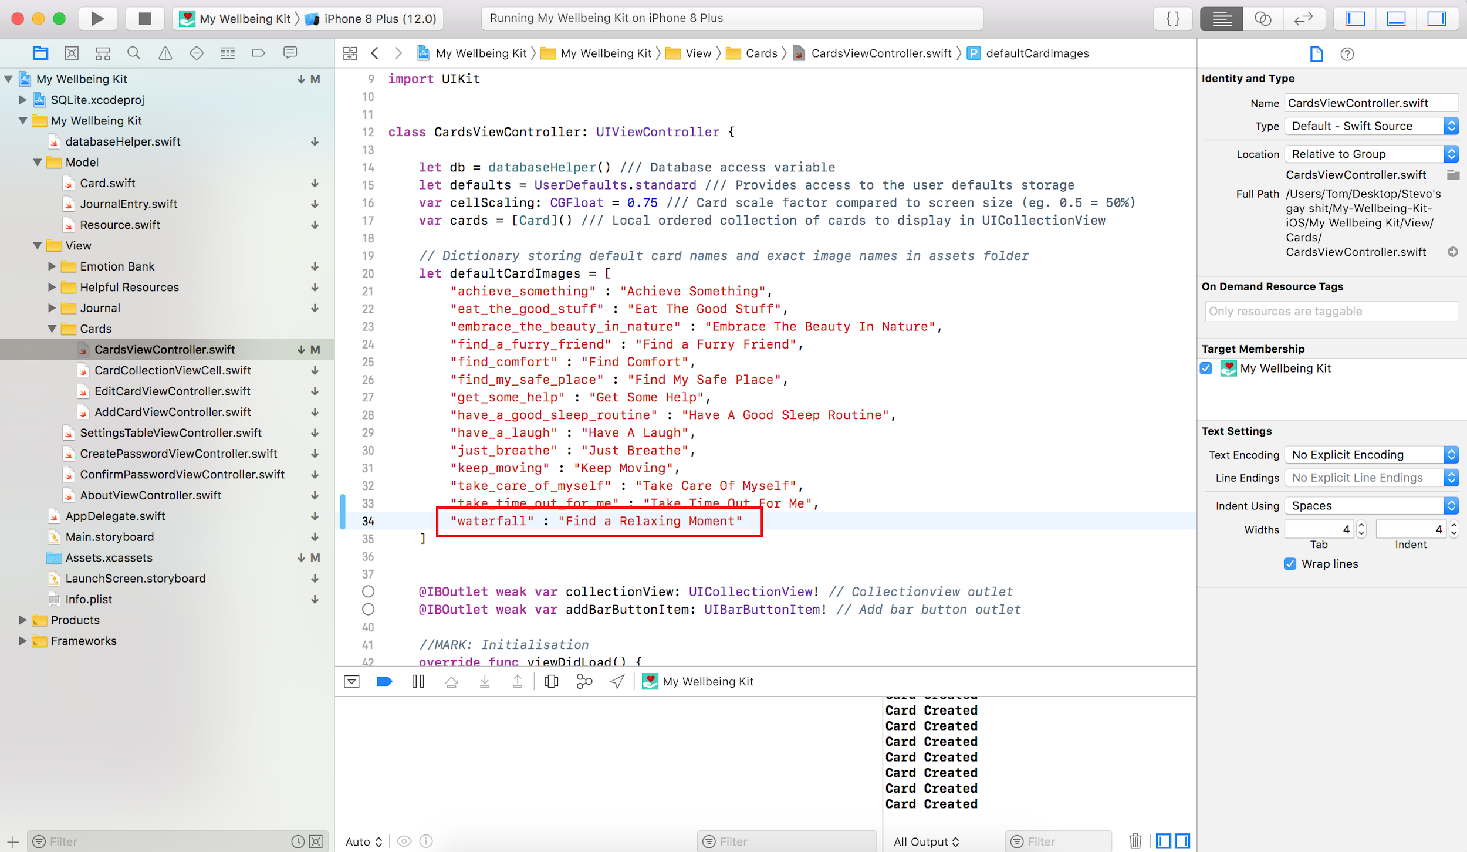
3. Build and run the application to view the new card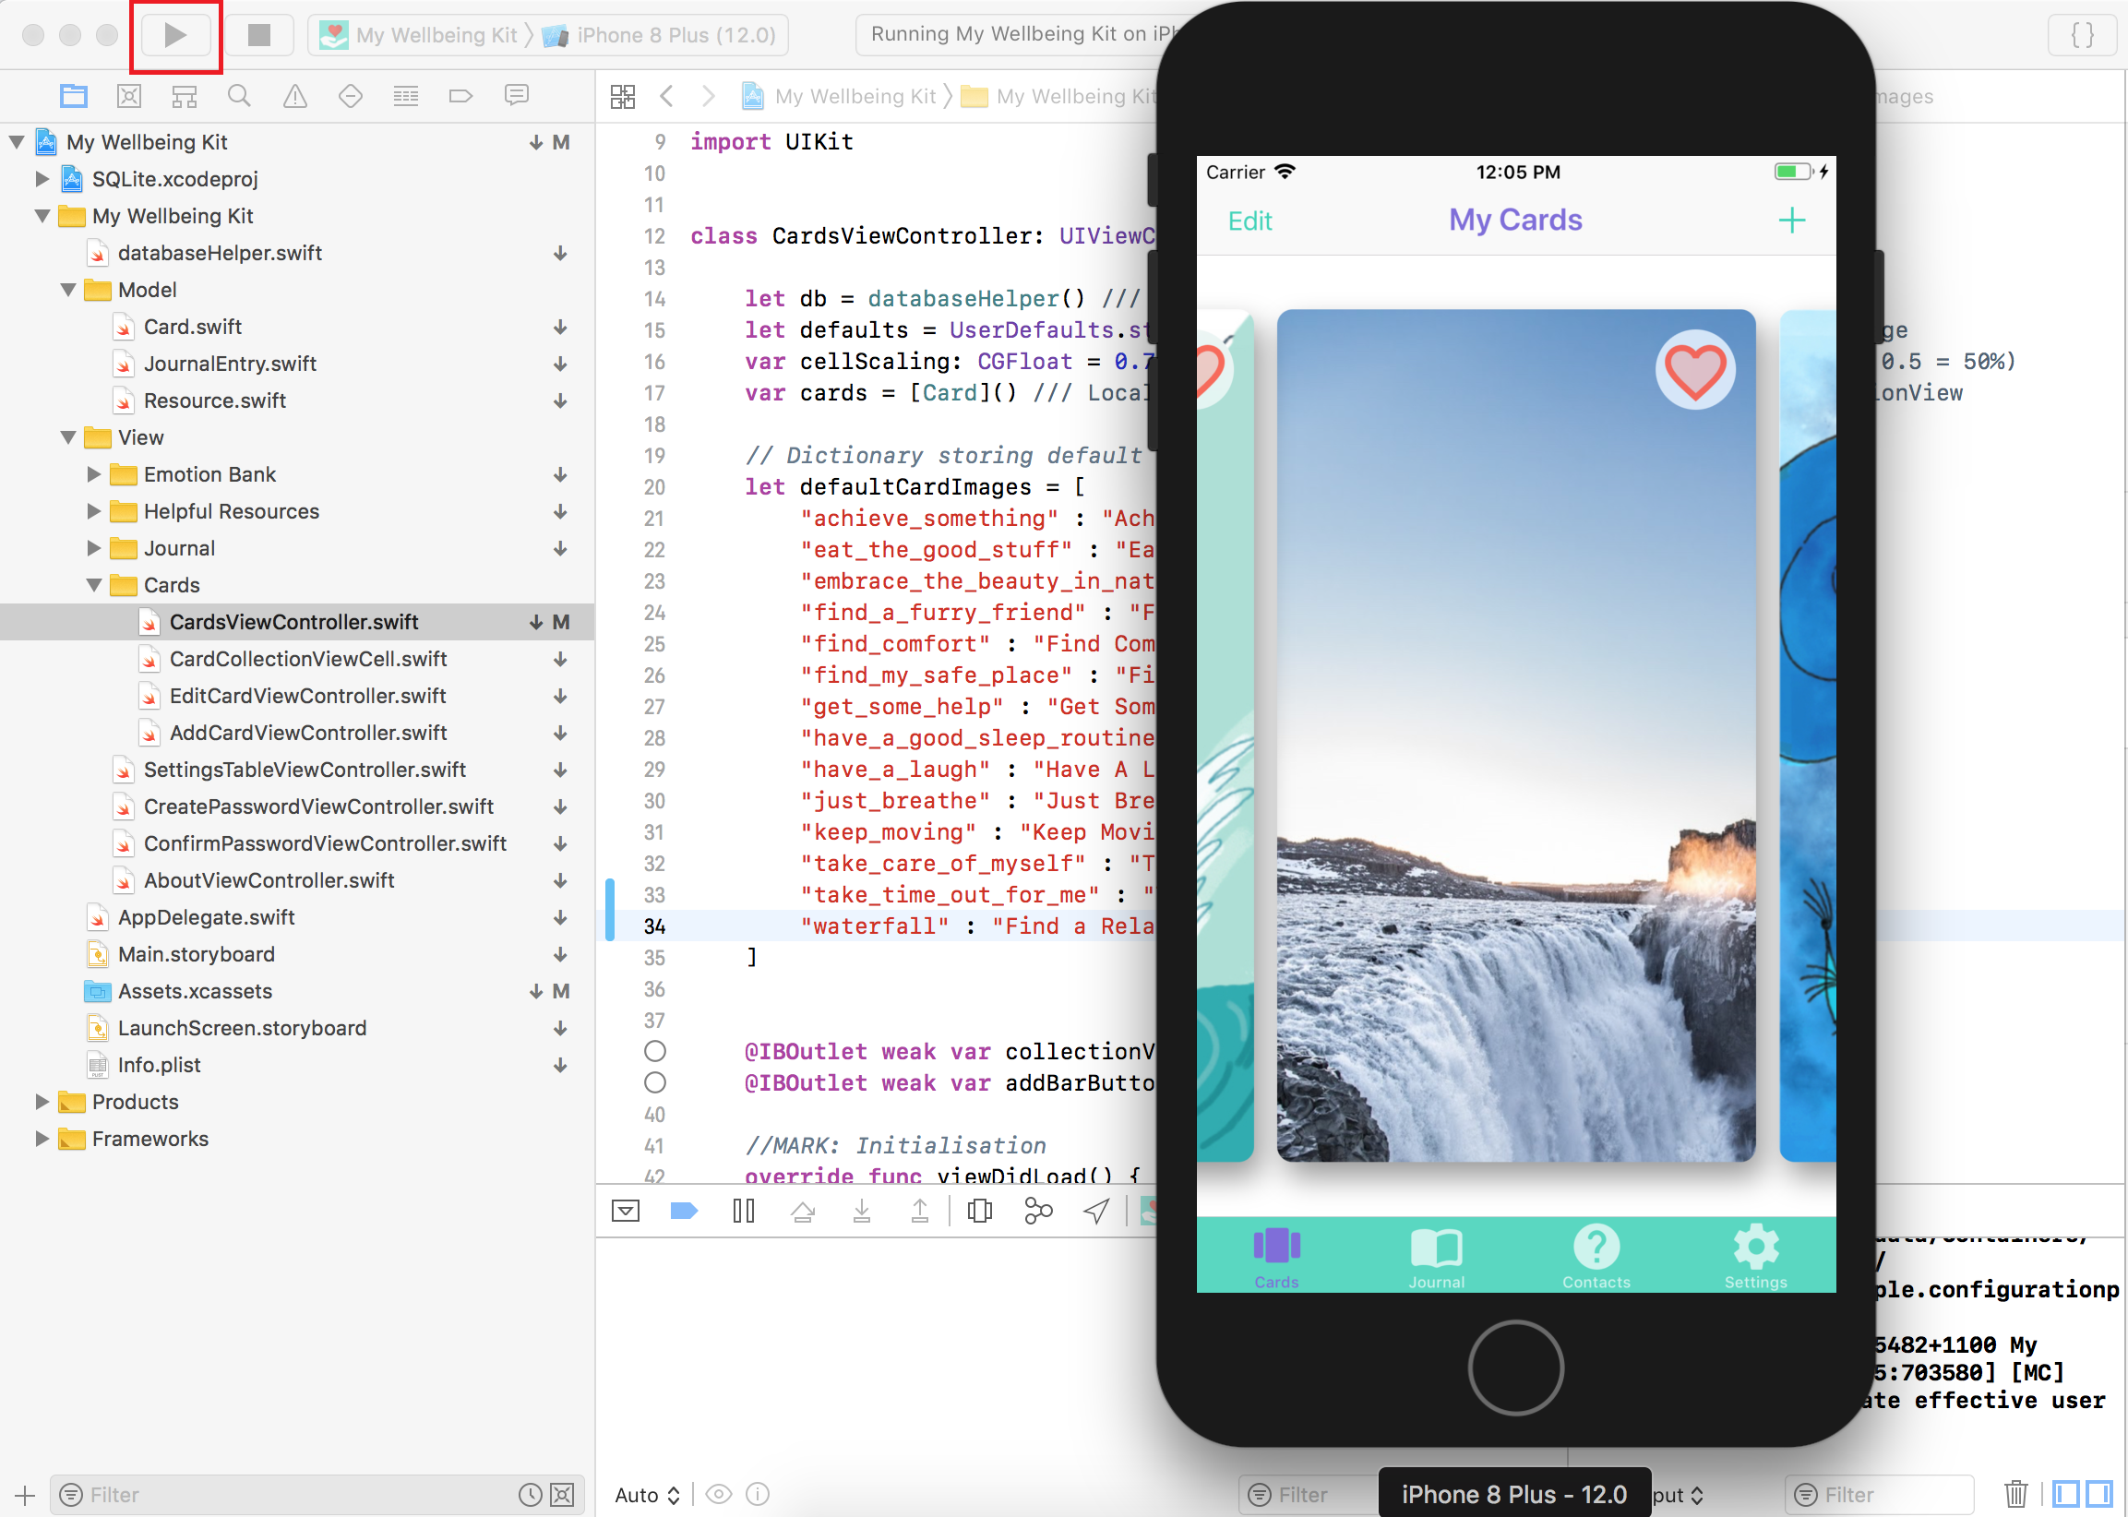

## **7.2 Editing About the Kit Information**

1. Open Main.Storyboard and find the About Scene 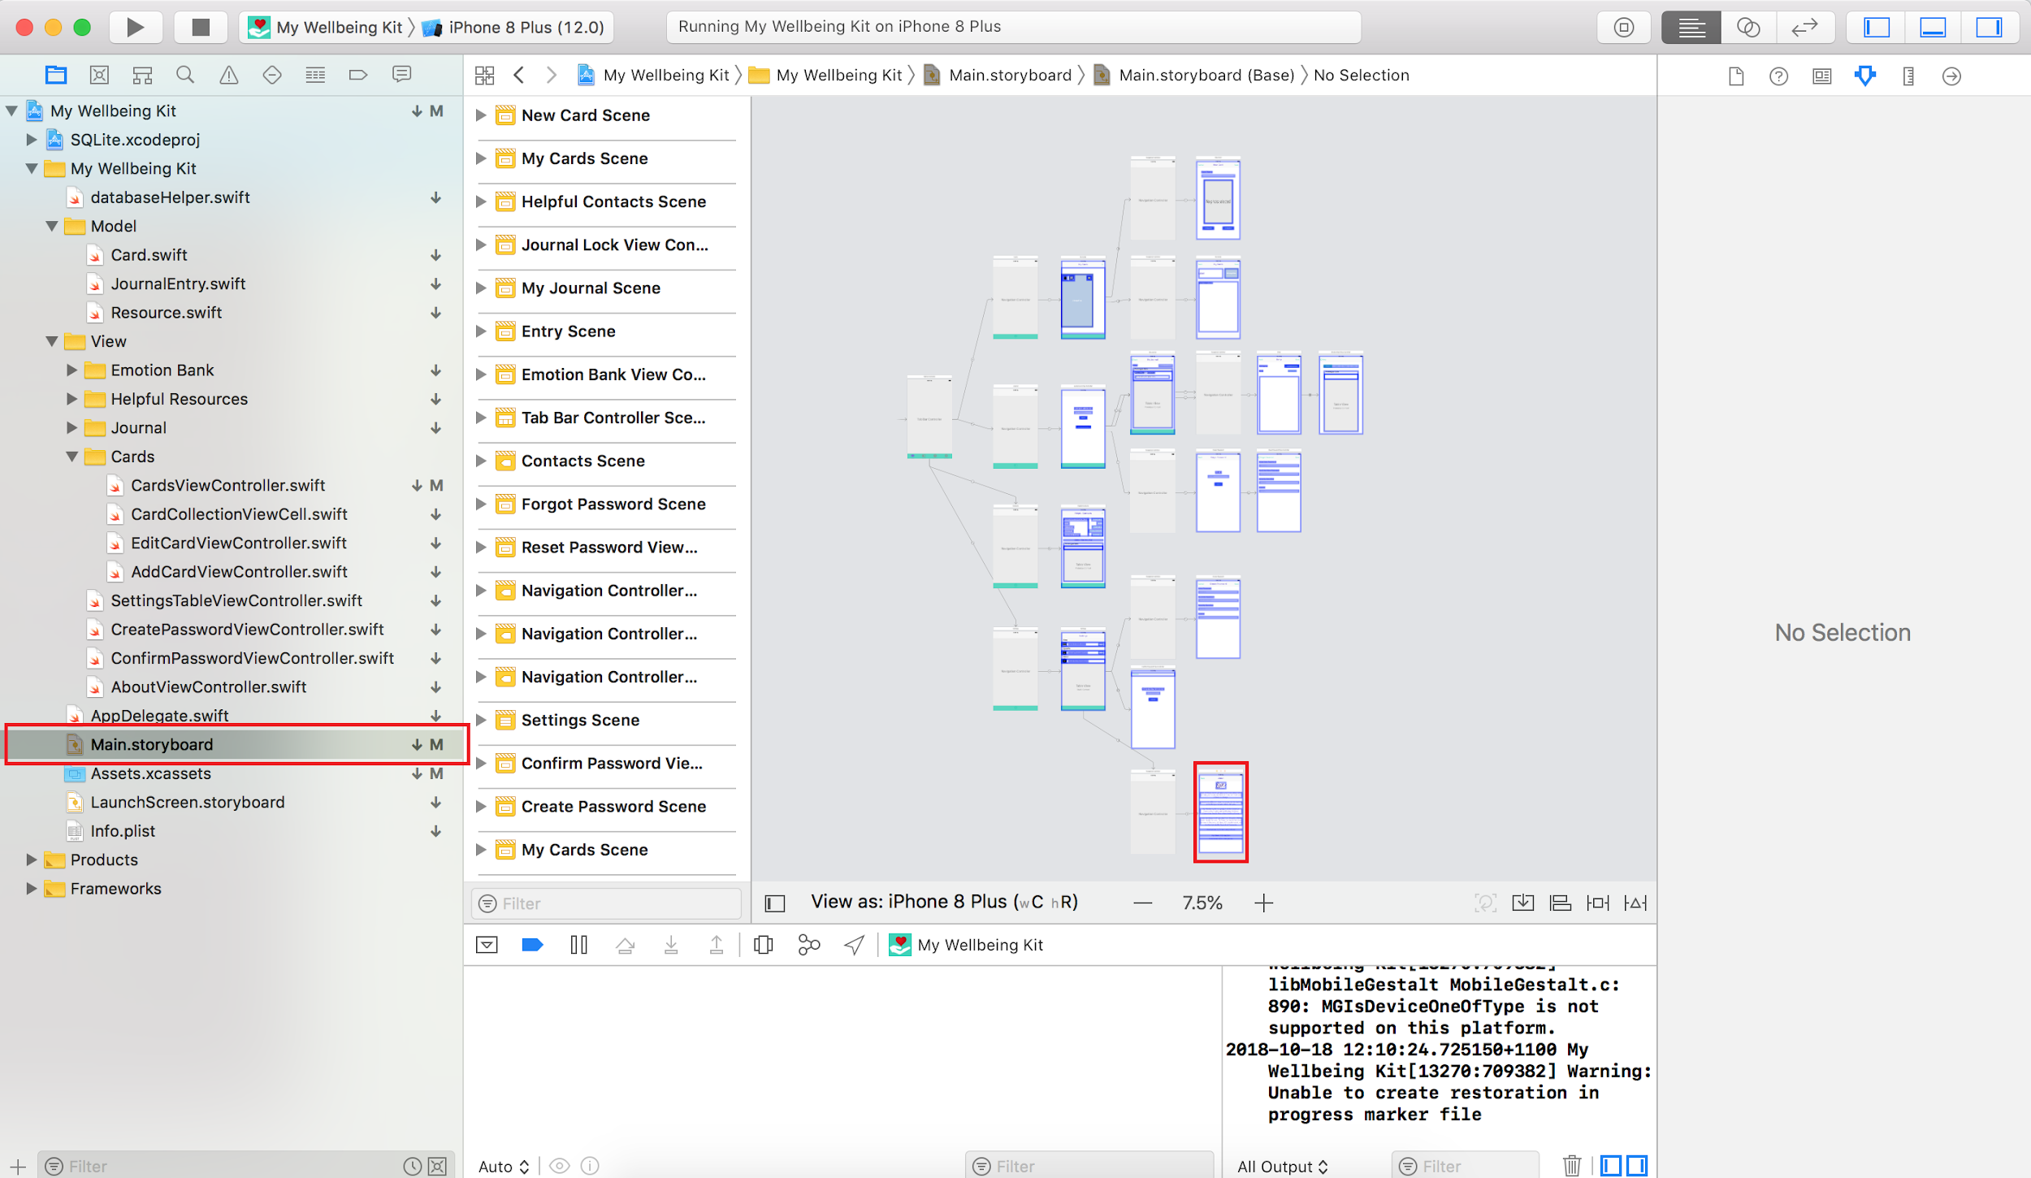
2. Find the Label you want to edit in the Document Outline panel or by clicking on it in the Storyboard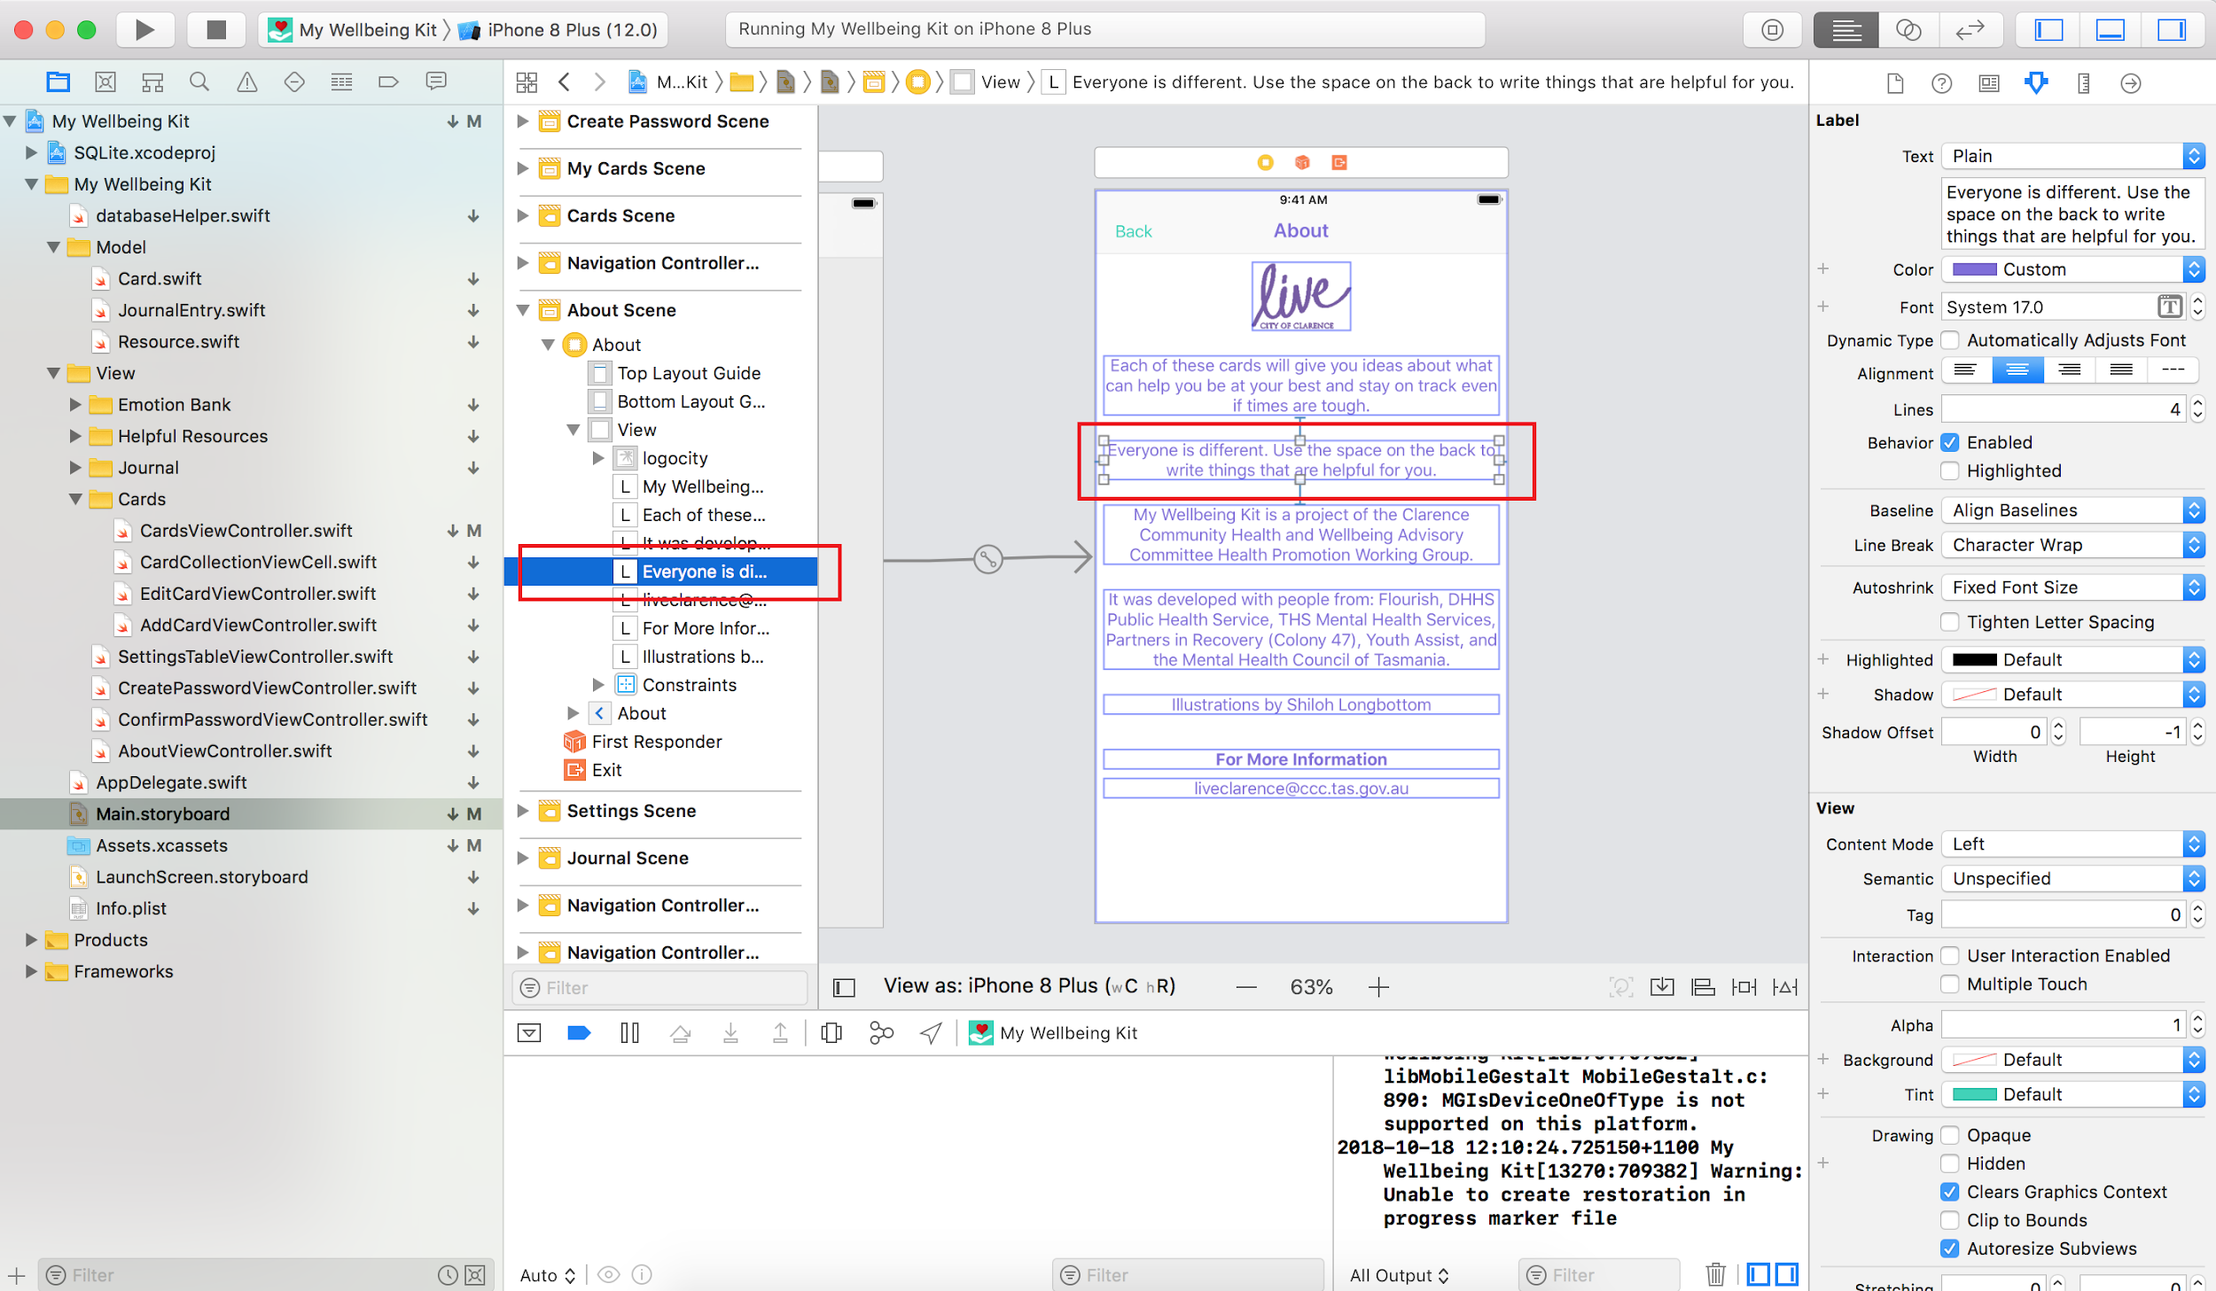
3. Ensure the Inspector is on the Attributes tab and change the text there 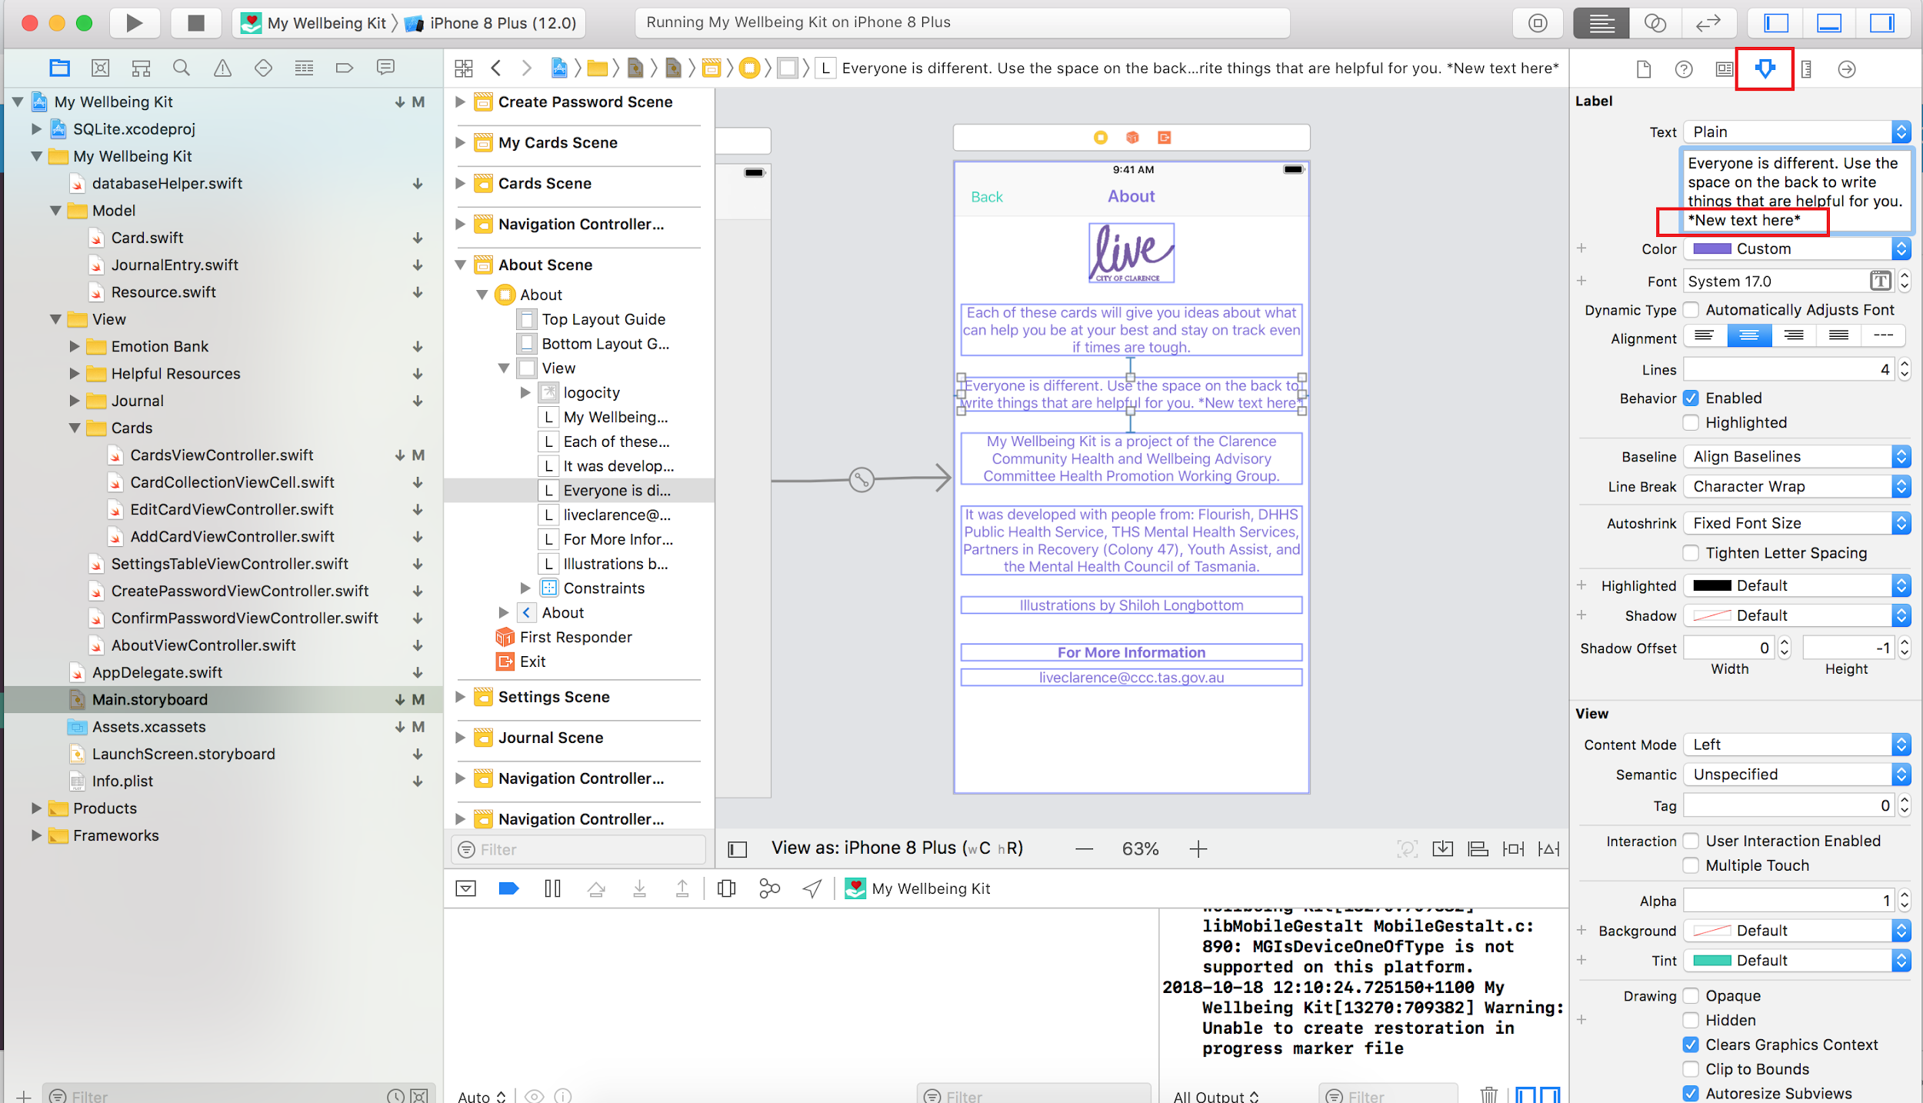
4. Build and run the application to view the changes 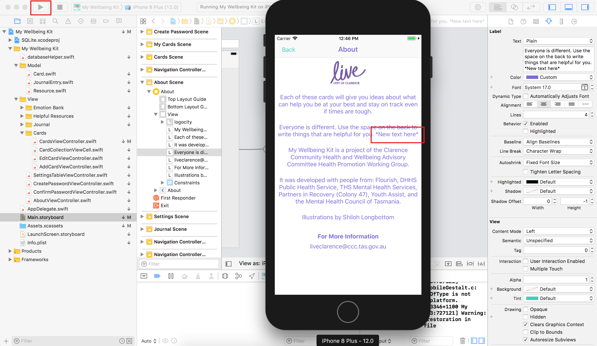

## **7.3 Editing Default Icons**

1. Open Assets.xcassets 
2. Select the icons subfolder 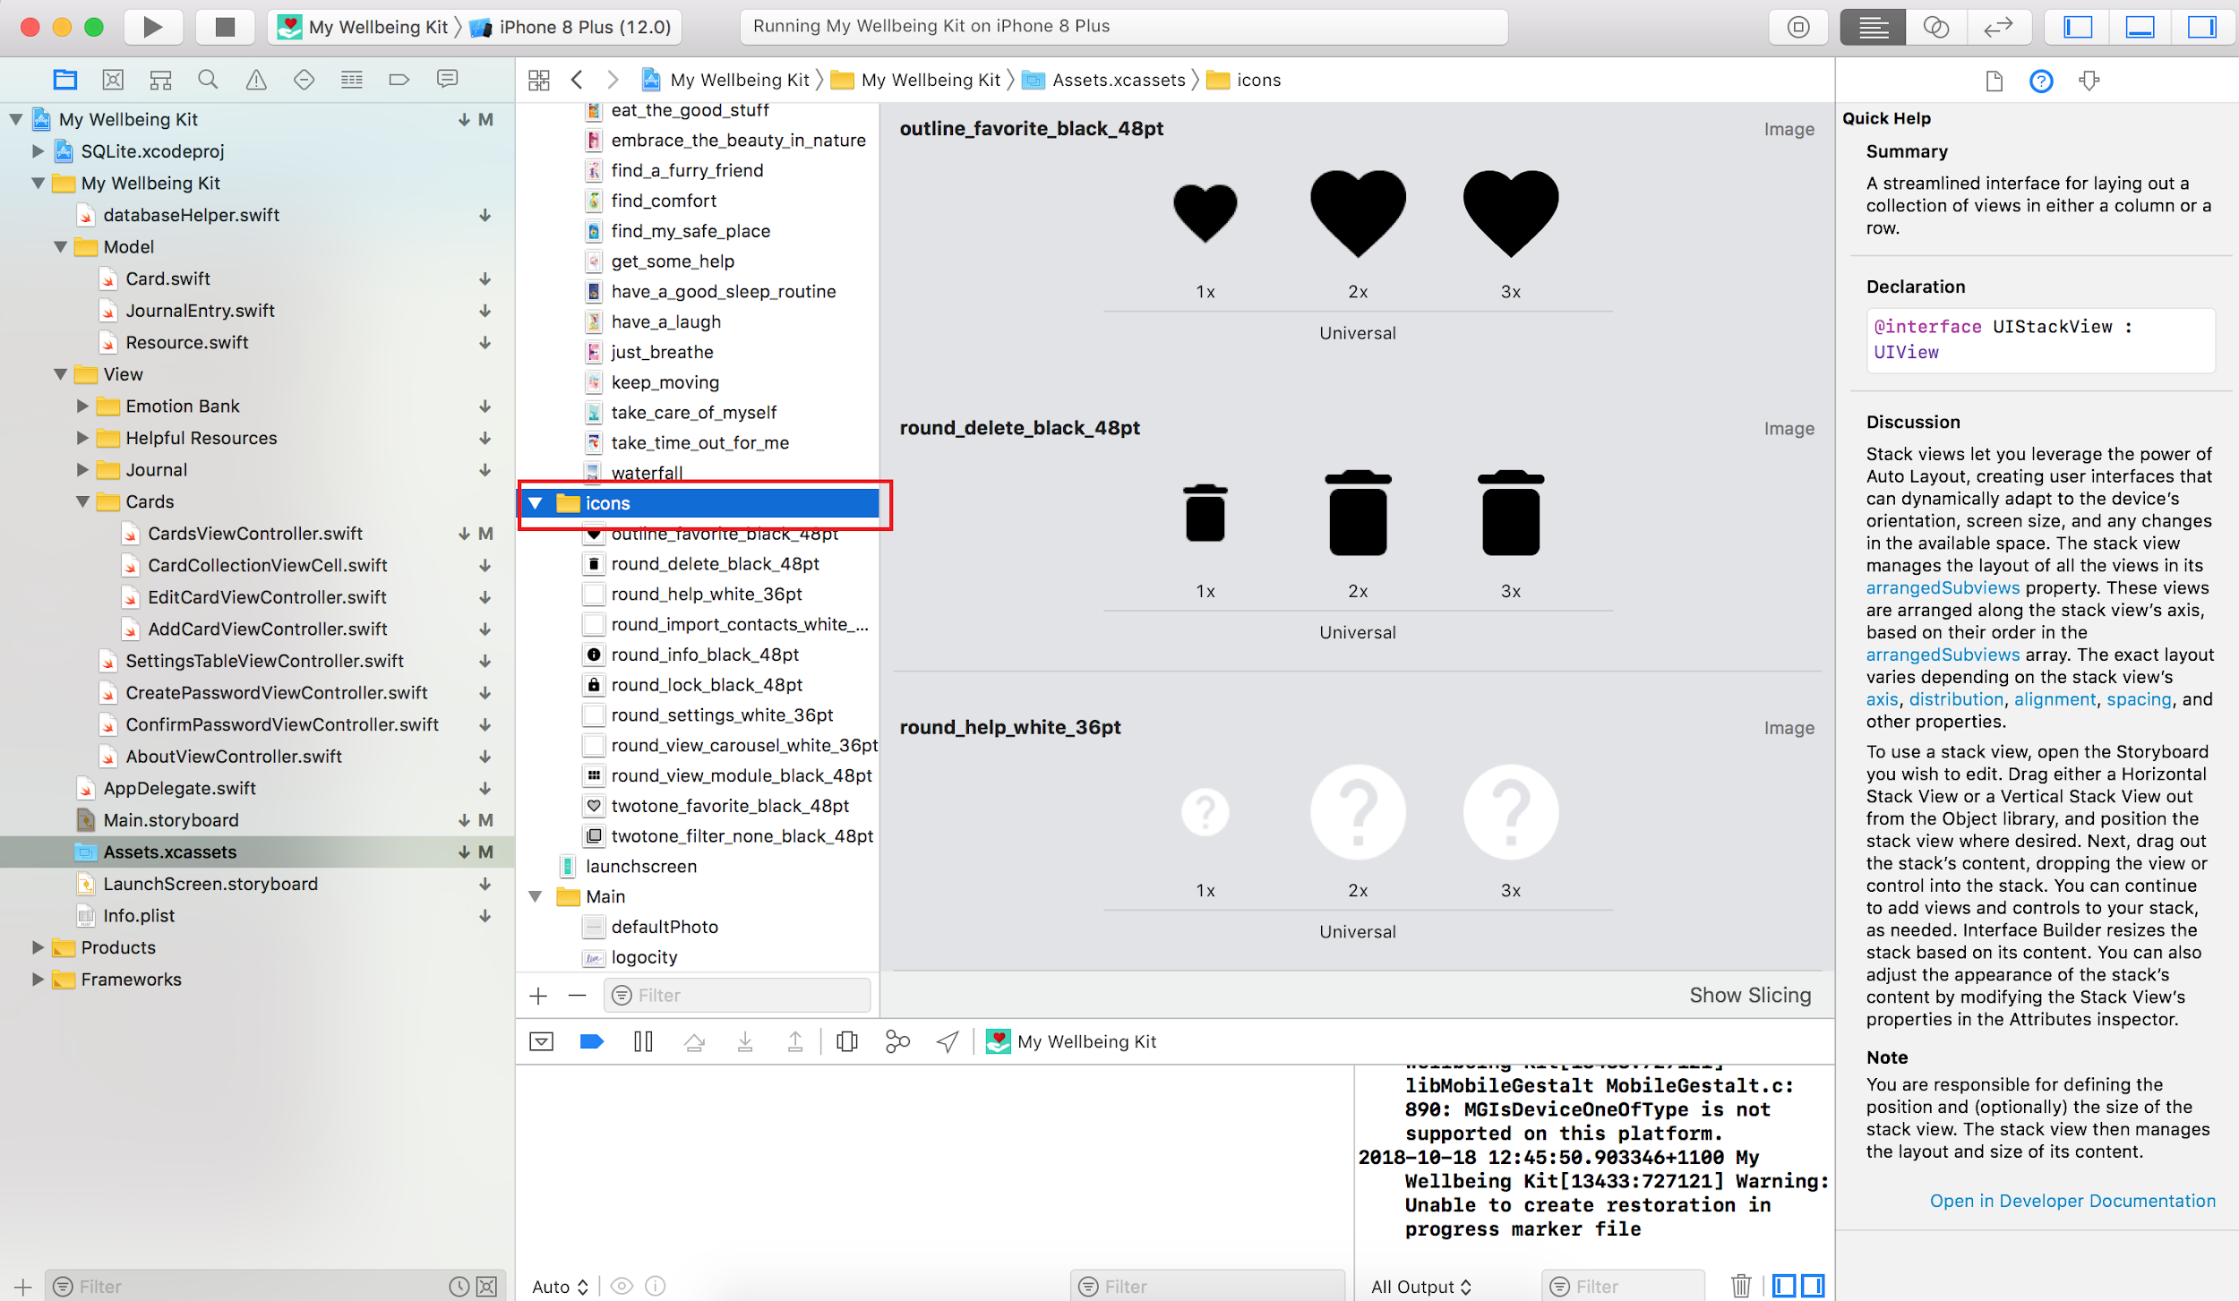
3. Drag the new .imageset folder into the main window 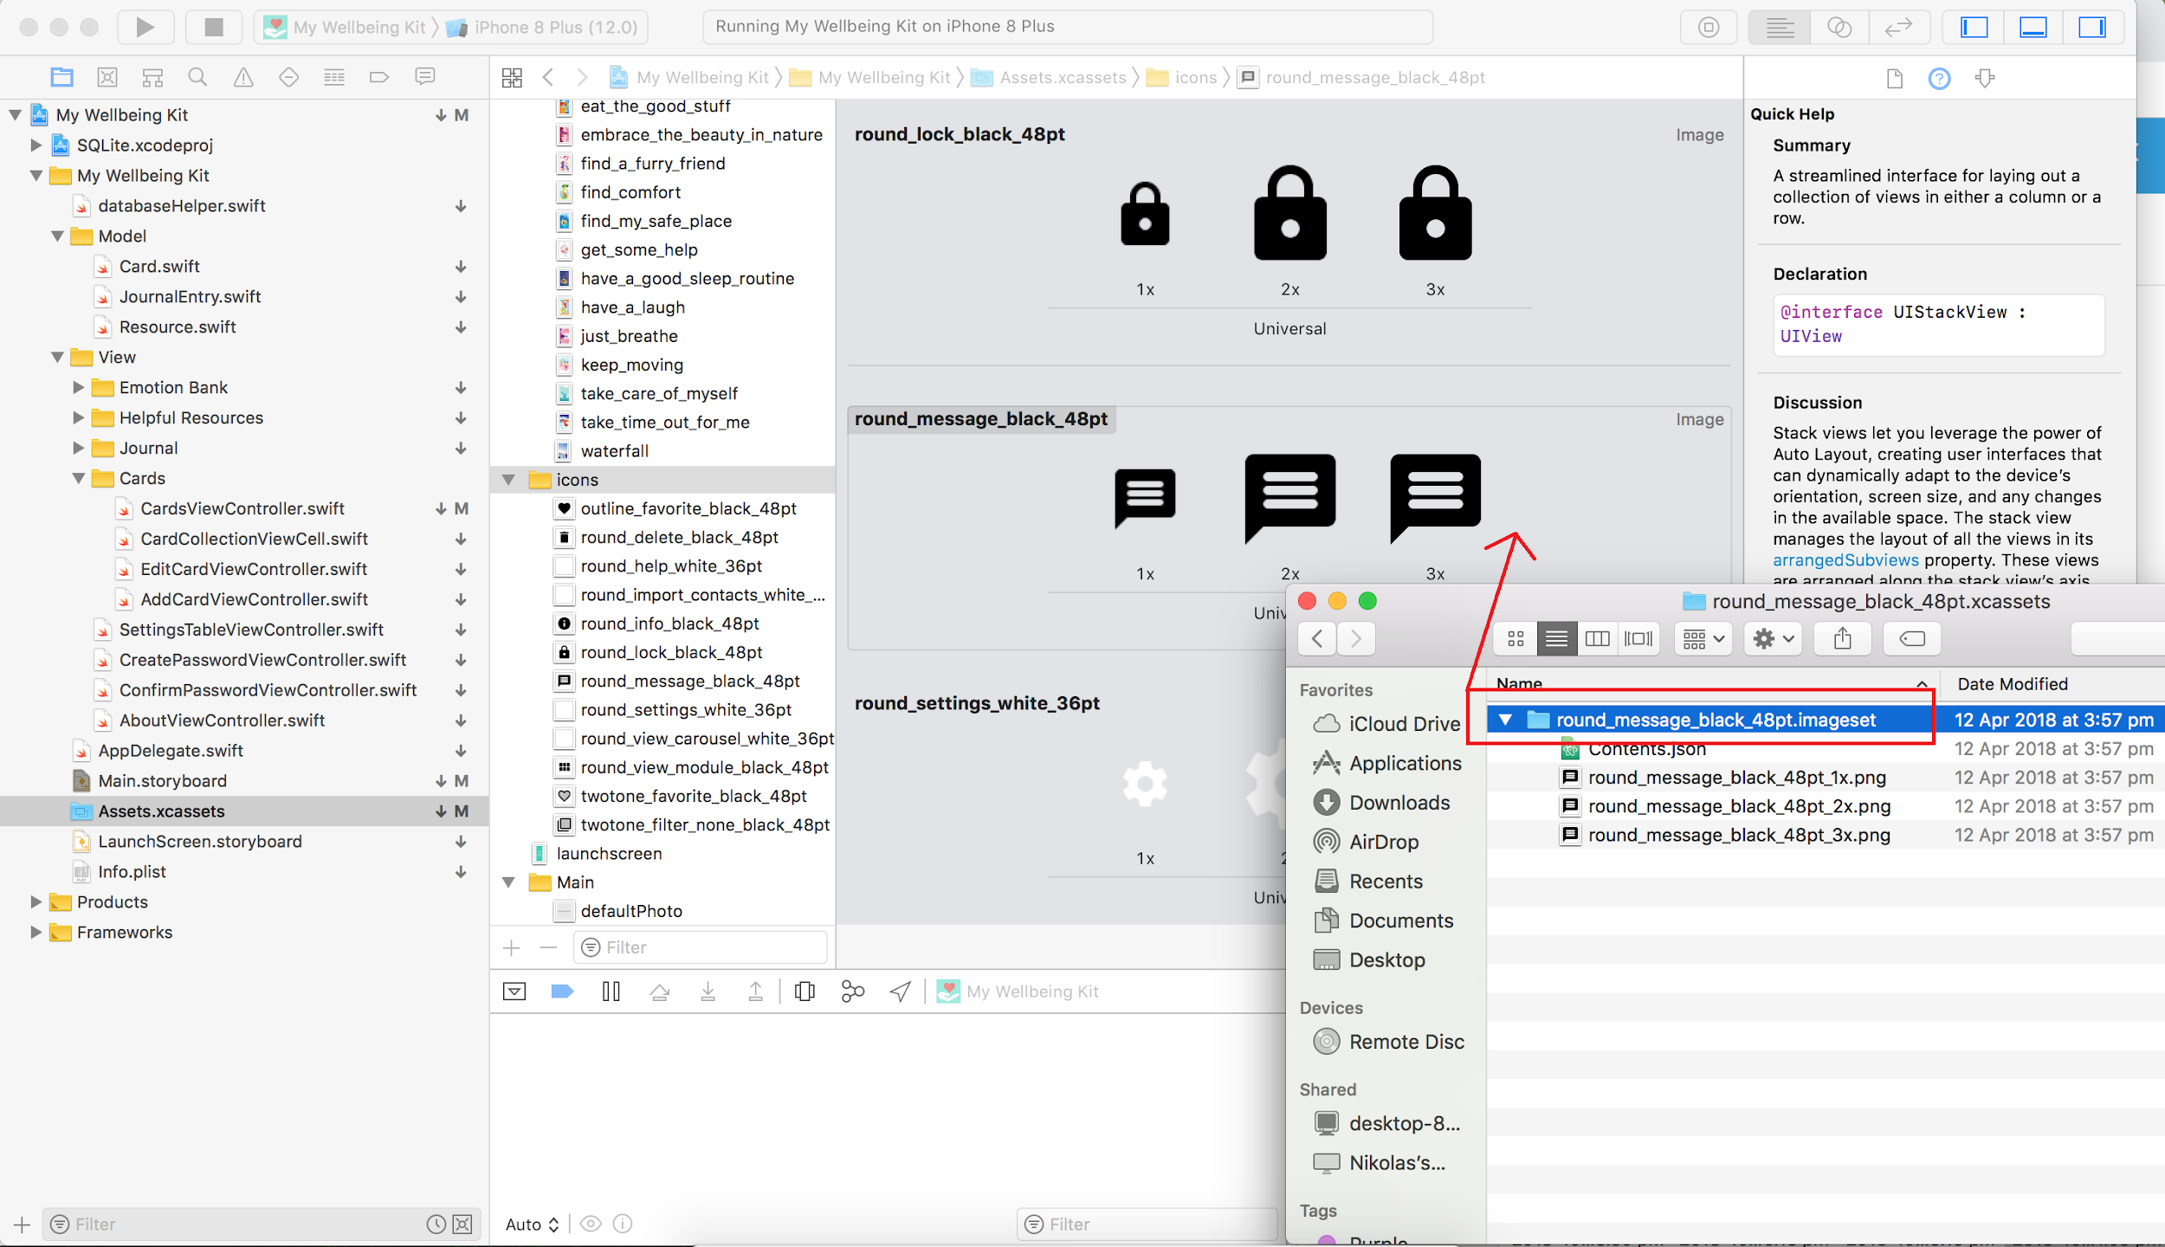
4. Open Main.storyboard and navigate to the icon you wish to change (in this example as we are changing a tab bar icon it needs to be done through the navigation controller attached to the tab bar controller) 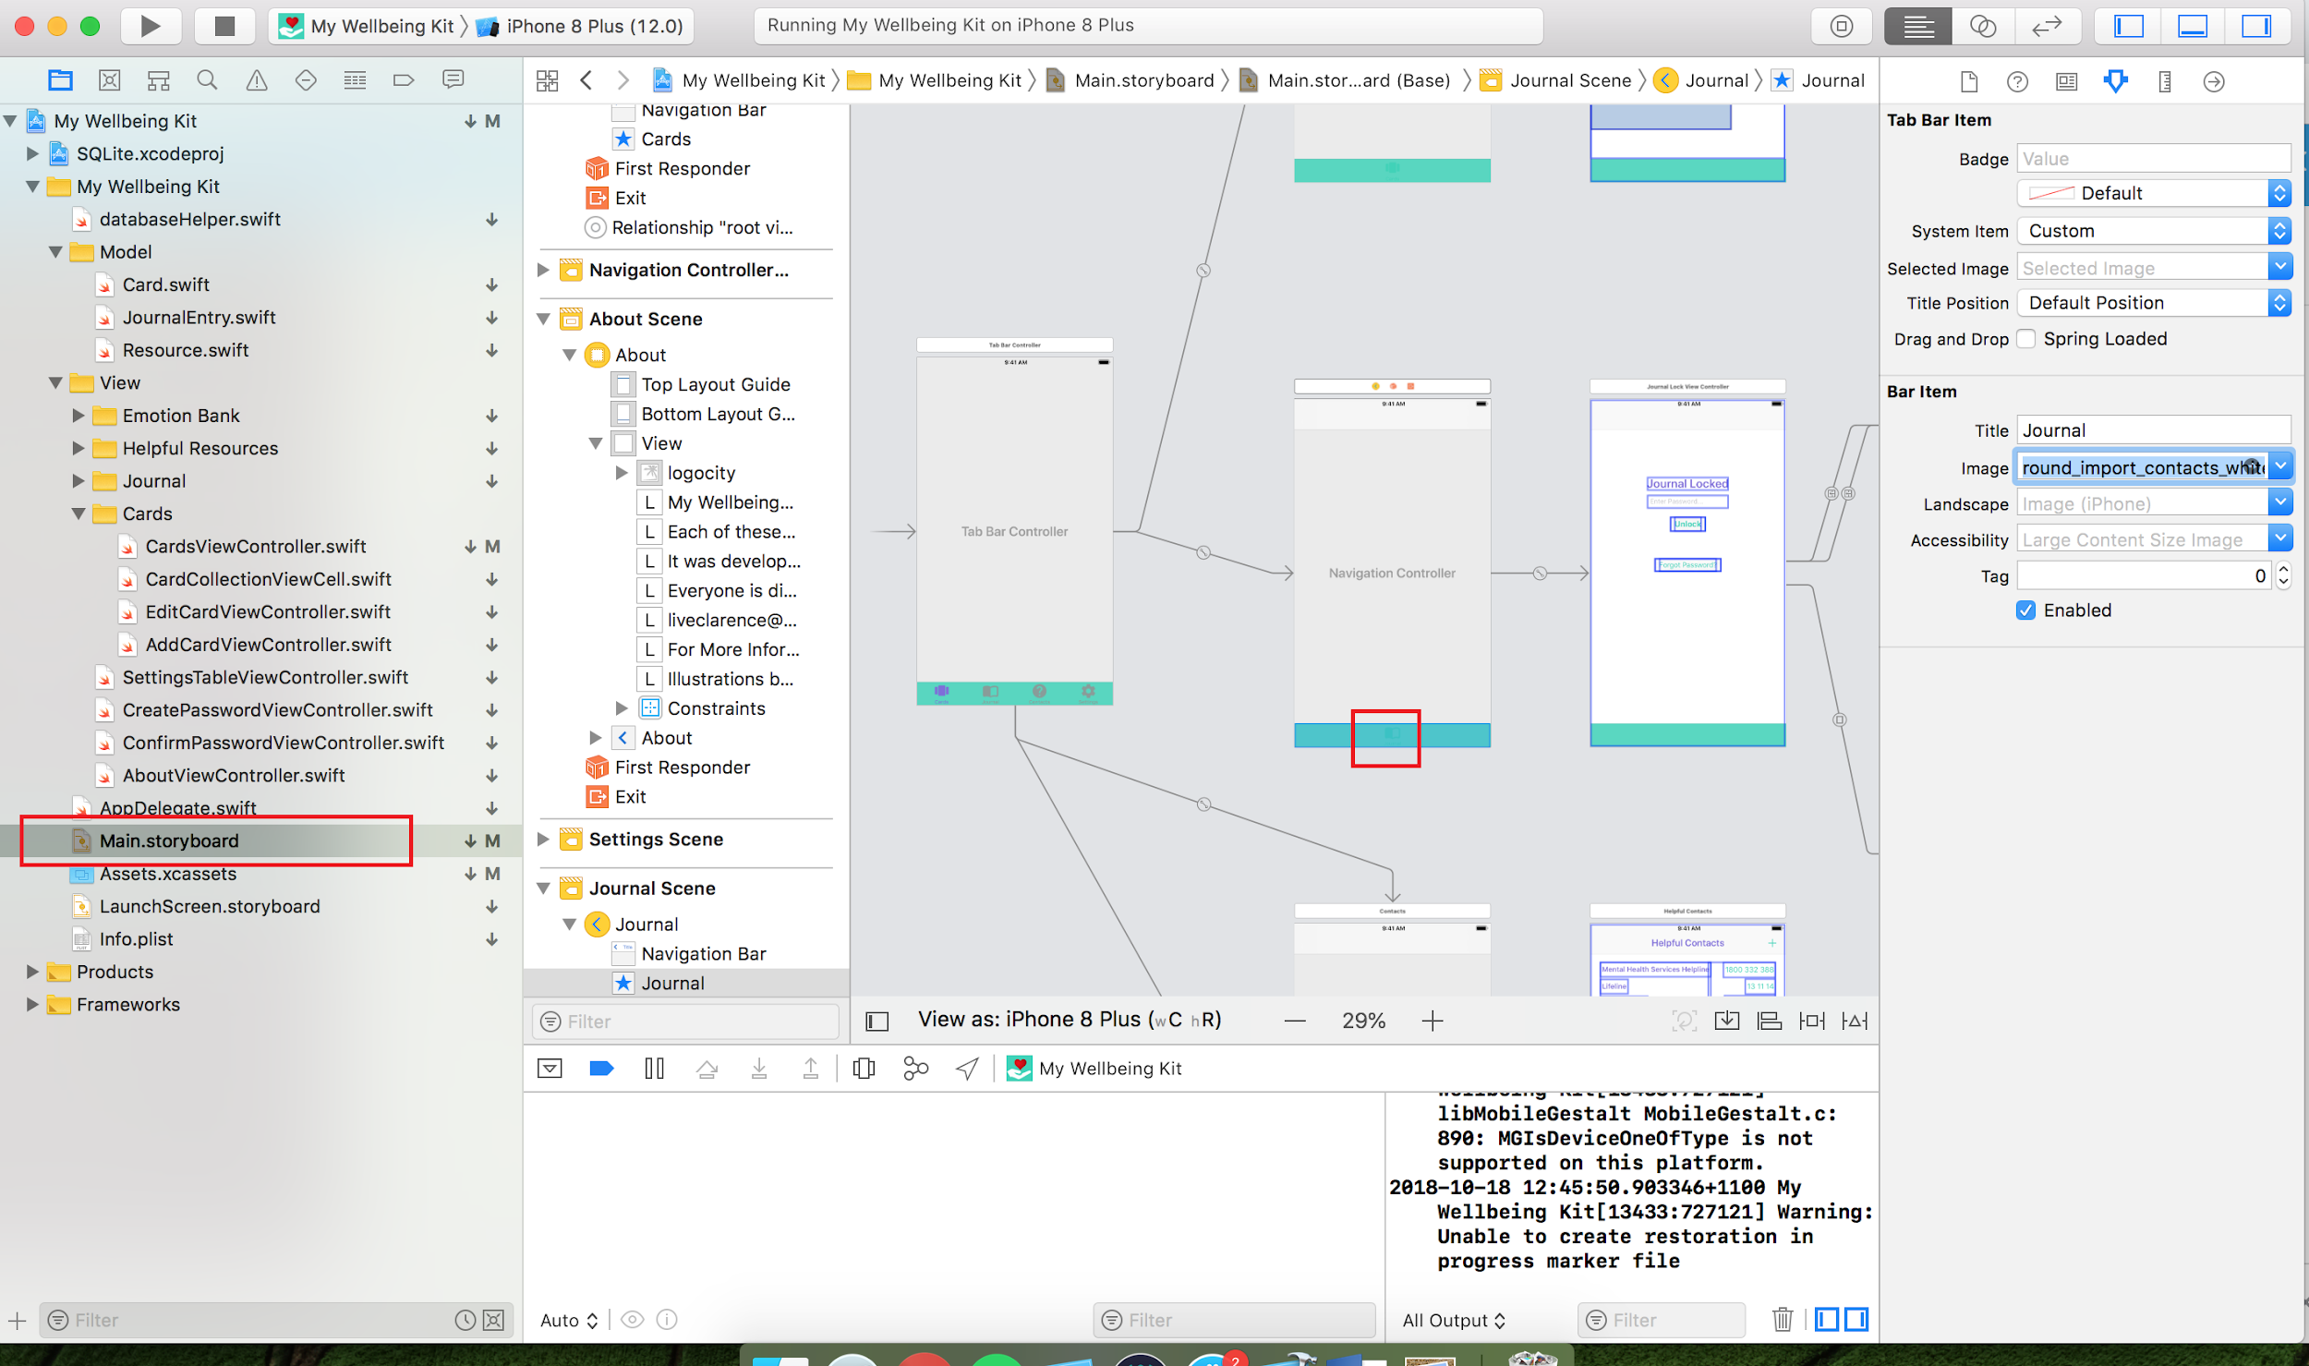
5. Make sure you are in the attributes tab and select the new image from the Image drop down menu in the Bar Item section 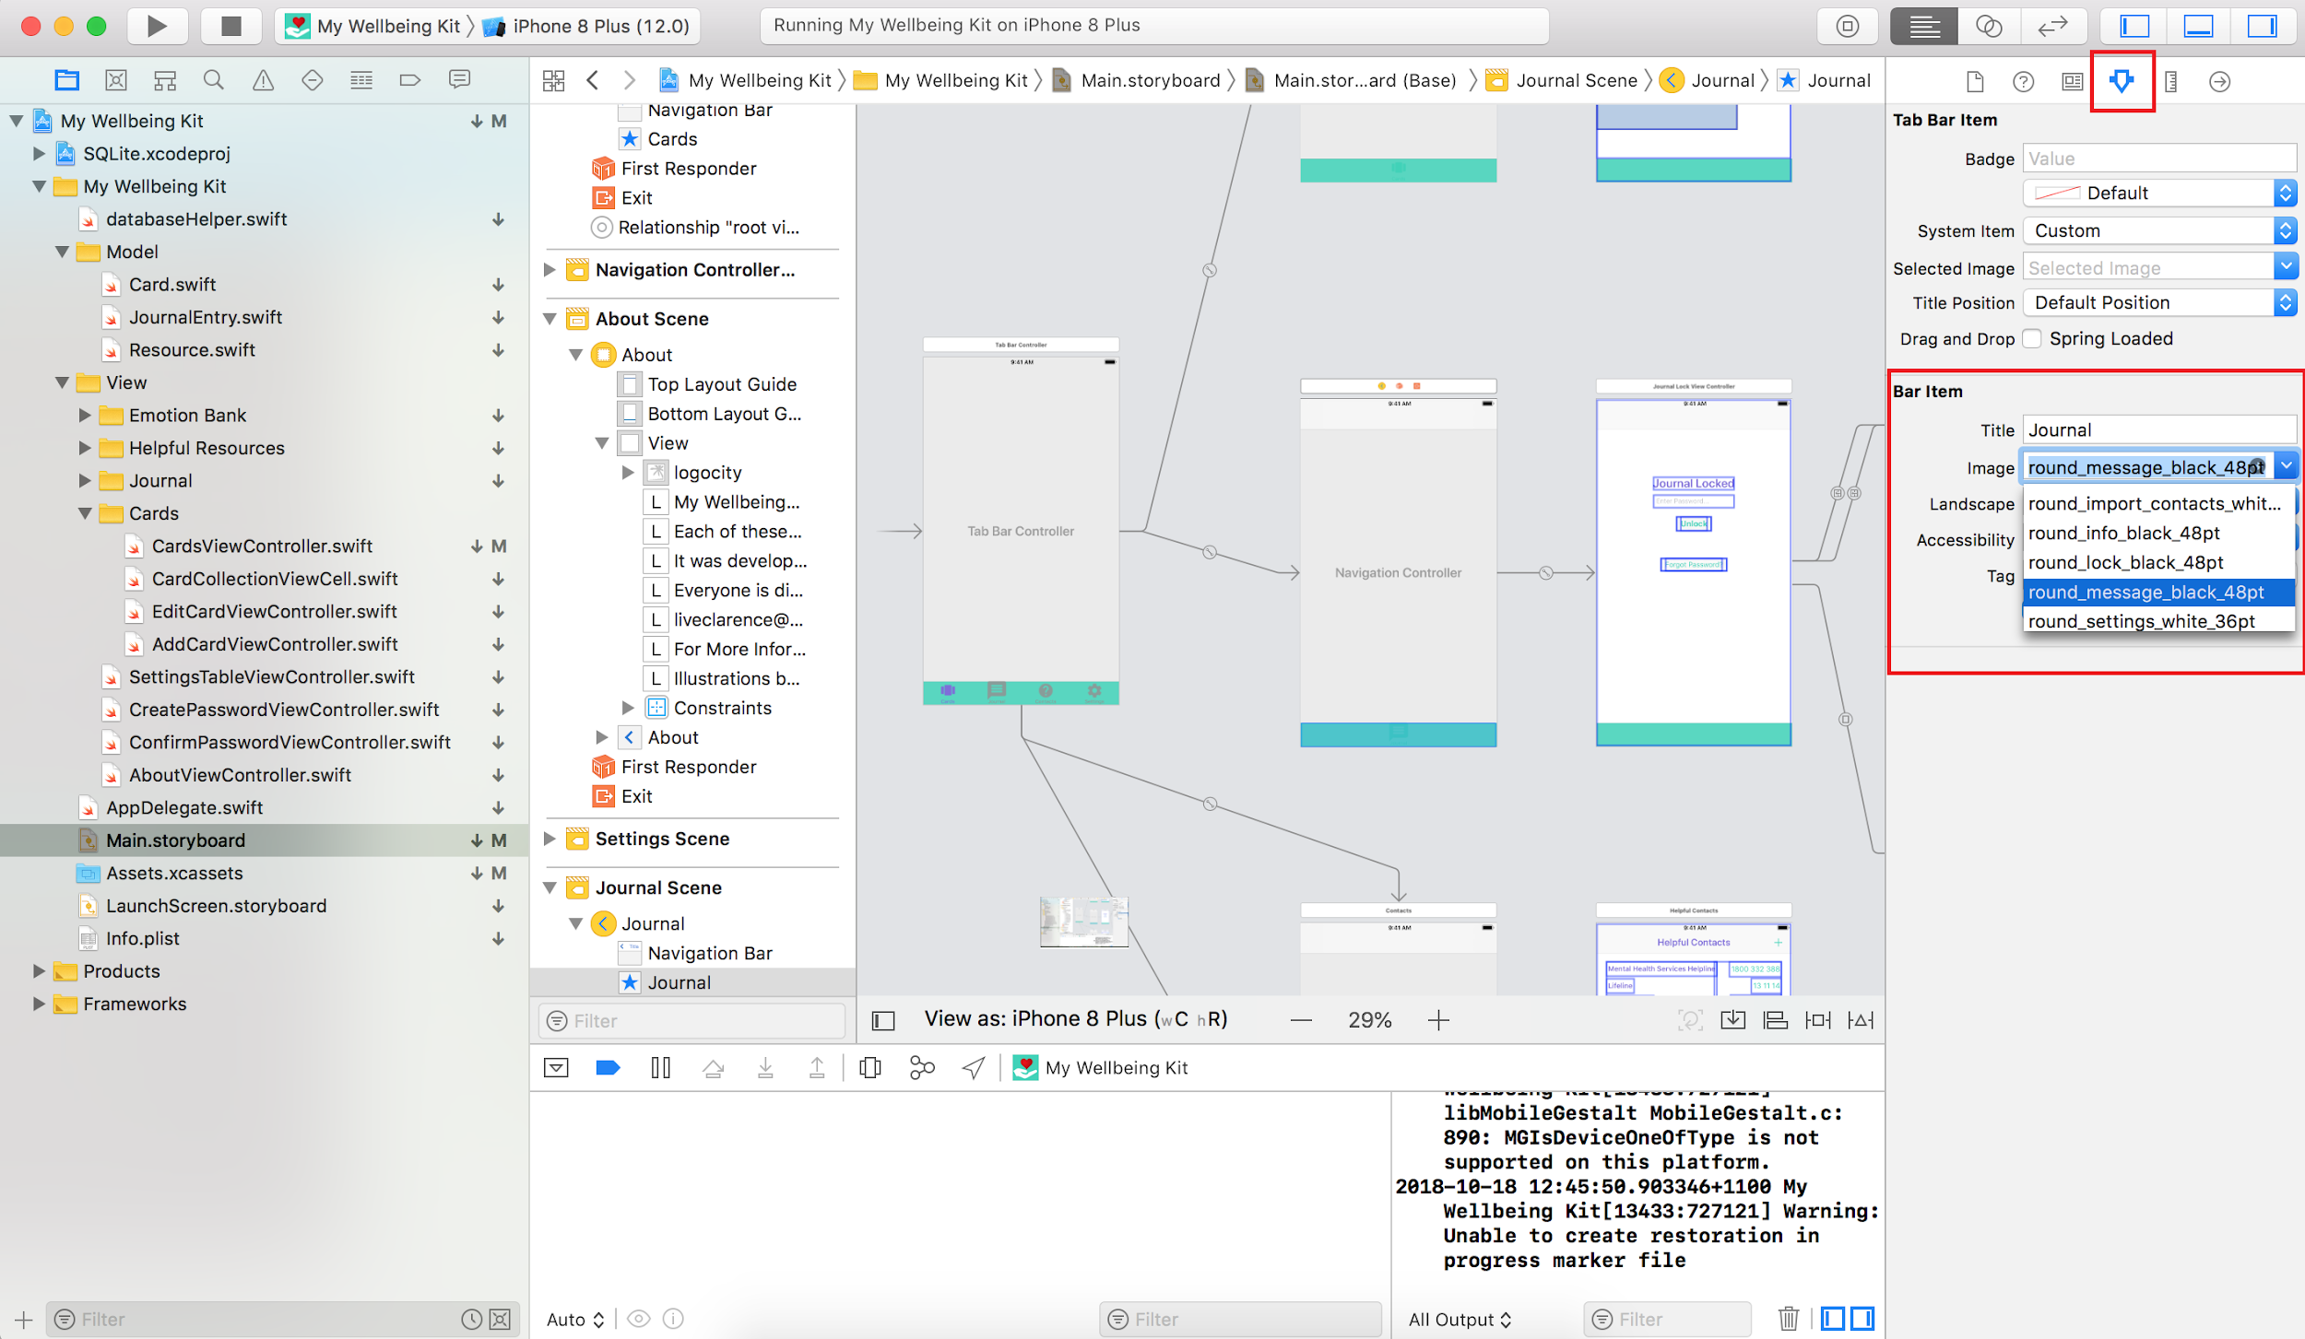
6. Build and run the application to see the new icon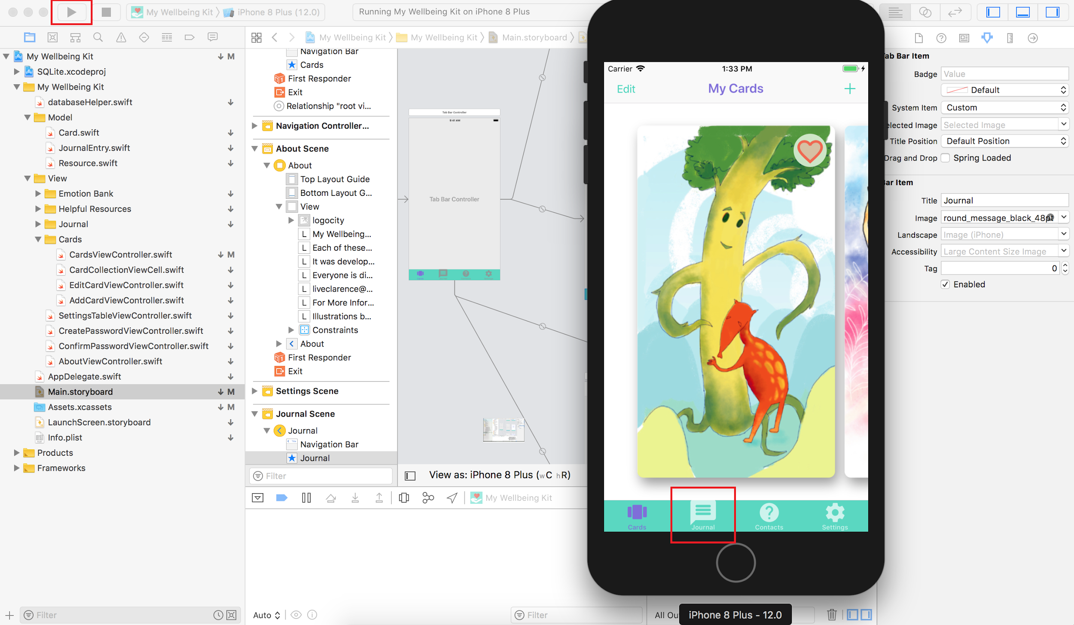

# **8. Publishing software**

## 8.1 Android

Building a .apk file for the Android My Wellbeing Kit software can be achieved in two ways. The first build will generate an unsigned .apk file. This means that the application may be usable generally, but does require lowering the security levels on your devices.

A signed .apk file however provides the user with the assurance that the application hasn't been tampered with since its release. Signed .apk files utilise a keystore. A keystore is a binary file certificate that provides the identification of the author and ensures that the security of the application. If you wish to publish to the Google play store you must provide a signed .apk.

### 8.1.1 Unsigned apk

This build will create an unsigned .apk file using the gradle build.

· Open the project in Android studios.

· Click the dropdown ‘select Run/Debug configuration’ menu in the top toolbar

· Select "Edit Configurations…"

· Click the "+" in the top right of the new ‘Run/Debug configuration’ window

o Select "Gradle"

· Name your build

· For the ‘Gradle project’ text field select the ‘picture of a file’ option to the far right

o Select Mobile-Wellbeing-Kit > :app

· For the ‘Tasks:’ text field type “assemble”

· Click ‘Run’

Once the apk has been generated indicated by the Runtime message “BUILD SUCCESSFUL.” Navigate to your projects files and follow the path:

…\mobile-wellbeing-kit\app\build\outputs\apk\debug

Here you will find the ‘app-debug.apk’ file.

This may be copied onto you device and installed using the ‘Install application directly from .apk:’ instructions (See 4.1.1).

### 8.1.2 Signed apk

To build a signed .apk file the user will have to generate a private keystore. This is all done The one process.

· Open the project in Android studios.

· From along the menu in the top toolbar menu select

o Build > Generate Signed APK…

· Within the new ‘Generate Signed APK’ window; underneath the ‘Key store path’ text field select the option ‘Create new…’

· In the New Key Store window select the ‘…’ which lies adjacent to the ‘Key store path’ text field

o In the navigator window select a location where you want your keystore file saved.

· Input and confirm a password that will lock the certificate (ensuring that you are the author)

o Do this both time for ‘New Key Store’ and then again for the key itself.

· Continue to fill in the certificate’s required (i.e. Name, location, etc.)

· Select ‘OK’

o This will close the ‘New Key Store’ window

· Select the ‘Next’ button from the ‘Generate Signed APK’ window

· Next to the ‘Signature Version:’ check boxes select the option ‘V2 (Full APK Signiture)’

· Select ‘Finish’

Once the apk has been generated indicated by the Run time message “BUILD SUCCESSFUL.” Navigate to your projects files and follow the path:

…\mobile-wellbeing-kit\app\release

Here you will find the ‘app-release.apk’ file.

This may be copied onto you device and installed using the install instructions below (pg #). This file is also ready to be uploaded to Google play via your account.

## 8.2 iOS

To publish to the Apple App Store there are a number of requirements that must be met. Before considering a submission the App needs to be up to a reasonable quality and not crash. The My Wellbeing Kit application should meet these standards.

### 8.2.1 How to Submit to the App Store

Apple are known to be quite slow with reviewing and approving apps. As such it is best to start this process as soon as possible.

**Registering App with iTunes**

1. Visit iTunes Connect (<https://itunesconnect.apple.com/login>) and login with your Developer Account
2. Select ‘Manage Your Apps’
3. Select ‘Add New App’
4. Select iOS App
5. Fill out the forms as prompted with the details for the application

**Create an Archive**

Archives are builds of the application that can be submitted to the app store. To create an Archive, the app needs to be built and run on a generic virtual device.

1. Open the My Wellbeing Kit with XCode (v 10.0)
2. Change the active scheme to ‘Generic iOS Device’ 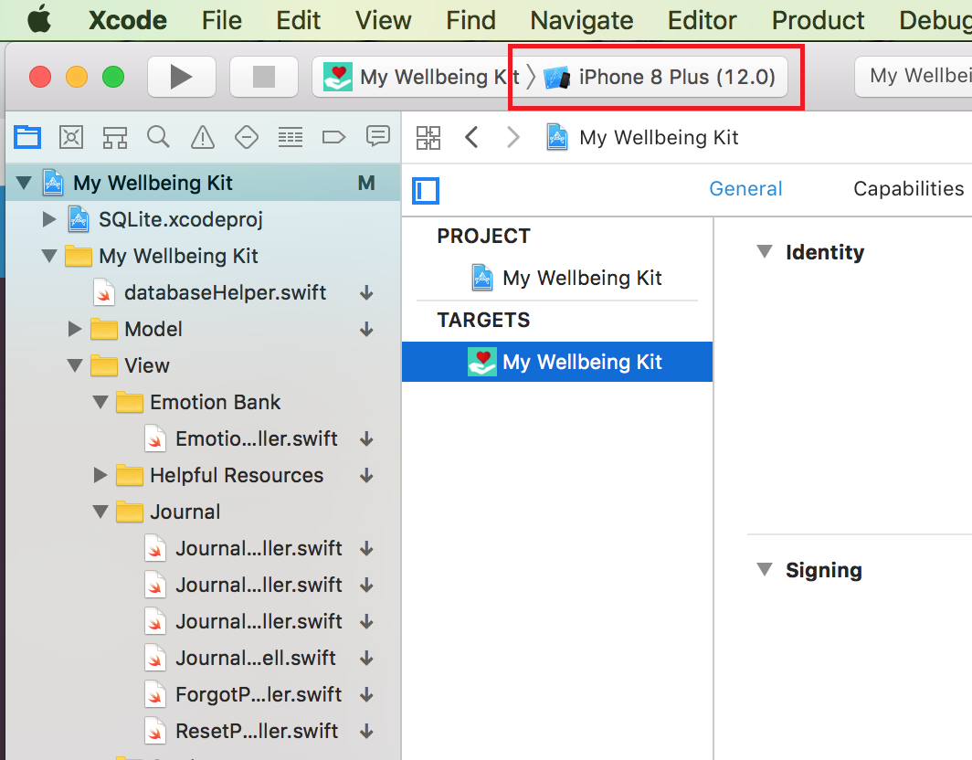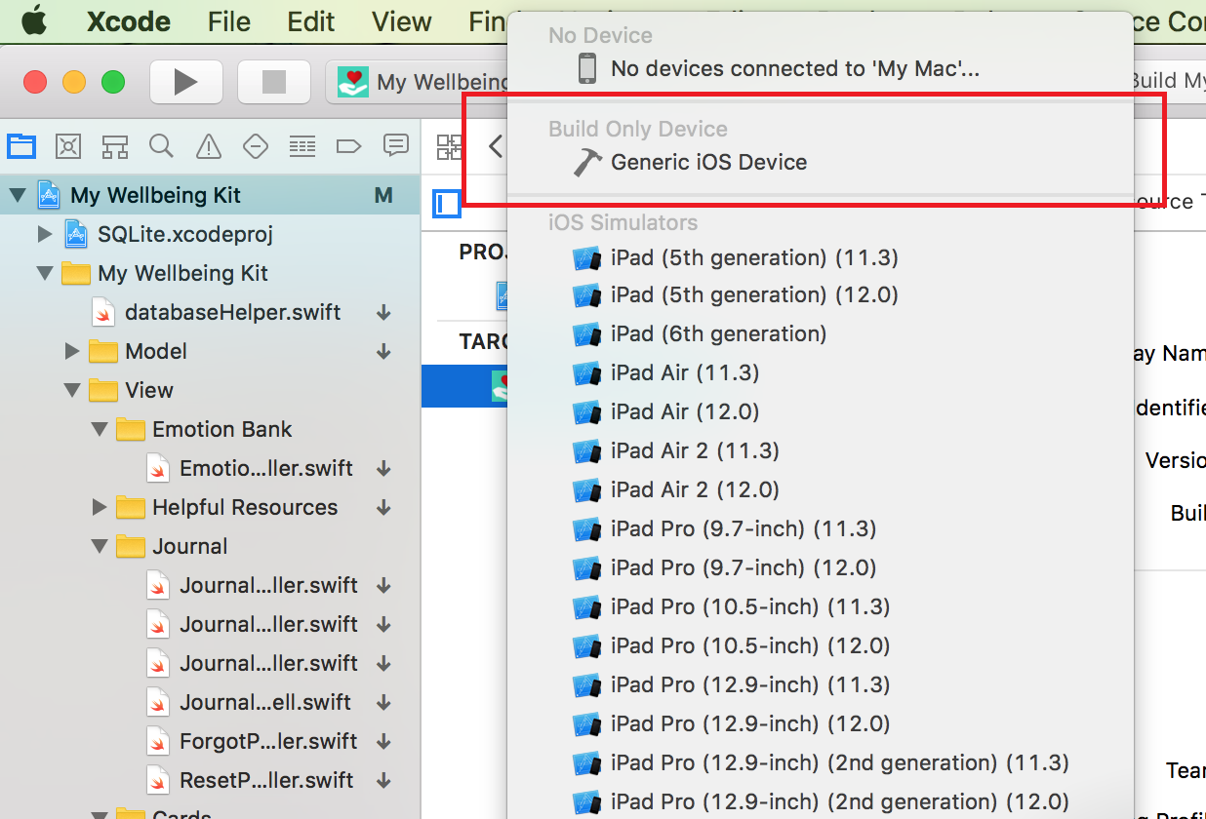
3. Select Archive from the Product menu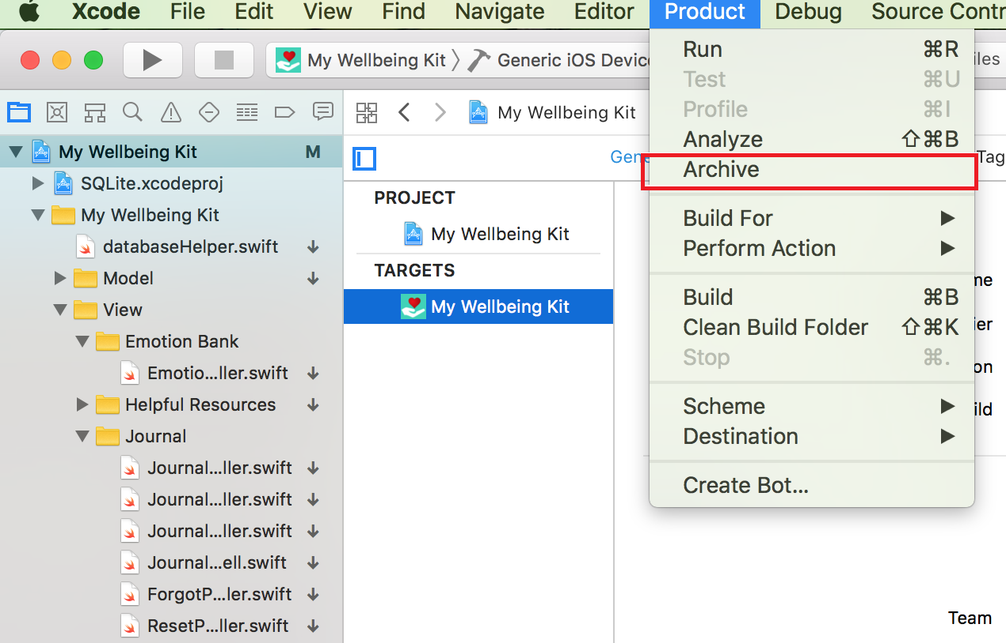
4. When the Archive has finished being created a window will appear. Select ‘Upload to App Store...’
5. The application will validate and then be submitted to Apple for review.

# 

# **9. Implementing Extra Features**

1. Take a short video for the wellbeing card.

This function allows user to use the mobile camera to take a short video and record it, once user clicks the card the video can play audio. The user will still be able to input text on the back of the card.

1. The user can share their cards on other social media.

The user can share the their cards online for the sharing with their friends.

1. The initial page can add a animation to open the card to show the users:

When the user click the icon of the application, the initial page popup and show to the user, once the user click the card, an animation will create like the cards opened in a box and after that show the cards to the user.

1. Add music in journal entry

It allows user to add music in the mobile phone and put into journal entry.

1. Events section

In helpful content section, allows user to see the mental health events holding information nearby the community.

1. Add online internet forum

Add a internet forum for users to share their stories and help each other to solve some situations in the community.

# **10. Appendix I - Method Definitions**

Explain each file, why it exists, and in general what is in it

You do not have to explain every method, so long as there are comments in your code explaining every method

If you are using an electronic documentation creator, such as javadoc, to explain each file and method, then include this content at the end of the manual as an appendix

Explain the format of every text file or database table that is used (or created) by your program

## 10.1 iOS

### 10.1.1 databaseHelper.swift

* func connectDB()
  + Establishes a database connection.
* func createTables()
  + Creates all tables required for storing user data.
* func insertCard(card:Card)
  + Inserts a card into the Cards table of the database.
  + - Parameter card : The card to be inserted into the database
* func insertJournalEntry(journalEntry: JournalEntry)
  + Inserts a journal entry into journal table of the database.
  + Parameter journalEntry : Journal entry to be inserted into database
* func insertResource(resource: Resource)
  + Inserts a resource into the resources table of the database.
  + Parameter resource : The resource to be inserted into the database
* func insertPassword(password: String?, question: String?, answer: String?,

journalLocked: Int)

* + Inserts a password, security question, answer and locked status of the journal into the settings table of the database.
  + Parameter password : String variable holding user password
  + Parameter question : String variable holding security question
  + Parameter answer : String variable holding the answer to the security question
  + Parameter journalLocked : An Integer value holding locked status of the journal

* func listCards()
  + Lists all cards in the database.
* func listJournalEntries()
  + List all journal entries in the database.
* func listResources()
  + List all resources in the database.
* func listSettings()
  + List all settings in the database.
* func getCard(ID:Int) -> Card
  + Returns a single Card object from the Cards table on the database.
  + Parameter ID : Integer Id value of the card to be retrieved.
  + Returns : Card
* func getJournalEntry(ID:Int) -> JournalEntry
  + Returns a single Journal Entry object from the database.
  + Parameter ID : Integer Id value of the entry to be retrieved.
  + Returns : JournalEntry
* func getResource(ID:Int) -> Resource
  + Returns a single Resource object from the database.
  + Parameter ID : Integer Id value of Resource to be retrieved.
  + Returns : Resource
* func isJournalLocked() -> Bool
  + Returns the journal lock status from the settings table in the databse (true or false).
  + Returns : Bool
* func getPassword() -> String
  + Returns the password String from the settings table in the database.
  + Returns : String
* func getFirstQuestion() -> String
  + Returns the security question from settings table in database.
  + Returns : String
* func getFirstAnswer() -> String
  + Returns the security question answer from the settings table in the database.
  + Returns : String
* func getAllCards() -> [Card]
  + Returns an array of all Card objects in the database.
  + Returns : [Card]
* func getAllCardsOrderedByFav() -> [Card]
  + Returns an array of Card objects, ordered by favourite cards first.
  + Returns : [Card]
* func getAllJournalEntries() -> [JournalEntry]
  + Returns an array of all journal entries in the database.
  + Returns : [JournalEntry]
* func getJournalEntriesByCategory(categoryToGet: String) -> [JournalEntry]
  + Returns an array of all journal entries which match the specified category.
  + Parameter categoryToGet : String holding the category to filter entries by
  + Returns : [JournalEntry]
* func getAllResources() -> [Resource]
  + Returns an array of all resource objects in the database.
  + Returns : [Resource]
* func updateCard(card: Card)
  + Updates a card objects details.
  + Parameter card : Card object to be updated in the database.
* func updateCardFav(card: Card)
  + Updates a cards favourite status in the database.
  + Parameter card : Card object to be updated.
* func updateJournalEntry(journalEntry: JournalEntry)
  + Updates a journal entry's details in the databse.
  + Parameter journalEntry : JournalEntry object to be updated.
* func updateResource(resource: Resource)
  + Updates a Resource objects details in the database.
  + Parameter resource : Resource object to be updated.
* func updatePassword(newPassword: String?, firstQuestion: String?, firstAnswer: String?, journalLocked: Int)
  + Updates the users journal lock password in the database.
  + Parameter newPassword : String holding the new journal password.
  + Parameter firstQuestion : String holding the new journal security question.
  + Parameter firstAnswer : String holding the new journal security question answer.
  + Parameter journalLocked : Integer of either 1(true) or 0(false) holding the locked status
  + of the journal.
* func deleteCard(ID: Int)
  + Deletes a single Card object from the database.
  + Parameter ID : Integer Id of the Card to be removed.
* func deleteAllCards()
  + Deletes all Card objects from the database.
* func deleteJournalEntry(ID: Int)
  + Deletes a single JournalEntry object from the database.
  + Parameter ID : Integer Id of the JournalEntry object to be deleted.
* func deleteAllJournalEntries()
  + Deletes all JournalEntry objects from the database.
* func deleteResource(ID: Int)
  + Deletes a single Resource object from the database.
  + Parameter ID : Integer Id of the Resource to be removed.
* func deleteAllResources()
  + Deletes all Resource objects from the database.
* func deletePassword()
  + Deletes the users journal lock password from the database and sets lock status to false.

### 10.1.2 CreatePasswordViewController.swift

* @IBAction func cancelButtonTapped(_ sender: UIBarButtonItem)
  + Dismisses the current view controller upon cancel button press
  + Parameter sender : Sender object of type UIBarButtonItem
* @IBAction func saveButtonTapped(_ sender: UIBarButtonItem)
  + Checks for inconsistencies in passwords and that a security question has been entered with
  + an answer, then dismisses.
  + Parameter sender : Sender object of type UIBarButtonItem

### 10.1.3 ConfirmPasswordViewController.swift

* @IBAction func cancelButtonTapped(_ sender: Any)
  + Dismisses the current view controller upon cancel button press
  + Parameter sender : Sender object of type UIBarButtonItem
* @IBAction func confirmButtonTapped(_ sender: Any)
  + Checks password entered against database value then either disables password lock or notifies user of incorrect password.
  + Parameter sender : Sender object of Any type.

### 10.1.4 AboutViewController.swift

* @IBAction func doneButtonTapped(_ sender: UIBarButtonItem)
  + Dismisses the current view and returns to Settings screen.
  + Parameter sender : Sender object of type UIBarButtonItem.

### 10.1.5 SettingsTableViewController.swift

* @IBAction func journalLockSwitchPressed(_ sender: Any)
  + Displays create password screen if switch toggled on or confirm password screen if toggled off
  + Parameter sender : Sender object of Any type
* @IBAction func gridViewSwitchPressed(_ sender: Any)
  + Enables and disables the cards grid view mode according to switch state
  + Parameter sender : Sender object of Any type
* func shake()
  + Shakes the view slightly from left to right. Mainly used for signaling a wrong password.

### 10.1.6 AddCardViewController.swift

* @IBAction func pickImageButtonTapped(_ sender: Any)
  + Launches image picker upon button press
  + Parameter sender : Sender object of Any type
* @IBAction func takePhotoButtonTapped(_ sender: Any)
  + Launches the phones default camera application upon button press
  + Parameter sender : Sender object of Any type
* @IBAction func saveButtonTapped(_ sender: UIBarButtonItem)
  + Checks that the new Card has required data before saving to database and returning to Cards list view.
  + Parameter sender : Sender object of type UIBarButtonItem
* @IBAction func cancelButtonTapped(_ sender: UIBarButtonItem)
  + Dismisses the view upon cancel bar button press
  + Parameter sender : Sender object of type UIBarButtonItem

### 10.1.7 CardCollectionViewCell.swift

* var favTapAction : (()->())?
  + Call back function to CardsViewController when Favourite button is tapped. Updates the favourite status of the card.
* var duplicateTapAction : (()->())?
  + Call back function to CardsViewController when Duplicate button is tapped. Duplicates the card
* var isEditing: Bool = false
  + Holds a true or false value determining if the view is in edit mode

### 10.1.8 CardsViewController.swift

* func createDefaultCards()
  + Initialises the set of 13 default cards into the database.
* func createDirectory()
  + Creates the document directory for storing images if it doesn't exist.
* func saveImage(image: UIImage) -> String?
  + Saves a UIImage to the document directory
  + Parameter image : UIImage to be saved locally
  + Returns : String path to the stored image.
* func saveImage(image: UIImage, name: String) -> String?
  + Saves an image to document directory given the UIImage and custom String (Used for default cards as we want particular names).
  + Parameter image : UIImage to be saved locally
  + Parameter name : Desired name of image file
  + Returns : String path to image in document directory
* func loadImage(fileName: String) -> UIImage?
  + Documents directory URL
* private func duplicate(indexPath: IndexPath)
  + Loads an image from the document directory.
  + Parameter fileName : Image file name as a String
  + Returns : UIImage
* func delete(cell: CardCollectionViewCell)
  + Duplicates a card object at given IndexPath in the UICollectionView and inserts it into database, updates view accordingly.
  + Parameter indexPath : IndexPath of Card object in UICollectionView to be duplicated.
* func lastIndexpath() -> IndexPath
  + Deletes a cell from the CollectionView and the object it represents from the database.
  + Parameter cell : CardCollectionViewCell to be removed from CollectionView

### 10.1.9 EditCardViewController.swift

* @IBAction func saveButtonTapped(_ sender: UIBarButtonItem)
  + Save changes to selected Card object and return to main cards list view.
  + Parameter sender : Sender object of type UIBarButton
* @IBAction func cancelButtonTapped(_ sender: UIBarButtonItem)
  + Dismiss the view upon cancel press, notify user if changes have been made that they will be lost.
  + Parameter sender : Sender object of type UIBarButtonItem
* func textViewDidChange(_ textView: UITextView)
  + Hide temporary label acting as text view hint text once user enters text.
  + Parameter textView : UITextView to monitor for change.
* func roundCornersForAspectFit(radius: CGFloat)
  + Rounds the corners of an image with specified radius.
  + Parameter radius : CGFloat radius of corners

### 10.1.10 ForgotPasswordViewController.swift

* @IBAction func backBarButtonTapped(_ sender: Any)
  + Returns to Journal locked screen if back button is pressed.
  + Parameter sender : Sender object of Any type
* @IBAction func submitButtonTapped(_ sender: Any)
  + Checks the security question answer against database values and either proceeds to unlock journal or notifies user.
  + Parameter sender : Sender object of Any type.

### 10.1.11 JournalEntryViewController.swift

* @IBAction func cancel(_ sender: UIBarButtonItem)
  + Returns to journal view controller if cancel button is pressed.
  + Parameter sender : Sender object of type UIBarButtonItem
* @IBAction func didUnwindFromEmotionBank(_ sender: UIStoryboardSegue)
  + Checks if view has returned from EmotionBankViewController and sets category accordingly.
  + Parameter sender : UIStoryboardSegue
* private func updateSaveButtonState()
  + Updates the state of the save button based upon journal text field data.
* func hideKeyboard()
  + Enables tapping on screen to dismiss on-screen keyboard easily.

### 10.1.12 JournalLockViewController.swift

* @IBAction func unlockButtonTapped(_ sender: Any)
  + Checks the input details against database values and either proceeds to unlock journal or notifies user the details are incorrect.
  + Parameter sender : Sender object of Any type.

### 10.1.13 JournalViewController.swift

* func populatePicker()
  + Populate the picker with emotion filtering options relevant to the current list of entries available.
  + Only show options that currently exist in the journal entries array.
* func checkForEmpty()
  + Checks if the list of entries is empty and displays text notifying user if the number of entries is less than zero.
* func populateJournal(data: String)
  + Populate journal list with entries retrieved from the local database according to the filter option given.
  + Parameter data : Emotion to filter journal entries by in String format
* @IBAction func unwindToJournalList(sender: UIStoryboardSegue)
  + Checks to see whether a new journal entry has been added or an old one has been updated.
  + Parameter sender : Sender of type UIStoryboardSegue

### 10.1.14 ResetPasswordViewController.swift

* @IBAction func saveButtonTapped(_ sender: Any) {
  + Checks that passwords entered match and if there is a security question and answer entered before saving data to database.
  + Parameter sender : Sender object of Any type.

### 10.1.15 ResourcesViewController.swift

* private func populateResources()
  + Populates local resources array with data from SQLite database.
* func numberOfSections(in tableView: UITableView) -> Int
  + Number of sections to display in table.
* @IBAction func addButton(_ sender: Any)
  + Launches an alert dialog containing a TextField and Submit button
  + whereby the user can input a new resource and add it to the database.
  + Parameter sender : Sender object of type Any

### 10.1.16 EmotionBankViewController.swift

* @IBAction func indexChanged(_ sender: AnyObject)
  + Upon interaction with the segmented control, updates the selected index and reloads appropriate data.
  + Parameter sender : Sender object of type AnyObject

## 10.2 Android

See attached file AndroidJavaDoc.zip. Unzip file to a suitable directory and open the index.html file in your browser of choice.